IMO Regulations, IBC-code
There are several international regulations, which are important for chemical tankers. The most fundamental regulation is the SOLAS convention which defines and sets into force the IBC-code.
Extract from SOLAS chapter VII -
PartB
Construction and equipment of ships carrying dangerous liquid chemicals in bulk
Regulations 8
Definitions
For the purpose of this part, unless expressly provided otherwise:
1 International Bulk Chemical Code (IBCCode) means the International Code for the Construction and Equipment of Ships Carrying-Dangerous Chemicals in Bulk adopted by the Maritime Safety Committee of the .Organization by resolution MSC.4(48), as may be amended by the Organization, provided that such amendments are adopted, brought into force and take effect in accordance with the provisions of article VIII of the present Convention concerning the amendment procedures applicable to the annex other than chapter I.
2 Chemical tanker means a cargo ship constructed or adapted and used for the carriage in bulk of any liquid product listed in chapter 17 of the International Bulk Chemical Code.
3 For the purpose of regulation 9, ship constructed means a ship the keel of which is laid or which is at a similar stage of construction.
4 At a similar state a/construction means the state at which:
.1 construction identifiable with a specific ship begins; and
.2 assembly of that ship has commenced comprising at least 50
tonnes or 1 % of the estimated mass of all structural material, -whichever is less.
Regulation 9
Application to chemical tankers
1 Unless expressly provided otherwise, this part applies to chemical tankers constructed on or after 1 July 1986 including those of less than 500 tons gross tonnage. Such tankers shall comply with the requirements of this part in addition to any other applicable requirements of the present regulations.
2 Any chemical tanker, irrespective of the date of construction, which undergoes repairs, alterations, modifications and outfitting related thereto shall continue to comply with at least the requirements previously applicable to the ship. Such a ship, if constructed before 1 July 1986 shall, as a rule, comply with the requirements for a ship constructed on or after that date to at least the same extent as before undergoing such repairs, alterations, modifications or outfitting. Repairs, alterations and modifications of a major character and outfitting related thereto, shall meet the requirements for a ship constructed on or after 1 July 1986 in so far as the Administration deems reasonable and practicable.
3 A ship irrespective of the date of construction, which is converted to a chemical tanker shall be treated as a chemical tanker constructed on the date on which such conversion commenced.
© Marstal Navigationsskole - February 02

Regulation 10
Requirements for chemical tankers
1 A chemical tanker shall comply with the requirements of the International Bulk Chemical Code and shall, in addition to the requirements of regulation 1/8, 1/9, and 1/10, as applicable, be surveyed and certified as provided for in that Code. For the purpose of this regulation, the requirements of the Code shall be treated as mandatory.
2 A chemical tanker holding a certificate issued pursuant to the provisions of paragraph 1 shall be subject to the control established in regulation 1/19. For this purpose such certificate shall be treated as a certificate issued under regulation I/I 2 or I/I 3.

The IBC-code (International Code for the Construction and Equipment of Ships Carrying Dangerous Chemicals in Bulk) has several purposes. First and most it is a construction code, which ensures that all chemical tankers are build to high standards.
IBC-code
(For chemical tankers build before 1. of July 1986 the BCH-code applies)
Furthermore the code has a lot of information which influences the daily operation.
The code consists of 19 chapters plus an index and some appendices.
During the normal operation the typical use of the code will be a check to see if the chemical the vessel is about to load will demand any special precautions.
® Marstal Navigationsskole - February 02

The Procedure is:
1. Find the chemical in the index

Index of Dangerous Chemicals Carried in Bulk

Name
beta-Methylacrolein
*METHYL ACRYLATE
- 2-Methylacrylic acid
- 2-Methylacrylic acid, dodecyi ester 2Methylacrylic acid, lauryl ester
* METHYL ALCOHOL
* METHYLAMINE SOLUTIONS (42% OR LESS) 1 -Methyl-2-aminobenzene 2-MethyM -aminobenzene METHYLAMYL ACETATE METHYLAMYL ALCOHOL METHYL AMYL KETONE
* 2-Methylaniline o-Methylaniline
2-Methylbenzenamine
o-Methylbenzenamine
Methylbenzene
Methylbenzenediamine
Methylbenzol
* 2-MethyM ,3-butadiene
3-Methyl-1 3-butadiene
* 2-Methylbutane
* 2-Methylbutan-2ol
* 2-Methyl-2-butanol
2-Methyl-4-butanol
* 3-Methyl-1-butanol
*3-Methylbutan-1-ol
3-Methylbutan-3-ol
*3-Methylbut-1-ene Methylbutenes
See
CROTONALDEHYDE
Chapter 17
METHACRYLIC ACID
DODECYL METHACRYLATE
DODECYL METHACRYLATE
Chapter 18
Chapter 17
o-TOLUIDINE
o-OLUIDINE
Chapter 17
Chapter 17
Chapter 18
o-TOLUIDINE
o-TOLUIDINE
o-TOLUIDINE
o-TOLUIDINE
TOLUENE
TOLUENEDIAMINE
TOLUENE
ISOPRENE
ISOPRENE
PENTANE (ALL ISOMERS)
terf-AMYL ALCOHOL
teri-AMYL ALCOHOL
ISOAMYL ALCOHOL
ISOAMYL ALCOHOL
ISOAMYL ALCOHOL
tert-AMYL ALCOHOL
PENTENE (ALL ISOMERS)
PENTENE (ALL ISOMERS)
UN No. MFAG 1919 330
1230 1235
306 320
1233 330
2053 305
1110 300

• In the index you will find a reference to Chapter 17 or 18 of the IBC-code or you will find another name for the chemical.
• If the name of the chemical is not in the index the shipper must be contacted to see if he has another name for the chemical.
• If the chemical cannot be found in the code the vessel is not allowed to transport it, unless a tripartite agreement is made by the flagstate's administration and the administrations of the port states (IBC 1.1.3). If the chemical is listed in chapter 17 or if the chemical is listed in chapter 18 with a pollution category D, the product must be listed on the ship's "Certificate of Fitness".
• Names in the index that are preceded by an .asterix are chemical names in correspondence with the system developed by IUPAC (International Union of Pure and Applied Chemistry)
© Marstal Navigationsskole - February 02

4
• In the fifth column of the index is found the MFAG number. This is a reference to the appropriate table in Medical First Aid Guide, and the table should be consulted to check whether the vessel needs an antidote for the product. (IBC 14.2.9)
• If the product is from chapter 18 without any pollution category there are no restrictions for transport other than commercial restrictions.
The products mentioned in chapter 18 are products which in spite of their chemical nature and names are not considered dangerous. This means that those products in principle may be transported in any tanker except for the fact that some of them present a minor pollution hazard. If the product has a Pollution Category D it must be listed on the vessel's Certificate of Fitness. If the ship is not a chemical tanker (i.e. holds no CoF) the product must be listed on a NLS-certificate ( Noxious Liquid Substances). Of course the equipment of the vessel such as coating, packings, pumps etc. is decisive as to which products actually can be carried.
Extract from the IBC-code, chapter 18
a Product name | b  UN number | c Pollution category for operational discharge (regulation 3 of Annex 11)
Acetone | 1090 | III
Acrylonitrile-Styrene copolymer dispersion in polyether polyol | - | D
Alcoholic beverages, n.o.s. | 3065 | III
Alcohols (C13+) | - | III
n-Alkanes (C10+) | - | D
Alkenyl(C8+)amide, Alkyl(C12+) acid ester mixture | - | D
Alkyf(C9+)benzenes | - | III
Alkyldithiothiadiazole (C6-C12) | - | D
Aluminium sulphate solution | - | D
Aminoethytdiethanolamine/ Aminoethylethanolamine solution | - | III
2-Amino-2-hydroxymethyl-1 ,3-propanediol solution (40% or less) | - | III
Ammonium hydrogen phosphate solution | - | D
Ammonium polyphosphate solution | - | D

© Marstal Navigationsskole - February 02
2. If the product is listed in chapter 17 the next step is to check the requirements in this chapter.
Extract from the IBC-code's "Summary of Minimum Requirements" (Chapter 17)
ii | h | c | d | e | 1 | S | h | i |  |  | 1 | k | / | Ot | n | 0
 |  |  |  |  |  |  |  | [kamal
 |  | ^ |  |  |  |  |  | equipment
Product nanic | S | 3C .=  .3 | •£ | , | 1 | ? S | gi •ll  & r^ | »" | /" | i""  | | E?  •a | ^ | -^  i- | "5.J  -s ri | § i  S 5 g £ | Spn.i,il requifcmrnU tsee chapter 15;
 | § | £ | ^ | •^ ^ | 1 | ±  h2 | ^1 | ^ | U | -3 s  l*. A | .S | ?-! | •Si | I! | it
Tall oil soap [diiproportionaledl solulion |  | B | P | 3 | 2C | Open | No |  |  | Yes | 0 | No | A |  | Nil | n.I'l.f). lh.2.(>, 16.2.')
1 eirachloroelhanc | 1702 | B | S P | 3 | 2C | Corn. | No |  | Nf |  | R | T | No |  | No | 15.12. 15.17, 15.19.6
Telraelhylenepenlamine | 232(1 | D | -S | ] | 2C | Open | No |  |  | Yes | 0 | No | A | N1 | No
Telrahydroluriin | 2056 | D | S | 3 | 2G | Conl. | No | T3 | IIB | No | R | F-T | A |  | No | 15.19.6
Tctrahydronaphlhalrne Ibh) |  | C | P | 3 | 2C | Open | No |  |  | Yes | 0 | No | A |  | No
Tetramelhylbenzene I'all isomers] |  | A | P | 3 | 2C | Open | No |  |  | Yes | 0 | No | A |  | No | lti.2.9. 1(>A.2.-'
Toluene (hill | 1294 | C | P | 3 | 2C | Conl. | No |  |  | No | R | r | A |  | No | I5.19.ft
Toluenediamine | 1709 | C | S'P | 2 | 2G | Conl. | No |  |  | Y» | C | T | A,0 | N1 | E | 15.12. IS^, 15.1"). »).3.7. 1(>.2.9
 |  |  |  |  |  |  |  |  |  |  |  |  | A
Toluene diisoi'vanale | 207B | C | S P | i | 2C | Corn. | dq | Tl | IIA | Yes | C | F-T | CK-1, U | N4 | E | IS.12, 15.1(>.2, 13.7, 13.1'). lu.2.')
o-Toluidiw | 17(18 | C | S'P | 2 | 2C | Con). | No |  |  | Yes | C | T | A |  | No | l'i.12. 1.5.17. 1X19
Triliulvl phosphatr |  | B | P | 3 | 2G | Open | NO |  |  | Yi", | 0 | No | A |  | No | IS.lt.h
1 .2.4-Trichlcirolien7en(' | 23-'1 | B | S P | 2 | 2G | Coni. | NO |  |  | Yw | R | T | A.B |  | No | IS.D.h. lh.2.'). lfiA.2.2

Summary of minimum requirements
All the columns in chapter 17 hold information that has a bearing on the operational procedures.

See comments above.
Column a:
Product Name:
Column b:
UN number:
Column c:
Pollution Category:
Column d:
Hazards:
Many of the products (but not all) have been assigned a unique 4-digit number. If the product has a UN number this should be part of the shippers information to the vessel.
The pollution category can be A, B, C or D according to the criteria laid down in MARPOL's Annex II or marked as IIIfl, meaning that the substance has been evaluated and found to be non-pollutant. The pollution categories are only kept updated in this list and not in MARPOL. If the pollution category is listed in brackets it means that the substance has only been provisionally assessed.
Indicates whether the product is considered dangerous due to Safety problems or due to Pollution problems.
© Marstal Navigationsskole - February 02

Chemical tankers will be assigned one or more ship types according to the. ship's construction.

are constructed and equipped to carry the most dangerous or reactive chemicals which require the most extensive precautions to avoid spill if the vessel is involved in a collision or grounding. Furthermore the requirements to intact stability and buoyancy after a collision or grounding are rather stringent
Type 1 ships
On the figure is shown the most important demands to the construction of the hull and the cargo tanks.
IMO Ship Types


a
inm «-
""»i»»<i—>
''" Hill,
•*——MlNtt

are constructed and equipped to carry less dangerous product than type 1, but nevertheless so dangerous that the vessel must be capable of surviving minor collisions and grounding without leaking cargo to the environment.
Type 2 ships
Type 3 ships
Depending on the size of the vessel type 2 ships are subject to almost the same requirements for damage stability as type 1 ships.
are constructed to carry products that represent a greater danger than oil products and consequently requires some protection. A type 3 vessel has no demands to the location of the cargo tanks, but is subject to some requirements as to damage stability.
® Marstal Navigationsskole - February 02

Column/:
Tank Type:
Independent tanks

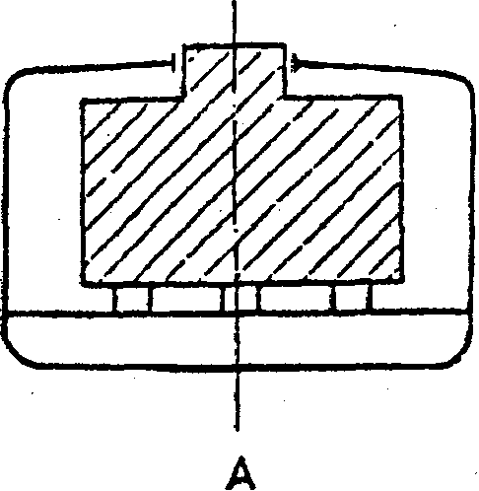
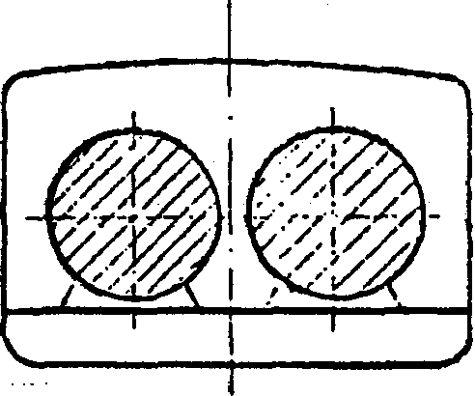
B
Integral Tanks

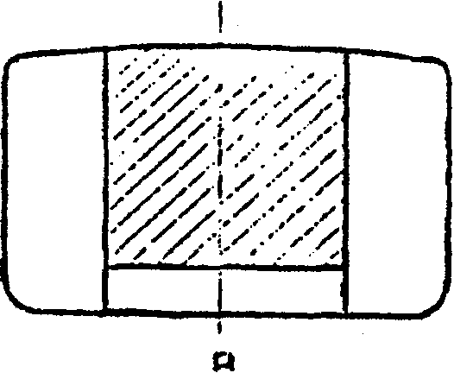


A

In addition to the requirements to the hull construction and the location of the cargo tanks, also the tank construction is classified.
Independent tanks
Integral tanks
Gravity tank
Pressure tank
Column g:
Tank vents:
(tank type 1G) means tanks which are not part of the hull structure. An independent tank is not essential to the structural completeness of the hull.
(tank type 2G) are tanks which form part of the ships hull and which may be stressed in the same manner and by the same loads which stress the hull.
means a tank having a design pressure not greater than 0.7 bar gauge at the top of the tank. It may be an integral tank or an independent tank.
means a tank having a design pressure greater than 0.7 bar gauge. A pressure tank should be an independent tank. (A pressure tank is not specified for any of the products currently in the IBC-code.)
The requirements for tank vents (Open or Controlled) will be dealt with in detail in chapter 10.
© Marstal Navigalionsskole - February 02

Column h:
Tank environmental
Control:
Inert:
Pad:
Dry:
Vent:
Column i:
Electrical equipment:
Column j:
Gauging:
Open:
Restricted:
Closed:
Indirect:
Column k:
Vapour detection:
The column offers one of four possibilities.
The tank and associated piping must be-inerted by filling
them with an appropriate gas or vapour, which will not
support combustion or react with the cargo.
The tank and piping must be filled with an appropriate gas
or liquid, which separates the cargo from the air and this
condition must be maintained during the voyage.
The tanks and piping must be maintained at a dewpoint of
-40°C or below.
The ullage space of the tanks must be ventilated - either
by natural or forced ventilation.
This column states the temperature class and electrical apparatus group for equipment to be used in gas dangerous areas. Furthermore it is stated whether the flashpoint is above 60°C or not. Chapter 10 of the EC-code deals in detail with the requirements for electrical equipment.
Also this column offers one of four possible devices.
A method of gauging which will expose the gauger to the cargo or its vapour. An example is the use of a normal ullage hatch.
A device which penetrates the tank, but only exposes the user to small amounts of vapour. Examples are portable gauging devices mounted on sounding pipes with a valve. Devices that penetrate the tank but which do not allow any vapour to be released during their use. Examples are float-type systems, pressure sensors and tank radars. A device which does not penetrate the tank and is independent of the tank as for example a flow-meter. Indirect devices are not presently specified for any of the products in the IBC-code, but may be used in stead of closed devices.
This column specifies whether the vessel must have on board special detector equipment for the product. If the column specifies F, the vessel must have at least two instruments capable of checking for a flammable atmosphere of the product.
If the column specifies T, the vessel must have at least two instruments which are usable for testing for toxic concentrations. If it is impossible to obtain measuring equipment for a specific gas where this column specifies T, the ship's Certificate of Fitness will reflect this by requiring additional supply of breathing-air.

© Marstal Navigationsskole - February 02

Column I:
Fire protection:
Column m:
Materials of construction:
Column n:
Respiratory and eye protection:
Column o:
Special requirements:
Certificate of Fitness
In either case one of the instruments can be a fixed installation.
Specifies which kind of fire-fighting media will be the best for the product. All chemical tankers must have a foam-system, but addition of some products to the Certificate of Fitness could mean requirements for large amounts of dry powder or for a water-spray system.
The column may specify Nn, Z or Yy where n can be a number from 1 to 6 and y a number from 1 to 5. The translation is found in chapter 6 of the IBC-code, but basically the N's are about materials not suited for the product and the Y's are notes on materials which should be used for the product.
Whenever an E appears in this column it means that the ship must have suitable respiratory and eye protection for every person on board. The equipment must include self-contined breathing apparatuses with at least 15 minutes air supply.
This column refers to special requirements from the code's chapter 15 and/or 16. The special requirements vary considerably from product to product, and as quite a lot of them has operational significance it is absolutely necessary to check these requirements for each product.
When a vessel has been surveyed and found to match the requirements of the IBC-code a "Certificate of Fitness" is issued either by the National Authority or by the Classification Society on behalf of the National Authority. Attached to the Certificate of Fitness is a List of Cargoes. This list states the tanks that may be used for the carriage of a product from chapter 17 of the code ( And category D product from chapter 18). The certificate will also mention any additional requirements or exemptions valid for the ship.
The Certificate of Fitness is subject to the same surveys as most of the other statutory certificates, i.e. Annual, Intermediate and Periodical surveys.
The CoF is issued for a 5-year period and the IBC-code states categorically, that no extension of the 5-year period should be permitted, meaning that it is of utmost importance to make sure that the surveys are carried out in due time.

© Marstal Navigalionsskole - Februaiy 02

10
Below is shown an example ogf the first page of a Certificate of Fitness and also a page from the accompanying product list.


No: 83775 Page 1 of 31

International Certificate of Fitness for the Carriage of Dangerous Chemicals in Bulk
Issued under the provisions of the Intemiiliomi Code for the Construction and Equipment of Ships Carrying Dangerous Chemicals in Bulk (resolutions MSC. 4(48) and MEPC. 19(22) and resolution A.718W) relating to the early implementation of the harmonized system of survey and certification)² under the authority of the Government of the Kingdom a/Denmark

Name of ship Distinctive number or letters Port of registry Gross tonnage Ship type* (Code paragraph 2-1.2) IMO number
Particulars of ship
DANCHEMBAST
OXAG2 D-13434
NYK0BING MORS
1666
2
9031624
Date on which keel was laid/ date on which the ahip waa at a eimila?

4 NOVHMBER 1991
Date of ffiitial / periodical' inspection 8 September 1997
The ship also complies fully with the following amendments to the Code:
Resolutions MSC 50(66) and MEPC 68(38)
The-shi wtMhe-following provisions of the Co
This is la certify:
1. 1.1 that the ship has been surveyed in accordance with the provisions of section 1.5 of the Code;
1.2 mat the survey showed that the construction and equipment of the ship complied with me relevant provisions of the Code;
2. that the ship has been provided with a manual, in accordance with the standards for procedures and arrangements as called for by regulations S, 5A and 8 of Annex II of MARPOL 73/78, and mat the arrangements and equipment of the ship prescribed in the manual are in all respects satisfactory and comply with the applicable requirements of the said Standards;
3. that the ship is suitable for the carriage in bulk of the products listed on page(s) 6 to 18 provided thai all the relevant operational provisions of the Code are observed;
© Marstal Navigationsskole - February 02

 |  | . - fast: 7 of 31
J .iqyq's List of Products
1 <? (.3.P TCl -^'1 ' ^'P ^{Name} : DANCHEM EAST <— Certificate No: 83775

 | Product (as referred to in paragraph 3) | Conditions of Carriage
 | Product (as referred to in paragraph 3) | Notes | Tank Groups
 | ANIMAL ACID OIL | 10. n, 41 | 1
 | FISH ACID OIL | 10. 11,41 | 1
 | LARD ACID OIL | 10. 11, 41 | 1
 | MIXED ACID OIL | 10, 11,41 | 1
 | MIXED GENERAL ACID OIL | 10, 11, 41 | 1
 | MIXED HARD ACID OIL | 10, 11,41 | 1
 | MIXED SOFT ACID OIL | 10, 11, 41 | 1
 | ANIMAL & FISH OILS. N.O.S. INCLUDING:
 | COD UVER OIL | 10,41 | 1
 | LANOLIN | 10, 24, 41 | 1
 | NEATSFOOTOIL | 10, 24, 41 | 1
 | PILCHARD OIL | 10, 11,41 | 1
 | SPERM OIL | 10. 24,41 | 1
 | ARYL POLYOLEFINS IC11-CB01 | 10, 11,41 | 1
 | AVIATION ALKYLATES (C8 pwfflns & iso-paraflins BPT 95-120 d*gr«es C) | 10, 11,27,42 | 1
 | BENZENE AND MIXTURES HAVING 10% BENZENE or more | 24, 27, 36 | 1
 | BENZENESULPHONYL CHLORIDE | 10, 11.24.27 | 1
 | BENZYL ACETATE | 10 | 1
 | BENZYL ALCOHOL | 10 | 1
 | BRAKE FLUID BASE MIX | 10. 11,41 | 1
 | 8ROMOCHLOROMETHANE |  | 1
 | BUTENE OUGOMER | 10, 11, 27 | 1
 | BUTYL ACETATE 1*11 xomwil | 10, 11.27 | 1
 | BUTYL ACRYLATE 1*11 isonrrel | 1,2,3,27, 29 | 1
 | BUTYLAMINE I •II iwnrrs I | 5, 10, 11. 13, 14,23, | 1
 |  | 27,29
 | BUTYL8ENZENE (all isonrrs) | 10,11,27 | 1
 | BUTYL BENZYL PHTHALATE | 10, 11, 27,29 | 1
 | BUTYL BUTYRATE 1«11 iiomarsi | 10, 11,27 | 1
 | BUTYUDECYL/CETYL/EICOSYL METHACRYLATE MIXTURE | 1, 2.3. 10, 11,24 | 1
 | BUTYLENE GLYCOL | 10, 11, 24,41 | 1
 | BUTYL METHACRYLATE | 1, 2, 3, 11, 27 | 1
 | it-BUTYL PROP10NATE | 10. 11.27 | 1
 | BUTYRALOEHYDE (all isomorsi | 6.27 | 1
 | B*mm«-BUTYROLACTONE | 10,41 | 1
 | CALCIUM ALKYL (CSI PHENOL SULPHIOE/POLYOLEFIN PHOSPHOROSULPHIDE MIXTURE | 10, 11.27.29 | 1
 | CALCIUM HYPOCHLORITE SOLUTION (15% or les» | 6 | 1
 | CALCIUM HYPOCHLORITE SOLUTION Imora than 15%) | 6,27 | 1
 | CALCIUM LONG-CHAIN ALKARYL SULPHONATE (C11-C50) | 10, 11,41 | 1
 | CALCIUM LONG-CHAIN ALKYL PHENATE SULPHIDE IC8-C40) | 10, 11,41 | 1
 | CALCIUM LONG-CHAIN ALKYL SALICYLATE IC13+) | 10, 11,37. 38 | 1
 | CAMPHOR OIL | 27,29 | 1
 | •psiton- CAPROLACTAM (molten or aqueous solutions) | 10, 11,24, 41 | 1
 | CARBOLIC OIL | 5, 10, 13,24,27. 28. 29  / | 1
 | Continued on page(s) numbered:- 8 to 31 Tank groups referred to in this list are identified on the tank group key on Page 19.

© Marstal Navigationsskole - Februaly 02
12
") , fage: 23 of 31
^{r} .low's
Kt^OTCn-^'T Ship Name: DANCHEM EAST
____^_______ Certificate No: 83775
15 1BC Code paragraph 15.20 or BCH Code paragraph 4.22, as applicable, must be complied with. Attention is drawn to the following :-
(i) The carriage temperature of this cargo should be maintained below 100 degrees centigrade. (1BC 15.20.1) (BCH 4.22.1)
16 1BC Code paragraph 14.2.8 or BCH Code paragraph 4.17, as applicable, applies to Ammonia Aqueous, 28% or less but not below 10%. (1BC 17, footnote a). When applicable, attention is drawn to the following :-
(i) Respiratory and eye protection should be provided for every person on board. Filter type respiratory protection not to be used from 1 July 1994 onwards.
17 If the product to be carried contains flammable solvents such that the flashpoint does not exceed 60 degrees Centigrade c.c., then special electrical systems and a flammable vapour detector should be provided. (1BC 17 footnote b).
18 Although water is suitable for extinguishing open-air fires involving this chemical, water should not be allowed to contaminate closed tanks containing this chemical because of the risk of hazardous gas generation. (1BC 17 footnote c)
19 Dry chemicals must not be used as a fire-fighting medium because of the possibility of an explosion,
alternative arrangements are to be provided for fire protection of the cargo deck area and cargo tanks. (1BC 17, footnote g)
20 Dry chemicals must not be used as a fire-fighting medium, alternative arrangements are to be provided for fire protection of the cargo deck area and cargo tanks. (1BC 17. footnote u)
21 Temperature of carriage of Sodium Hydroxide 55% Aqueous solution is not to exceed 55 degrees Centigrade.
22 Temperature of carriage of Potassium Hydroxide 50% Aqueous solution is not to exceed 50 degrees Centigrade.
23 This cargo has a low boiling point. For low boiling point cargoes to which BCH Code paragraph 4.11/IBC Code paragraph 15.14 does not apply, operational measures may be necessary in order to maintain cargo temperature below the boiling point.
24 This cargo may require healing. The cargo's melting point should be indicated on the shipping document. Temporary heating arrangements may be required.
25 This cargo has a range of melting points, some of which exceed +55 degrees Centigrade. It is to be ensured ' • that the grades carried on this vessel do not exceed a melting point of +55 degrees Centigrade.
26 1BC Code paragraph 15.9 or BCH Code paragraph 4.21, as applicable, must be complied with. Attention is drawn to the following :-
(i) Tanks and associated equipment which have contained this product may be used for other cargoes after thorough cleaning by washing and purging. (1BC 15.9.1) (BCH 4.21.1)
(ii) In the event of spillage of this product, all spilled liquid should be thoroughly washed away without delay. To minimize fire risk, spillage should not be allowed to dry out. (1BC 15.9.2) (BCH 4.21.2)
27 1BC Code paragraph 15.19.6 or BCH Code paragraph 4.14.1, as applicable, must be complied with. Attention is drawn to the following :-
(i) Loading operations should be terminated at once in the event of any system essential for safe loading becoming inoperative.
'ontinued on page(s) numbered:- 24 to 31
The notes in the product list reflect various operational notes from the IBC-code and the Classification Society's interpretation of those notes.
© Marstal Navigalionsskole - February 02
Chemical Families

All the hydrocarbons mentioned in chapter 3 consisted of carbon and hydrogen only. Very often also other elements are present in the organic compounds e. g. Oxygen, nitrogen, halogens etc. These compounds may be grouped in different chemical families. In the following, chemical families often carried will be discussed. The grouping is also in accordance with the US Coast Guard Compatibility Chart and the numbers in () refer to that.
Alcohols. (20)
An alcohol is derived from a hydrocarbon by substituting a H- atom by the hydroxyl group -OH. Their names have the suffix -ol. They are generally toxic but in a very varying degree. They are all flammable. The following are some of the more common alcohols:

Methanol (methylalkohol) CH₃OH
H
H—C—0—H

H H H—C—C—0—H Ethanol (ethylalkohol) C₂H₅OH
H H
H H H
„ '_'_•_„ 2-propanol (iso-propylalkohol) (CH₃)₂CHOH

H
0
H
H

Also some of the higher alcohols, such as 2-ethylhexanol (octanol) are commonly encountered.
Glycols (20)
have 2 OH groups and are also called dihydric alcohols. Some glycols are very toxic. Typical examples from this group are:
H H
Ethyleneglycol CH₂OHCH₂OH
H—0-
H H

is a trihydric (three OH groups) alcohol. It is non toxic. Used widely in the explosives manufacturing business.
Glycerol (20)
© Marstal Navigationsskole - February 02

14

Phenols and cresols
(21)
Ethers (41)
Formally these substances also belong to the alcohol family, but generally they are considered as an independent group. The phenols consists of a benzene ring with one or more -OH groups attached. Cresois furthermore have a methyl group attached to the benzene ring.
The phenols are acidic as they are able to yield H⁺ they are very toxic also by skin contact.
The most well-known is phenol (carbolic acid) C₆H₅OH
and naphtol C₁₀H₇OH , which have two benzene rings
linked.
Cresol, also called methyl phenol, has the formula CH₃₋C₆H₄-OH
and are found in three isometric compounds.
are alcohol anhydrides as they may be derived from alcohols by elimination of water thereby having the generic formula ROR' where R and R' are organic radicals:

The most important is ethylether C₂H₅-O-C₂H₅ the same as ether in common speaking.
Ketones (18)
Organic acids (4)
An other common ether is 1,4-dioxane C₄H₈O₂, a glycol anhydride with a ring shaped molecule. The formula is often more correctly written in the following way:
OCH₂CH₂OCH₂CH₂

All ethers are toxic, more or less, typical with a narcotic effect, and the vapours form flammable mixtures with air.
O
C
is a class of liquid compounds in which the carbonyl group (=CO) is attached to two carbon atoms i. e. the denominating group is inside the hydrocarbon chain. The substances have very different properties, but most of them are narcotic and flammable.
The simplest and most well-known ketone is acetone:
H 0 H H—C—C—C—H Dimethylketone (acetone)
CH₃COCH₃

H H
Another commonly transported ketone is the methyl ethyl ketone, CH₃COC₂H₅, which often is abbreviated MEK.
The most important group of organic acids contains in the molecule the carboxyl group -COOH or more correctly
0 Marstal Navigationsskole - February 02

o
Anhydrides (11)
II
—C—O—H
which always will be at the end of the chain.
The strongest organic acid is formic acid H-COOH. The strength of the acids decreases with increasing number of carbon atoms.
The most well known are acetic acid CH₃-COOH and propionic acid C₂H₅-COOH.
Also two -COOH groups are possible e. g. the oxalic acid HOOC-COOH or malonic acid HOOC-CH₂-COOH.
If water is removed from acid, an acid anhydride is formed. They may be very toxic and might react violently with water giving off heat.
The most common are acetic anhydride (CH₃CO)₂O and propionic anhydrid (CH₃CH₂CO)₂O. The constitutional formula of acetic anhydride is as follows:

H O O H
H___C___C___O___C___C___H
H H

Organic compounds corresponding in structure to a salt in the inorganic chemistry. Esters are considered as derived from acids by the exchange of the replaceable hydrogen for an organic radical. Their names normally are derived from acid names with the suffix -ate
Esters (34) (Сложн.
Эфиры)
Esters have very different properties, some are very volatile with a narcotic effect if inhaled. They often have a pleasant odour, and are generally not very reactive. Waxes are esters derived from fatty acids and alcohols, while fats are esters from fatty acids and glycerol.

Commonly carried are:
O H
I II I
H—C—C—0—C—H
Methylacetate СH₃COO-CH₃

H H

?
H H

H—C—0—C—C—H
H H
Ethytformate HCOO-C₂H₅
and also some of the phthalates such as Diisooctylphthlat-late (DIOP).
© Marstal Navigationsskole - February 02

Alkylene oxides (16) (Epoxides)
Organic compounds containing a reactive group resulting from the union of an oxygen atom with two other atoms (usua]ly carbon) that are joined in a triangle. Characteristic properties are a very wide flammability range, burns violently and are very difficult to extinguish by smothering due to the oxygen content.
Transportation is carried out in incited tanks. Heating should be avoided.
The only product normally encountered in chemical tankers is:

Propyleneoxide C₃H₆O
H H H I I I
Wf-0 H
-H

Aldehydes (19)
Amines (7,8, & 9)
Aliphatic amines (7)
Aromatic amines (9)
is a broad class of organic compounds having the generic formula RCHO, and characterized by the unsaturated car-bonyl group ^o
r"
f^^ C-^
They are all very toxic with vapours irritating to the eyes and mucous membranes. Most of them are soluble in water and alcohol and some of them are able to polymerize.
The smell is characteristically pungent.
The simplest as formaldehyde HCHO and acetaldehyde CH₃CHO are transported as water solutions, while pro-panal CH₂CHCHO, butanal CH₃CH₂CH₂CHO and furfu-ral C₄H₃OCHO are transported as pure products.
A class of organic compounds of nitrogen that may be considered as derived from ammonia (NH₃) by replacing one or more of the hydrogen atoms with alkyi groups. As a general rule, hydrocarbons containing nitrogen are more toxic than equivalent compounds without nitrogen.
Amines are subdivided into subgroups according to the organic radicals connected to the nitrogen atom.
consists of one or more alkyles joined to the nitrogen atom e. g. ethyl amine CH₃CH₂NH² and diethylamine
(C₂H₅)₂NH. N(CH)₄CH
have one or more benzene groups. Example: aniline C₆H₅NH₂ and pyridine

© Marstal Navigationsskole - February 02

Alkanol amines (8)
Amides (10)
A compound such as ethanolamine HOCHaCH^NHz or trielhanolamine (HOCHzCHz).^, in which nitrogen is attached directly to the carbon of an alkyi alcohol.
are organic compounds containing the group -CONHz e.
S-~- -H 0 H
H_-(L4—,ll Acetamide CH3-CONH2.

H H

are compounds containing nitrogen in the form of -OCN. Most of them are iso compounds i. e. iso cyanates. Frequently carried is toluene-2,4-diisocyanate CH3C6H3(NCO)2.
are monomere esters from acrylic acid. The denominating molecular structure is CHz.'CHCOO-.
Cyanates (12)
Generally transported is methylacrylate CH2:CHCOOCH3. Acrylates must normally be inhibited during transport.
Acrylates (14)
are derived from propene (=allene). Polymerizable substances with the group CHa.'CHCHs-. Known examples are:
Allylalcohol CH2:CHCH20H and
AUyls (15)
acrylonitrile CH2.-CH-CN.
Epichlorohydrin (17) CH2CHOCH2CI is an epoxy compound that is able to polymerize at elevated temperatures. It is poisonous and flammable and reacts with several other cargoes.

Vinyl halides (35)
Halogenated hydrocarbons (36)
are derived from vinyl CH2:CH- (= ethene) with halogens attached to the free bonds. Most of them are gases at ambient temperatures. Common are:
Vinyl chloride CH:2:CHC1 and vinylidene fluoride CH2:CP2.
Compounds between hydrocarbons and halogens. Some
of them are poisonous especially as they decompose when
heated and forms toxic gases. Some of them are used in
fire fighting (they quench the flames) others are used as
refrigerants.
Regularly transported is ethylene dichloride (EDC)
C1CH2CH2C1

© Marstal Navigationsskole - February 02

are transported widely under the trade name "cellosolve" and are mostly used in the paint industry. When transported they are often mixed. They are chemical stable compounds but also very often both flammable and harmful to the health.
Glycol ethers (40)

Example:
Ethylene glycol dimethyl ether C^OCI^CHzOCHs.
NitrocompOimds. (42) are compounds with nitrogen apart from those already mentioned. The radical -NOz is seen frequently. As mentioned earlier all nitrogen-hydrocarbons should be regarded as toxic especially in a fire situation in which different nitrogen oxides may be formed.
Example:
Nitmbenzene C6H5N02.

Water solutions. (43)
CC.C
Compatibility Chart
16 CFK fS'0
Using the Compatibility Chart
This name cover a great variety of many different substances. The only common property is that they are all water soluble and contain water. They should not be stowed adjacent to cargoes reacting with water. The properties of a solution might be quite different from those of the pure product.
If chemicals are mixed in tanks or pipelines, the resulting chemical reaction might be very violent, high temperatures or pressure might arise or dangerous substances or vapours might be evolved.
The IBC code gives no help on this problem, it simply mentions that cargoes or slops, that dangerously may react with each other, should be separated by an intervening compartment that not contain a reactive substance.
US Coast Guard, Department of Transportation has regulated this problem in the Code of Federal Register, 46 CFR 150.
The cargoes are divided into chemical groups or families and group numbers 1-22 represents reactive chemicals, while 30 - 43 are products that do not react mutually with each other. The missing numbers are reserved for future extensions of the chart.
If you wish to investigate whether two cargoes are compatible or not, you must find the group numbers in table 1.

© Marstal Navigationsskole - February 02

If both group numbers are between 30 and 43 incl. the products are compatible, and it is then not necessary to use the chart.
If both group numbers are not between 30 and 43 you enter with one group number in the left side and the other from the top of the chart.
An "X" in the chart means that the two products are not compatible with each other, unless informed otherwise in the Appendix 1 - "Exceptions to the chart".
If the intersection is blank, there will normally be no problems with compatibility, but there might be exceptions which also are mentioned in App. 1.
A foot note "2" in table 1 means that the substance should be checked further in App. 1.
Group Compatible
butyraldehyde - acetic acid 19/4 yes allyl alcohol / toluene diisocyanate 15/12 no decene / ethyl benzene 30/32 yes ethanolamine / acetone 8/18 yes ammonia / dimethylformamide____6/10____no
tf two or morefnpn compatible cargoes^ has to be loaded, they should be separated from each other by two barriers such as a cofferdam, an empty tank, a piping tunnel or a tank containing a cargo compatible with both other cargoes. Isolation across a cruciform joint is equivalent to isolation by two barriers.
Also the piping and venting system from the two incompatible cargoes has to be separated by e. g. Removing a valve or spool piece and blanking off the pipe ends or Installing two spectacle flanges in series with a means of detecting leakage into the pipe between the spectacle flanges. A "Seutelven" valve is usable.
The US Coast Guard regulations apply in US waters only, but are widely used in other parts of the world, also in Europe.
© Marstal Navigalionsskole - February 02
2]

Tank Coating and Tank Construction Materials
Most tanks in modem tankers are coated, i.e. covered by a protective layer of a substance mostly of a polymer nature. A number of coatings with very specific properties has been developed for use in chemical tankers, and to avoid damage to the coating it is necessary to have a thorough knowledge of their possibilities and to treat them properly.
Tanks are coated for the following purposes. 2. Diminishing of corrosion in the tanks.
2. Avoidance of contamination of the cargo by ferrous substances such as rust or by residues from former cargoes.
3. Easier tank cleaning and gas freeing.
4. Easier tank inspection
To comply with the various demands which are aroused for chemical tankers several types of coatings have been developed in all kinds of qualities. Some of the more important are:
Resistant to many chemicals and light organic acids, poor resistance to strong solvents such as ketones.
Epoxy:
Polyurethane:
Neoprene:
Zinksilicate:
Siloxirane
Comparable to epoxy but with better resistance to fatty acids, and poorer resistance to alkalines.
Primarily for acids and alkalines. Poorer resistance to solvents and hydrocarbons.
Very resistant to solvents and hydrocarbons, but normally only resistant to products in the pH-range from 6.5 to 9.
Siloxirane is a multifunctional polymer coating with a very dense, highly cross-linked molecular structure.
The resistance is very good and also the physical properties are promising. This kind of coating is rather new in the shipping industry and has yet to prove its long-term value.
Prior to any loading in a vessel with coated tanks thetRe.
sistance Lists \of the coating should be consulted to find any restrictions valid for the product. If a product is not included in the list or if in doubt, the company should be contacted to get instructions. Any errors in this field might lead to ruined coating and cargo.
Below is shown an example of a resistance list comprising 5 systems i.e. System 1, 2 and 3 which are Zincsilicate coatings and system 4 and 5 which are high-build epoxy coatings.
© Marstal Navigationsskole - February 02

22
The resistance list offers a lot of information, for example:
Chemical formula, if known.
The name of the product. . .
UN-number
MARPOL pollution category
IMO Ship type
Resistance information and limitations
A thorough explanation of the different comments is given in the introduction to the list, but below is as an example showing Note 16:
Note 16 Miscellaneous ayyressive products and chemicals
These commodities should not be carried within the first 3 months following application of the lining,
The lining must he conditioned by carrying fully approved cargoes (resistance category " +") for a period of minimum 30 days when:
One cargo with SPECIFIC NOTE 16 has been carried for a period of 30 days
or when
- The transportation periods of more cargoes with SPECIFIC NOTES 12 or 16 are adding up to 30 days, the transportation periods being in uninterrupted succession or not.
© Marstal Navigationsskole - February 02
23
CHEMICAL FORMULA | CARGO | UN NO. | MAJ  POL | i | 1MO | SYSTEM N0.1,2,3 | SYSTEM N0.4 |  |  | SYS' NO. | TEM  5
C7H4NS2Na(sol» | Mercaptobenzottnazoi, sodium .sail solution |  | B |  | 3 | - | -
 | Me-sanioll, (TM) |  |  |  |  | + / | + |  |  | i
C5H100 | Me.siiyl oxidu | 1229 | U |  | 3 | + | mm. .f5 "C + 19
C4H602 | Methacrylic acid | 2531 | D |  | 3 | - | -
Methacrylic resin in 1,2-dichloroethaue solution |  |  | B |  |  | Max. 43 "C  + / | Max. 30"C . -i 131626
C4H5N | Methacrylonitrile | 3079 | (B> |  | 2 | + | - |  |  | -
(:2H4NNaS(«»l) | Methani .sodium solution |  | A |  | 3 | -
CH4S | Medianethiol |  |  |  | -
C5H1202 | 3-Metlioxy-1 -hutan») |  | 111 |  | - | + 7 | Ma\. 35 °C + 79 2/t
C7H1403 | 3-Melhoxybutyl acetate | 2708 | D |  | - | Max. 43°C  + / | + 13 16
C7H1402 | 4-Methoxy-4-rnethylpentan-2-one |  | • |  |  | + | Max. JO-C + 1226
OH602 | Methyl acetate | 1231 | 111 |  | - | Mux. 43"C  + / | - |  |  | -
C5H803 | Methyl acetoacetale |  | D | Mm. 43 "a -+ /
C4H602 | Mediyl acrylale | 3919 | B |  | 2 | Max. 43"C + / | Max. 30" C + 12 13 18 |  | i 13 |  | 79
CH40 | Methyl alcohol, crude | 1230 | in | Max. 43 "C + / |  |  | mm. 30"C -f // 16 18 |  | mm. i // |  | 3')"C 19 2S
CH40 | Methyl alcohol, gasoline grade | (230 | in |  | - | + | mm. 30'>C + 16 18 | Max. • 19 |  |  | 35°C 2K
CH5N(sol) | Meiliylaniine soludcns (42% or less) | 1235 | c |  | 2 | - | - |  |  | -

Repairs of the coating should only be undertaken in accordance with instructions from the manufacturer of the coating. Normally the Company should be consulted before undertaking such repairs due to the possibility of infringement of warranty etc.
The use of hot water during tank cleaning should also be considered well as most coatings has a temperature limit of approximately 70° C.
If packing or heating-coils of special materials are incorporated in the cargo system, the resistance of those should also be considered.
© Marstal Navigationsskole - February 02
24

Vessels with stainless steel tanks are considered to be resistant to most products, but anyway care should be exercised as some products will damage the surface of the steel. The most problematic products in this respect are of course the strong inorganic acids such as Sulphuric Acid and Phosphoric Acid.
Stainless steel
Any tank cleaning involving sea water should always be followed by a fresh water wash in order to remove traces of Chloride as sea water and chloride is very corrosive to stainless steel.
Below is shown an exempt of assistance lis^ for a high grade stainless steel.

^^. AVESTA CHEM |  |  |  |  |  |  |  |  | LOG '89
PRODUCT NAMES IN ALPHABETK |  |  |  |  |  |  |  |  | CAL ORDER
CHfMLOG | MODUCT NAMS | FORMULA | SOL. | SKC. | BOIL | FRBZI | E HASH | AS | n- mm
NUM»» |  |  | IN | GXAV | TEMP. | m». | TEMP. | SIST | MARK
 |  |  | WATBI |  | •C | °c | "C
935 | HY6ASE (LUBE ADDITIVE) | HA. | N.A. | N.A. | N.A. | N.A. | NA | YES
627 | HYDRACRYLIC ACID BETA LACTONE | 02-C3-M4 | YES | 1.15 | 155 | -33 | 75 | YES
149 | HYDRACRYLONITRILE | N-0-C3-M5 | YES | 1.06 | 117 | -46 | 21 | YES | 1992
57 | HYORAUN | 0-C6-H12 | 2 | 0.95 | 161 | 24 | 68 | YES
51 | HYDRATEO LIME | 02-CA-M2 | 1 | 2.34 | N.A. | NA | N.F. | YES
651 | HYORAZINE | N2-H4 | N.A. | 1.00 | 114 | 2 | 5 | YES | 2029
742 | HYORAZINE 1,1-UMETHYL- | N2-C2-H8 | YES | 0.78 | 63 | -58 | -15 | YES | 1163
65) | HYDRAZINE BASE | N2-H4 | N.A. | 1.00 | 114 | 2 | 5 | YES | 2029
651 | HYORAZINE, ANHYDROUS (DOT) | N2-H4 | N.A. | 1.00 | 114 | 2 | 5 | YES | 2029
912 | HYDRO CXACATE (GASOLINE) | NA | N.A. | N.A. | NA | NA | NA | YES
159 | HYDROCHLORIC ACID | Cl-M | YES | 1.16 | 60 | NA | N.F. | NO | 1789
159 | HYDROCHLORIC ACID (DOT) | Cl-M | YES | 1-16 | 60 | N.A. | N.F. | NO | 1789
147 | HYDROCHLORIC ETHER | CI-C2-H5 | NO | 0.89 | 12 | -142 | -50 | ^ | 3 1037
159 | HYDROCHLORIDE | CL-H | YES | 1.16 | 60 | NA | N.F. | NO" | 1789
280 | HYDROCYANIC ACID. SODIUM SALT | N-C-NA | YES | N.A. | 1496 | 563 | NA | YES | 1689
177 | HYDROFLUORIC ACID | F-H | YES | 1.00 | 19 | -83 | N.F. | NO | 1052
177 | HYDROFLUORIC ACID (DOT) | F-M | YES | 1.00 | 19 | -83 | N.F. | NO | 1052
408 | HYDROnUOROSILIC ACID | F6-S1.2H | YES | 1.29 | NA | NA | N.F. | NO | 1778
408 | HYDROFLUOROSILICIC ACID (DOT) | F6-S1.2H | YES | 1.29 | N.A. | NA | N.F. | NO | 1778
408 | HYDROFLUOSIL1CIC ACID | F6-S1.2H | YES | 1.29 | N.A. | NA | N.F. | NO | 1778
314 | HYOROFURAN | 0-C4-H8 | YES | 0.89 | 64 | -108 | -17 | YES | 2056
152 | HYDROGEN CARBOXYUC ACID | 02-C-M2 | YES | 1.22 | 101 | 8 | 69 | YES | 1779
159 | HYDROGEN CHLORIDE | Cl-H | YES | 1.16 | 60 | NA | N.F. | NO | 1789
159 | HYDROGEN CHLORIDE SOLUTION | CL-H | YES | 1.16 | 60 | NA | N.F. | NO | 1789
176 | HYDROGEN DIOXIDE | 02-H2 | YES | 1.20 | 150 | -51 | N.F. | 12 2015
177 | HYDROGEN FLUORIDE | F-H | YES | 1.00 | 19 | -83 | N.F. | NO | 1052
177 | HYDROGEN nuOMOC (DOT) | F-H | YES | 1.00 | 19 | -83 | N.F. | NO | 1052

If the tank surface has been damaged it might be necessary to perform a new passivation of the stainless steel surface. The passivation can be performed in several ways, but the most general is to spray the tank with a 20% nitric acid solution. In all cases it is always a good idea to consult the manufacturer of the steel plates before a passivation is carried out.
Passivation
©Marstal Navigationsskole February 02

25
Gas and vapour formation and distribution.
Very intensive investigations on the behaviour of gases and vapours have been performed, especially on oil and product tankers, so that it should be possible make a judgement on where and when dangerous gases might be present.
In the following we will not distinguish between vapours and gases from oil products or chemicals but use the common word "gas".
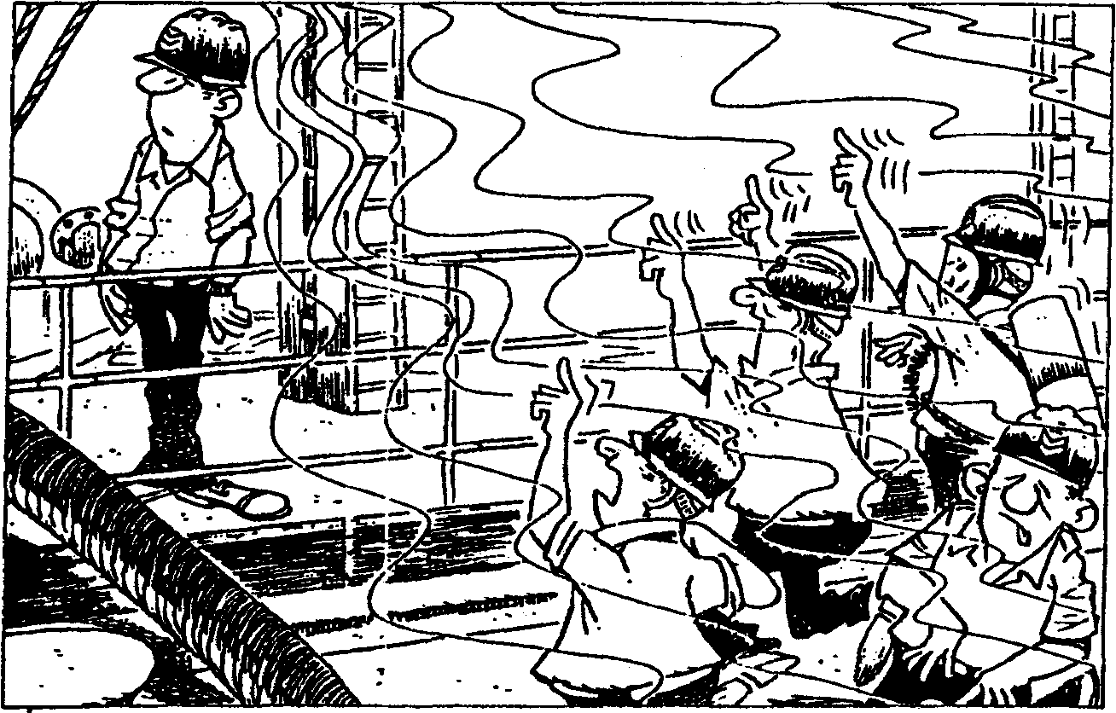

Loading into a gas free tank
When loading a non-volatile cargo at temperatures well below the flashpoint there will be no flammable gas hazard. On the other hand loading a volatile cargo will have the effect that a certain amount of gas is evolved depending of the vapour pressure of the product.
As a high vapour pressure cargo enters the empty gas free tank there is a rapid evolution of gas. Because nearly all gases are heavier than air, the gas forms a layer at the bottom of the tank which rises with the liquid surface as the tank is filled.
Once it has been formed, the depth of the layer increases only slowly over the period of time normally required to fill a tank, although ultimately an equilibrium gas mixture is established throughout the ullage space.
The amount and concentration of gas forming this layer at the beginning of the loading depend upon many factors, including:
The true vapour pressure (TVP) of the cargo.
The amount of splashing as the chemical enters the tank.

©Marstal Navigationsskole February 02

26

The gas concentration of the layer varies with distance above the liquid surface. Very close to the surface it has a value corresponding to the TVP of the liquid. For example if the TVP is 0.75 bar the gas concentration just above the surface is about 75 % by volume.
The loading rate
The gas layer depth varies of course also according to the circumstances. But normally the gas layer depth during loading will not be higher than 3 m when the TVP is less than 1 bar. A rather steep decrease in gas concentration is normal in the upper part of the layer so that only a relative small part of the tank atmosphere is between LFL and UFL and therefore flammable.
air
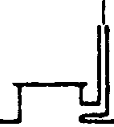
air and perhaps toxic vapours

• too lean gas

• flammable gas
• toorichgas
. liquid

air
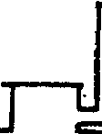
air and perhaps toxic vapours -tooleangas -
WJW JVU g»a - • .-• ....••• •. , -1 I I I, r-
(lannaablegas . X\\t\\V\\\V
toorichgas. mssnsoszm
liquid
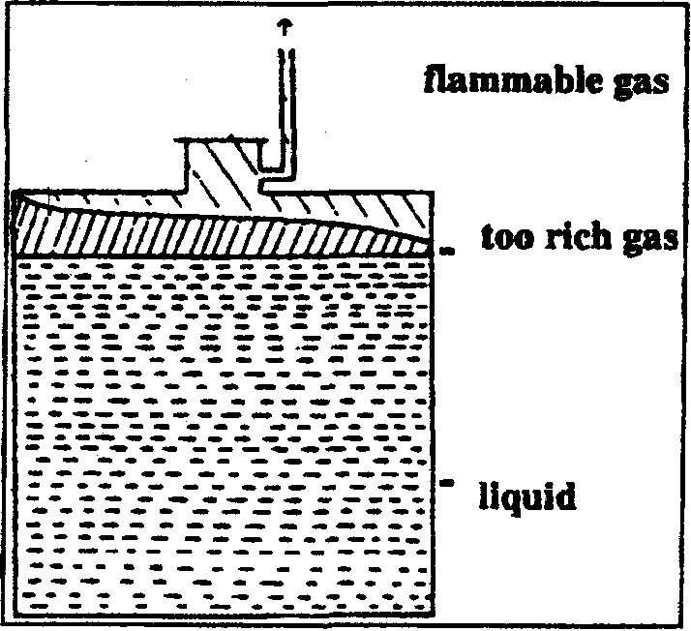
©Marstal Navigalionsskole February 02

Loading into a non gas free tank
Gas evolution after loading
Venting the gas
Gas evolution during discharging
27
Before loading it must be expected, that the gas concentration is nearly the same all over the tank, and might very well be flammable. If the last cargo has been a very volatile product, the gas air mixture might be over-rich.
Both the tank and the gas outlet must be considered dangerous.
When the loading is completed and vent system closed the evaporation will continue until the equilibrium gas mixture equal the TVP has been established. During the voyage further evaporation might take place due to climatic changes with increasing temperature of the liquid.
The amount of gas which has to be vented during loading depends on the evaporation rate and the loading rate. The composition of the vent gas is dependant on the position of the gas layer in the tank.
When loading into a gas free tank the vent gas at the beginning will be nearly clean air. During the loading the gas concentration increases and during the final part of the loading toxic and flammable vent gas is to be expected.
Gas concentrations from 30 to 50 % or even more with high vapour pressure cargoes are not unusual during the end of the loading and when topping off.
If loading is performed into dirty or non gas free tanks, dangerous vent gas must be expected during the whole loading period.
When a product is discharged from a tank, the same volume of air has to be introduced into the tank through vent openings. The incoming air dilute the gas in the tank by turbulence and eddies whereby the gas concentration decreases.
During and after discharging a non volatile cargo, only small gas concentrations in the tank is expected unless the cargo has been heated during discharging, in which case some evaporation might occur.
During discharge of volatile products, some constant evaporation from the liquid surface occurs and due to turbulence in the tank the whole tank atmosphere might become flammable.
This flammable tank condition might very well be present during the whole discharge period. Discharge rate seem to be of minor importance to the gas concentration. After discharge the whole tank atmosphere is to be considered

©Marstal Navigationsskole February 02

28

Gas evolution during introduction of water into the tank
Gas dispersion
explosive, or at rare occasions overrich. Inciting during discharging assure a safe tank condition.
If water is introduced into the tank through the cargo lines it must be anticipated that also gas might enter the tank, even though tank cleaning and line flushing has been performed. The gas might be present as a relatively thin layer on top of the water surface.
Investigations during the latest years has considerably increased the knowledge of how gas is dispersed and diluted to non flammable and non toxic concentrations.
Situations to which special attention has been paid are those where outlet of gas might present a potential risk to the crew and the ship. E. g.:
a: Gas evolution during loading and ballasting.
b: Outlets from P/V valves especially during the loaded voyage.
c: Gas evolution and outlet when tank cleaning. d: Gas freeing and tank ventilation.

e: Disconnection operations.

The investigations has revealed that flammable and toxic gas may exist in a considerably larger distances from outlets than assumed earlier. Furthermore the investigations has shown that the greatest gas concentrations are met when topping off with open ullage holes, and that the largest gas volumes discharged to the atmosphere are during gas freeing.
There is a potential danger of fire if the flammable gas zone reaches any location where there may be sources of ignition such as:
a: The cargo deck which, although it is usually regarded as free of sources of ignition, is a -work area.
Superstructures and deckhouses which the gas can enter through doors, ports or ventilation intakes.
c: An adjacent jetty, the ship's side and the water surface about the ship where boats with ignition sources might enter.
b:
©Marstal Navigationsskole February 02

29

^•^..^Z!^^^-^^'^^^'^''-'^¹"-^^^^ ___L, q . -Jy""**"**- _»^^^^^i»_^
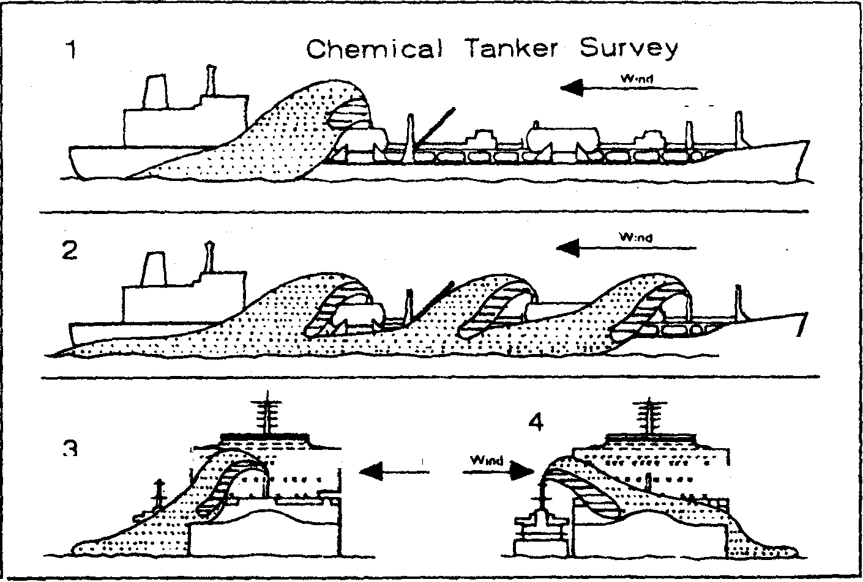
- 1 •/-^v' •.;;•••] ^ W.nd Wind^ ^'Sii;.''"'''"'"'"''-!
^^is^^ji--" _J
^. 7 GflJ distribution when one tank is being topped off. fig. 2 Three tanks being topped up fig. 3 Loading from lighter. fig. 4 Discharging to lighter
5 /Sli^F
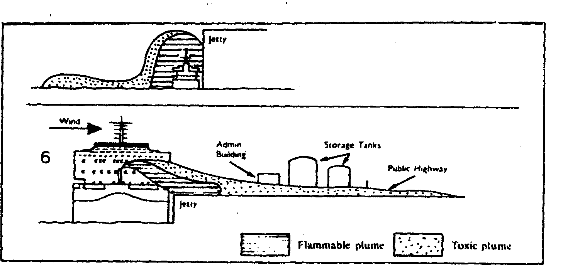
WiM ^ —^-
-^'———Wt^^ '»*"•" S'°"«« T'"'"
6 r—^^^'^^ s"* r^^-^'? ^^^-Wn.D. .JS^"

fig. 5 Topping off at low tide fig. 6 Problems at shore during topping off
Wind speed
Investigation conditions: Calm wind. High vapour concentration (50 %). Test chemical: Pentane.
Dilution of vent gas is directly dependent on the wind speed. But experience at terminals seems to suggest that at wind speeds above about 5 m/s dispersion is sufficient to avoid any flammability risk, when venting through the designated vent stacks.
At lower wind speeds caution should be observed as the dispersion might further be complicated because the direction and location of the gas movements are not always predictable.
©Marstal Navigalionsskole February 02

30
In calm weather the density of the gas is important and dangerous gas concentrations should be suspected at low places on deck, along the ship's sides and on the water surface.
A'l^^Slion^rbP&n'K^ ^"^ regulations for vent systems has been laid down for . chemical tankers. All tanks should be provided with a vent • system appropriate to the cargoes the ship is certified to carry. Common gas outlets are only acceptable if the vapours from the carried products cannot react with each other in any way. IMO distinguish between different tank vent systems.

Open venting:
Controlled venting:
Open venting either through ullage openings or through open pipings is allowed only for products with a flashpoint above 60° C, and not offering a significant inhalation health hazard.
Controlled venting system require pressure/vacuum valves on the vapour line from each tank and might either be completely independent or connected on the pressure side into common header or headers with due regard to cargo segregation.
Valves in the vent system are not accepted, but by pass valves is allowed for certain operations.

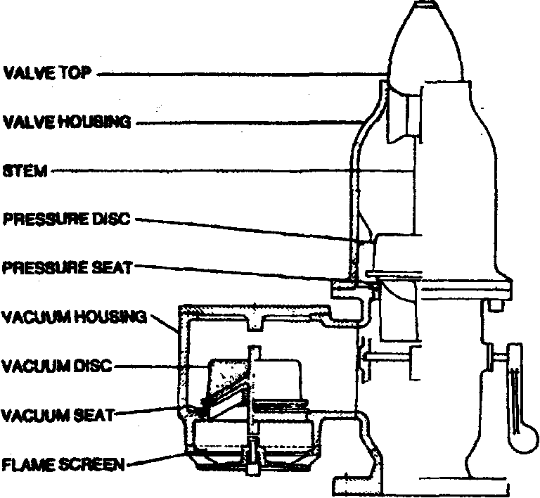
PRES-VAC High Speed Valve
Gas outlets should be positioned at least 6 m (4 m if the ship is built before 1. January 1994) above the weather deck or above the raised walkway if fitted within 4 m of the walkway. If high velocity vent valves with a minimum discharge velocity of at least 30 m/s pointing the gas stream upwards are fitted the height of the vent outlet might be reduced to 3 m.
©Marsta) Navigationsskole February 02

31
Gas freeing after tank cleaning
Ships with IG system:
Ships without IG system:
Personal safety
Outlets should be positioned at least 10 m from any air intakes or openings to accommodation, service and machinery spaces and ignition sources.
Toxic products might require larger outlet heights and distances.
Safety relief valves are required only on pressure tanks on ships carrying special products with high vapour pressure.
After tank cleaning it might be tempting to open the tank hatches and tank cleaning openings believing that this would contribute to a faster or a natural gas freeing process. This is however an unsafe and dangerous method, unpredictable amounts of gas might be present on the deck area for a long time and the tanks are completely unprotected from ignition sources.
SOLAS prescribe in reg. 59,2 how purging and/or gas freeing of cargo tanks should be performed.
Purging with IG until the gas concentration is below 2 % before purging with air.
1. Venting with air through vent outlets positioned as described above.
2. Venting with a vertical vent velocity of at least 20 m/s through openings positioned at least 2 meters above deck level and furnished with flame screens.
When the gas concentration is measured below 30 % of LFL tank hatches etc. might be opened.
In addition to fire and explosion hazards crew members working on the tank deck should be aware of the possible presence of harmful gases during the different cargo operations. Personal safety protection equipment should always be used whenever the slightest possibility of personal contact with the cargo or harmful gases exists e. g. when taking samples, ullage and temperature measurements, or connecting and disconnecting hoses.
When standing at open hatches, don't stand with the wind on your back as gas eddies might be formed on your front side and eventually inhaled.
©Marstal Navigationsskole February 02
32
Positioning at open hatches

Wrong
Correct

Wind direction
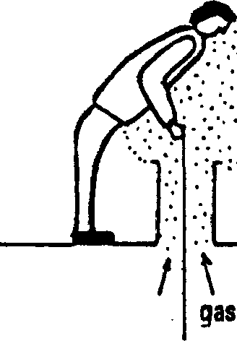
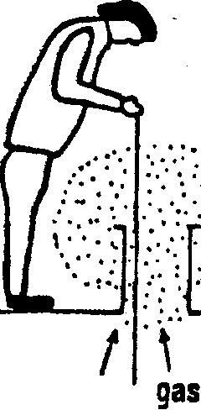
wind from the side

In stead of just releasing the gas evolved during loading, resulting in air pollution it is possible to divert the gas back to the terminal for further processing. Some of the products mentioned in IBC chapter 17 require the ship to be equipped with a vapour return system but the code itself does not in details specify the technical construction of this system.
Vapour Control Systems VCS
From 1990 USA has regulated this subject and the rules will of course have an influence on the tank ventilation and the vapour return system. In the following the American rules are summarised:
©Marstal Navigalionsskole February 02

33
These regulations apply to oil- and chemical tankers. The regulations are found in Code of Federal Regulations title 46 part 39, abbreviated to 46 CFR 39, and deal with Vapor Control Systems (VCS). Please note that these regulations do not apply to gas tankers.
The regulations demand personnel who are in charge of operations involving VCS to have participated in a training program covering the VCS of the particular ship. The education or training shall include exercises and/or demonstration of the system installed on the ship covering normal operation and emergency procedures.
The training program must as a minimum cover the following:
• Purpose of a vapor control system;
• Principles of the vapor control system;
• Components of the vapor control system
• Hazards associated with the vapor control system
• Coast Guard regulations in this part
• Operating procedures, including:
Testing and inspection requirements, Pre-transfer procedures. Connection sequence, Start-up procedures, Normal operations;
• Emergency procedures.
In 46 CFR 39 there are several requirements regarding design and capacity of the Vapor collection System which will be too extensive to deal with in this course manual but :
some of the interesting points are:
• The vapor collection piping must be permanently installed, with the vessel's vapor ^ connection located as close as practical to the loading manifold ;:;; • Incompatible vapors must be kept separate throughout the entire vapor collection ^ system ;
| • Vapor collection piping must be electrically bonded to the hull and must be elec- :
^ trically continuous i;< % • An inerted tankship must have a means to isolate the inert gas supply from the vapor $ j collection system J, ^ • An isolation valve capable of manual operation must be provided at the vessel vapor ^
^ connection. The valve must have an indicator to show clearly whether the valve is ",-
<'<• ''•' ^ in the open or closed position ',!>
'% • The last 1.0 meter of vapor piping before the vessel vapor connection must be: :;;;
Painted red/yellow/red with the red bands 0.1 meter wide, and the middle yellow ^ band 0.8 meter wide; and labeled ""VAPOR" in black letters. Each vessel vapor f connection flange must have a permanently attached 0.5 inch diameter stud at "/ least 1.0 inch long projecting outward from the flange face. This stud fits into a '% hole in the hose flange and should thus prevent a liquid hose from being con- ^ nected to the vapor system. ^
©Marstal Navigationsskole February 02
34
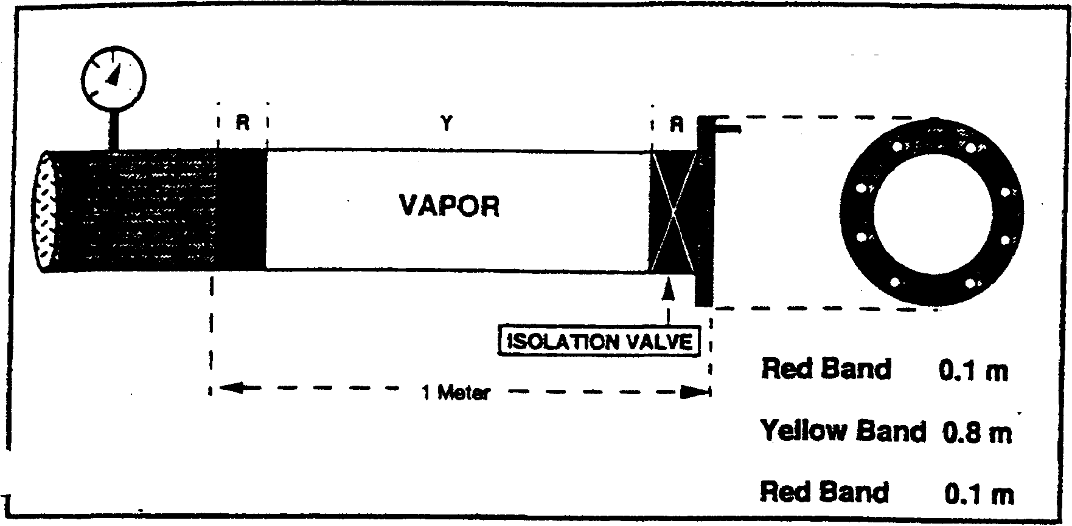
DETAIL AT VESSEL MANIFOLD END OF VAPOR CONTROL PIPING
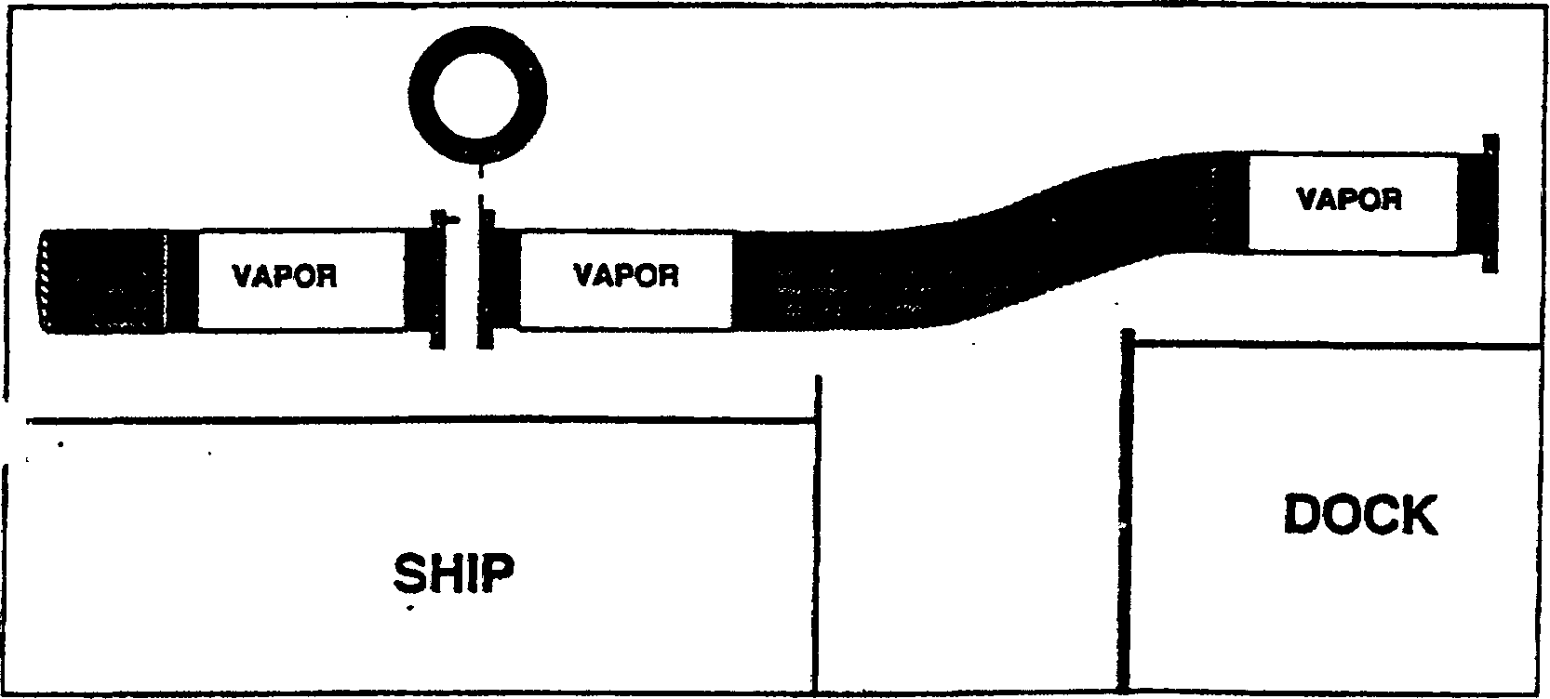
VAPOR CONTROL HOSE
Each cargo vapor connection must be determined for each cargo handled by the vapor collection tank of a vessel that is connected to a vapor collection system must
be equipped with a cargo gauging device which provides a closed gauging
arrangement and must be equipped with an intrinsically safe high level alarm and
a tank overfill alarm. The VCS must be capable of discharging cargo vapor at 1.25 times the maximum
transfer rate The VCS must have pressure sensors giving alarms at a high pressure of not more
than 90 percent of the lowest pressure relief valve setting in the cargo tank venting
system. The pressure drop through the vapor collection system from the most remote cargo
tank to the vessel system at the maximum transfer rate and at lessor transfer rates.
©Marstal Navigationsskole February 02
35
This drop in pressure must be included in the vessel's transfer procedures as a table or graph showing the liquid transfer rate versus the pressure drop.
• A cargo tank must not be filled higher than 98.5 percent of the cargo tank volume; or the level at which an overfill is set. ' "
• A cargo tank must not be opened to the atmosphere during cargo transfer operations except as for gauging or sampling while a tank vessel is connected to a vapor control system unless certain requirements given in 46 CFR 39.30 - Ig (1 - 4) are complied with.__________________________________
The above were extracts from the most essentially regulations but it is highly recommended to acquaint oneself with the regulations and be sure to fulfil the requirements regarding training in the system of the particular ship.
©Marstal Navigationsskole February 02
35
This drop in pressure must be included in the vessel's transfer procedures as a table or graph showing the liquid transfer rate versus the pressure drop.
• A cargo tank must not be filled higher than 98.5 percent of the cargo tank volume; or the level at which an overfill is set. ' "
• A cargo tank must not be opened to the atmosphere during cargo transfer operations except as for gauging or sampling while a tank vessel is connected to a vapor control system unless certain requirements given in 46 CFR 39.30 - Ig (1 - 4) are
__complied with.__________________________________
The above were extracts from the most essentially regulations but it is highly recommended to acquaint oneself with the regulations and be sure to fulfil the requirements regarding training in the system of the particular ship.
©Marstal Navigationsskole February 02
37
Special Cargoes Precautions in When handling corrosive liquids especially three danger
, ,. , , i details should be born in mind;
relation to extremely
corrosive liquids ^{1:} ^"g^ ^{of} corrosion of ship or equipment Com-mon ship-building materials will be corroded pretty
fast and many of the products in this group can only be transported in ships equipped with special tank-materials, special coating and with gaskets used to the purpose. It is important to check if the concentration of the product has in influence to the resistance of the materials.
2: Danger of fire: When corrosive liquids attack metal, fumes are evolved which may be flammable or explosive if mixed with air. Especially acids evolve free hydrogen, which is very explosive mixed with air, and do not forget that corrosive liquids themselves may be flammable and may cause auto ignition in saw dust, rags or other similar materials.
3; Health hazards. The liquids will when they come in contact with skin or tissue damage or even destroy this. The wounds which come will be painful and heal slowly. Eyes and mucous membranes are very sensitive to corrosive liquids, so therefore do not neglect the use of protection equipment.
Tank cleaning after corrosive products may require quite special procedures and relevant tank cleaning guides should be consulted.
Precautions when ^"^{e} pfcduct⁸ in this connection can be split into several
handling very ^"P⁸ ^{Le:}
reactive chemicals I? Liquids with a self reaction. There will normally be two kind of reactions in question and that is decomposition or polymerization. Both reactions may be catastrophic to the ship, and when transporting such liquids it is important to monitor the temperature of the cargo at certain intervals. A rise in temperature may indicate that a reaction is in progress, and some measures should be taken to bring the situation under control. Decomposition will also cause heavy rise in pressure. Such liquids will normally be added an inhibitor and may require in-erting, and the shipper should give a clear loading instruction and voyage-instruction in relation to control of inhibitor and eventually addition of extra inhibitor.
©Marstal Navigationsskole February 02
38
2: Liquids which react violently with water. Many chemicals cannot come in contact water unless it causes violently reactions. The reaction may be decomposition with formation of enormous amounts of dangerous fumes; it may be formation of acids or salts with hydrogen evolution, and there may be an undesirable temperature rise. Other reactions can cause discolouration of the product or may form other materials which may attack the coating or tank materials. Information about reactions can be found in hand-books.
3: Liquids which react with air. As many products may react with air it will often be necessary to inert the tanks. The grade of inerting depends of the product and its purity. It may be assumed that the shipper will give accurate instructions about the inerting and whether traditional inert gas or pure nitrogen may be used.
4: Liquids which react with other chemicals. How
far some of the products that are to be loaded can react with each other, shall often be considered on board, even if it may be expected that the shipper will give information about this problem. The best guide to this problem is US Coast Guard Compatibility Chart, but the information from this compatibility chart should also be compared with the information from the shipper's data sheet.
CxnrJSB^efuR Ite^culs-imber of cargoes are contaminated by remnants of the previous (edible oils) cargo carried in a ship's tank, despite thorough and conscientious cleaning prior to loading. This naturally creates a serious problem whatever cargo is contaminated, but becomes even more serious when the cargo is meant for human consumption.
NIOP and FOSFA The National Institute of Oilseed Products (NIOP) in the USA, and the Federation of Oils, Seeds and Fats Association (FOSFA) in the UK have both conducted studies and research in order to eliminate the potential contamination problem. Discussions have taken place with representatives of importers and some shipowners in this connection, and cargo lists have been prepared.
FOSFA lists of cargoes FOSFA gives a list of so called "Banned immediate previous cargoes" with more than 50 products and a list of "Acceptable previous cargoes" giving about 110 different cargoes which can be accepted as previous cargoes.
©Maistal Navigationsskole February 02
Acceptance procedure
European Union
i0-9f
Conclusion
Discharging
39
Before a ship can be accepted as carrier of edible oils it shall comply with the FOSFA "International. Qualifications for all Ships Engaged in the Ocean and Short Sea Carnage and Transhipment of Oils and Fats for Edible and Oleo-Chemical Use" giving requirements mainly to materials of construction and tank coatings.
A statement, in the form of the FOSFA "International Ship's Qualifications Combined Master's Certificate" signed by the ship's captain/chief officer shall be provided for the shipper, certifying that the ship is qualified for the coming voyage with edible oil.
The ship must also comply with the FOSFA "International Operational Procedures for all Ships Engaged in the Ocean and Short Sea Carriage and Transhipment of Oils and Fats for Edible and Oleo-Chemical Use" which for example details the requirements to the previous cargoes. It is worth noting that in order to accept a cargo as "Acceptable Previous Cargo" it shall have been not less than 60% by volume of the tank! The "Operational Procedures" will also give details such as inspection of tanks, sampling, heating instruction and loading through shore hose directly into ship's tanks.
When trading to or between members of the European Union special regulations apply. They are much similar to those of FOSFA, but are more strict as regards the requirements to previous cargoes.
It is hoped, by following the standards given by the recognised organisations, that cases where cargoes meant for human consumption are contaminated can be avoided.
Mostly the same precautions should be taken during the discharge as during the loading.
Again it is important to check the function of P/V-valves.
At the very start of the discharge emergency stops should be tested.
If the tanks have been filled above the level of the highest high-level alarm, all tanks should be disharged to a level below the high-level alarm in the beginning of the discharging operation, thus allowing the alarm to be put into operation, and giving the possibility of a warning if a leaking valve in the system causes a tank to be filled during the discharge of other tanks with the same product.
Sometimes it is not allowed that air is drawn into the tank during discharge, so in order to prevent vacuo the tanks must be refilled with inert gas or nitrogen. This is not a

©Marstal Navigationsskole February 02

40
Ballasting
lllfl
problem in ships with their own inert gas generator, but in other ships it will be necessary to connect a vapour return or a nitrogen source from shore.
During the discharge it is necessary to be aware of the conditions in the pump room, if any. Even if the pumps can be run from outside the pump room it is sometimes necessary to enter the pump room to inspect the pumps or valves there. Despite the operation of mechanical ventilation, it must be a standing order, that nobody enters the pump room without permission from the responsible officer. This officer is the one to decide whether to use protective equipment and moreover assure that the regulations for entering the pump room are adhered to.
It might be necessary to use uncleaned cargo tanks containing residues as ballast tanks. This is not permitted in tanks which have contained water reactive chemicals, as well as it is of cause only allowed to ballast in accordance to the regulations in MARPOL's ANNEX 2. If tanks which have contained flammable or toxic cargoes are used as ballast-tanks, it must be remembered that a lot of vapour is released when taking ballast into these tanks. The local regulations on air pollution should also be consulted in this situation.
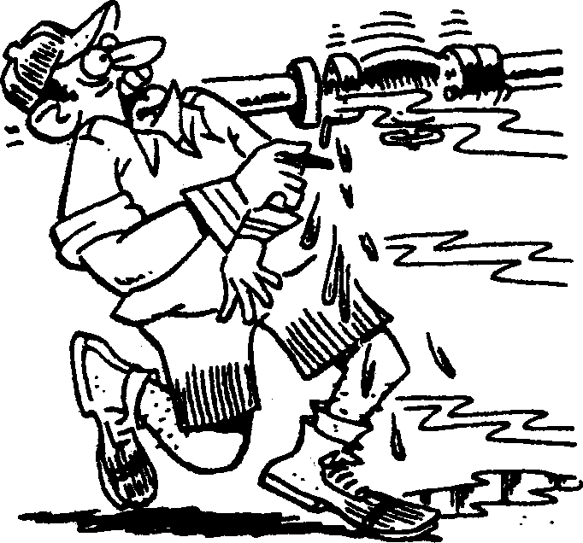
©Marstal Navigationsskole February 02
Tank Cleaning
Tank Cleaning is one of the most important routines in a chemical tanker. The cleaning itself may be accomplished in a number of ways, but it is of utmost importance always to ensure a safe operation.
In this chapter the safety matters will be discussed first, and later the actual cleaning operations will be looked upon.
General Safety Rules for Tank Cleaning in Chemical Tankers
General To achieve maximum safety all aboard should be kept informed whenever a tank cleaning operation is commenced, and also when gas freeing is over. Only necessary personnel should be allowed on deck during tank cleaning and gas freeing. All non-used openings to tanks should be kept closed.
As a general rule, tank cleaning and gas freeing should not take place concurrently with cargo handling. If for any reason, this is necessary, there should be close consultation with, and agreement from, both the terminal representative and the port authority.
The responsible officer should check that all equipment is in safe working order and remain so throughout the operation.
All tank cleaning hoses should be tested for electrical continuity in a dry condition prior to use (max. resistance 6 ohms per metre length), and hoses should be indelibly marked to allow idenfication. A record should be kept showing the date and result of electrical continuity testing.
No one should enter any cargo tank unless permission to do so has been received from the responsible officer and all appropriate precautions have been taken, including the issue of an entry permit.
Furthermore all recommendations from IMO and ICS should be strictly adhered to, as well as should any special instructions issued by the company.

Tank washing may be caried out in one of the following atmospheres:
Tank washing
atmospheres
Inerted
An atmosphere made incapable of burning by the introduction of inert gas, and the resultant reduction of the overall oxygen content to below 8% by volume.
©Marstal Navigationsskole February 02

42

Non-inert
Cleaning in a non-inert atmosphere without previous ventilation
Tank cleaning hoses
Tank cleaning water
Sounding
An atmosphere which may be above, below or within the flammable range.
In Scandinavian tankers this is the most- commonly used procedure. For chemical tankers of more than 20.000 TDW built after 1986 Chapter Q-2 of the SOLAS convention specifies that this procedure can only be used if all of the following conditions are met:
- Individual tank capacity is less than 3000 m³
- Tank washing machine capacity per nozzle does not exceed 17.5 m³ per hour; and
- Total combined washing machine throughput in the tank is less than 110m³ per hour.
These conditions have been introduced in order to minimise the risk of fire and explosin resulting from the generation and discharge of static electricity. It is therefore recommended that 'new' chemical tankers below 20.000 TDW and existing chemical tankers of all sizes also comply with them.
The hoses should be tested for electrical continuity (Max. 6 ohms pr metre length) before they are used. If an external bonding wire is used, this should also be inspected.
Immediately before use the tank cleaning hoses and machines should be flushed with water, and it is essential that the hoses and bonding wires are interconnected and connected to the tank cleaning line before they are lowered into the tank, and that they remain connected until the tank cleaning machine is on deck again.
Recirculated wash water must not be used and chemical additives (tank cleaning chemicals) must not be used. The wash water may be heated, but not in excess of 60°C. Steam must never be injected into the tank.
The tanks should be kept drained during washing, and washing should be stopped to clear any build up of wash water.
All these restrictions are valid for the initial cleaning where the possibility of gas and static electricity exists. If further cleaning is necessary, the tanks should be gas freed and then the cleaning operation can be resumed without restrictions.
During washing and for five hours thereafter sounding rods of metallic materials may only be used if they are

©Marstal Navigationsskole February 02

43

Cleaning in a non-inert but ventilated atmosphere (Too-lean)
Washing in an Inerted Atmosphere
Tank Cleaning Operation
earthed to the ship or if they are introduced through a sounding pipe. Non-metallic equipment may, in general, be used without restrictions.
Ropes made of synthetic polymers should not be used for lowering equipment into cargo tanks.
If a tank is to be washed in a Too Lean Atmosphere, the following precautions should be observed in addition to the procedures set out for washing in a non-inert, non-ventilated atmosphere:
The tank should be isolated from other tanks.
The tank bottom and the piping system, including pumps, crossovers and discharge lines, should be flushed with water and drained.
Before washing, the tank should be ventilated to reduce the gas concentration of the atmosphere to 10% or less of the lower flammable limit (LFL). Gas tests must be made at various levels and due consideration given to the possible existence of local pockets of flammable gas. Mechanical ventilation and gas testing should continue during washing. Ventilation should as far as possible provide a free flow of air from one end of the tank to the other.
If portable washing machines are used, all hose connections should be made up and tested for electrical continuity as is explained above for an undefined atmosphere.
During washing regular gas tests must be made at various levels.
Small quantities of chemical additives may be used provided the temperature of the wash water does not exceed 60°C.
Wash water may be heated. If the wash water temperature is above 60°C, washing should be discontinued if the gas concentration reaches 35% of the LFL.
If during washing the oxygen level is kept below 8% by volume and the tank pressure is kept above atmospheric pressure, none of the above mentioned restrictions are valid, but it is still recommended, that all hose connections for portable washing machines are tested for electrical continuity. In this way cleaning in an incited atmosphere gives the possibility to apply the best cleaning procedure.
Cleaning of cargo tanks in connection with the transport of liquid chemicals in bulk calls for special considerations, which may be quite different from oil transport.
It must be taken into consideration, which product has been in the tanks and which products are to be loaded.

©Marstal Navigationsskole Februaiy 02

44
Furthermore it is of importance, which equipment is at hand and how much time is available. Cleaning from and to chemical cargoes can be both time consuming and expensive. - -
In all cleaning operations it is essential to remember that all safety rules must be strictly adhered to.
The actual cleaning operation will almost invariably follow the flow diagram shown below, as the same questions will arise each time.
The details of the flow diagram are explained below.
CHEMICAL TANKER CLEANING
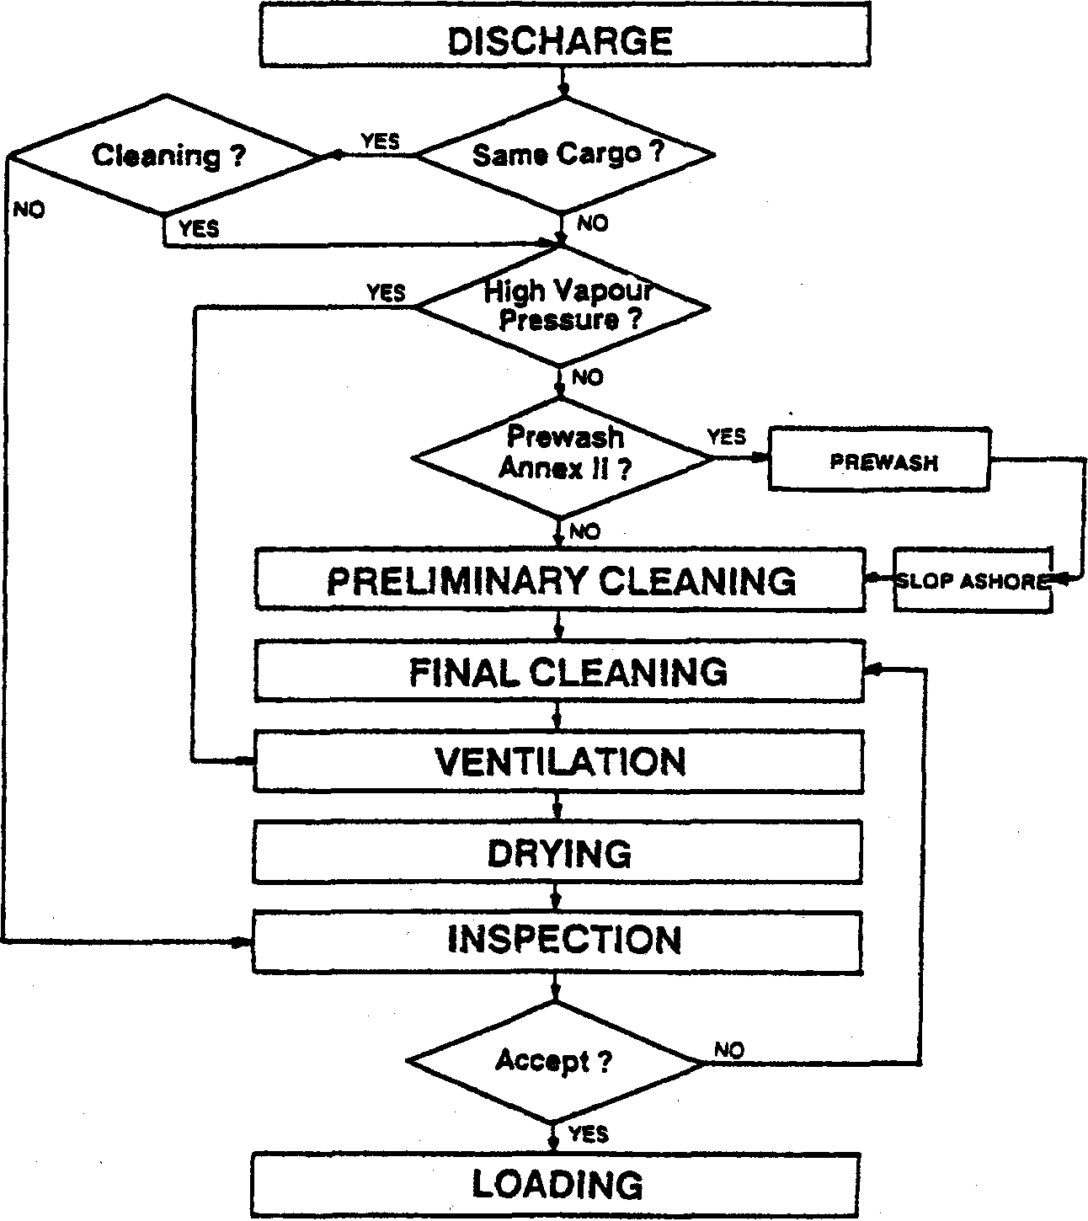

If the vessel is to carry the same product on the following voyage, the cleaning operation might be omitted. Of course this is not always the case, as there still may be a number of reasons for the shipper to demand clean, gasfree tanks before loading.
Same Cargo?
One such reason might be that the final use of the product is quite different.
©Marstal Navigationsskole February 02

High Vapour Pressure?
Prewash Annex II
45
If the vapour pressure of the product exceeds 50 mb at 20°C, tank cleaning may be accomplished simply by ventilation according to MARPOL's Annex U. Whether this is an efficient technique or not depends on the product and the vessel's equipment. For example it is possible and allowable to ventilate pure Benzene, but it might be unwanted because of the toxic properties of Benzene vapour, and because of remaining smell and/or solid residues in the tank.
Tank cleaning by ventilation alone requires efficient blowers and MARPOL specifies a minimum blower capacity according to the diameter of the air and the depth of the tanks.
Tank cleaning by ventilation is an excellent procedure with many High Vapour Pressure Products, as it eliminates the need to decide what to do with slops. The method is particularly efficient if the vessel features a hot air or dry air system.
MARPOL's Annex n specifies a Mandatory Prewash for many substances. If this is relevant for the product to be cleaned, the procedures in the vessel's P&A-manual should be strictly adhered to.
Mostly the above mentioned considerations will be dealt with quickly, and what is left is the actual tank cleaning where the purpose generally is to get the tanks as clean as possible, as the next cargo might not have been decided upon.

Preliminary Cleaning For the first and possibly the only cleaning it must be decided whether to use water or not. A few cargoes will react with water (for example TDI) and form insoluble sediments. For the great majority of cargoes there is, however, no doubt - the tanks are washed with water.
The next question will be whether to use hot or cold water, and this might well be the most important question. With many products a wrong choice of washing temperature will not mean a lot, but when cleaning after a "drying oil" (veg- and animal oils with a low content of free fatty acids) it is of utmost importance to start with cold water as the product otherwise will dry into a coat on the tank surfaces which is very difficult to remove. Using hot water will also be a great mistake after many polymerisable products.
If in doubt consulting various Tank Cleaning Guides, Survey Companies or the shipper might give a suggestion, and
©Marstal Navigationsskole February 02

46
if it impossible to get enough information the washing procedure should be initiated with cold water.
Below is shown a list of some vegetable oils and animal oils.

High acid value Hot water
Vegetable and animal oils
Low acid value
Cold water Drying oils
China wood oil Fish oil
Hempseed oil Linseed oil Menhaden oil Oiticica oil Perilla oil Safflower oil Soyabean oil Tall oil Tung oil Walnut oil
Semi-drying oils Non-drying oils
Cold water
China wood oil Babassu oil Almond oil Fish oil Candle but oil Arachis oil Hempseed oil Corn oil Camphor oil Linseed oil Cotton seed oil Canaga oil Menhaden oil Croton oil Cashew nut oil Oiticica oil Fish oil Castor oil Perilla oil Herring oil Coconut oil Safflower oil Maize oil Cod liver oil Soyabean oil Poppy seed oil Ground nut oil Tall oil Sesame oil Lard oil Tung oil Sunflower oil Neatsfoot oil Walnut oil Wheat oil Olive oil Palm oil Peanut oil Pine oil Rape seed oil Sperm oil Tallow oil Whale oil
Furthermore it must be decided how long the washing should go on. The time will always depend on the ship's equipment, and might vary from one cycle to several hours depending on the tank structure, the product and the washing machines. Again reference to a Tank Cleaning Guide might be useful.
Tank Cleaning Guides Several companies, which manufacture cleaning agents, also publish handbooks or instructions to explain how to use the cleaning agents for various products. Also some independent companies publish such tank cleaning guides and as an example of such a guide is used the Tank Cleaning Guide published by Laboratory Dr. A.Verwey, Rotterdam.
This guide takes both the discharged cargo and the product to be loaded into consideration. The list advises on the cleaning operation between 409 different products. Below
©Marsta] Navigalionsskole February 02

47
is shown a copy from the first part of the book which gives a cleaning code by entering with the products in question.
PBOM TO 176 177 178 179 180 181 182 183 184 186 186 187 188 169 190 191 182 183 194 195 1B8 197 198 199 200

178 | ETHYLENEGLYCOLDIMETMYIETHER |  | D | D | D | 0 | D | D D D 0 D D D 0 EE 0 ,0 D 0 ^D 0 D | a d | D
177 178 179 | ETHYtHEXYLACnYLATEP-) ETMYLHEXYLAICOHOLO-) ETWWeXYlAMINB(2-) | L P C | P C | L C | L P | L | L | LLLL4LLl.Jt^l-LLtL | '•i l  .S P  'c c | L P C
 |  |  |  |  |  | C | C | CCCCCCCCEEC:CCCCCC | '•i l  .S P  'c c | L P C
180 | ETMYOACTATE | C | C | c | C |  | C | CCCCCCCCFFCCCCCCC | c c | c
181 | EmYLMETHACByiATE | J | J | J | J | J |  | J J J J 1. J J J J J J J J 'J 1. 1. | i. J | J
182 | EmVLPHENOLfM-) | H | H | H | H | H | H | H H H J H H H H H 'H H H ,H J J | '•J H | H
183 | ETHYLPHENOUP-) | S | S. | S | S | S | S | S S S T S S S S S S S S S T T | r .s  i | S | 0
184 | ETWLPBOPIONA-nE | 0 | D | D | 0 | 0 | D | DO DODDDDDDDODEE | 0 0 | D | i
18S | FATTYALCOHOLS(C13-C18) | f | T | T | T | T | T | T T T T T T ;T T T T T T T T ;T | T .T | T | *•
1M | F1SHOIL | J | J | J | J | J | J | J J J J J J J U. J J J ,J J J J | J J | J | s
187 1W 188 1(0 | FORMAtOEHYOE(SOL<45%)  formamioe  roiUNCACID FUELOU. | D P | D  P | 0 | D | D | D | D D 0 D C ODDOOODDCC | S o | D | !?  >
 |  |  |  |  |  |  |  |  | F F 00 DO | F DO | !?  >
187 1W 188 1(0 | FORMAtOEHYOE(SOL<45%)  formamioe  roiUNCACID FUELOU. | • DO | OD | DO | OD | 00 | DO | DO 00 DO 00 DO DO DO 00 00 'DO 00 'DO DO 'DO 00 | F F 00 DO | F DO | !?  >
181 | fWVWML | E | E | E | E | E | E | EEEEEEEEE >E E E ,'E ,'E .E | e e | E
1*2 | FURRJRYLALCOHOL | E | E | E | E | E | E | E E E E £ 'E E f E E ;' ;E .'E \E E E | £ E | ,E
183 | GASOL | J | J | J | J | J | J | J J J J J J J J EE 'J J : 'J 'J J J | J J | J
W | OASOUNE | 00 | 0000000000 |  |  |  |  | 0000 00 00 00 00 '00 '00.00.00 0000; 000000 | 000000
19B 18* W | <3LUTARALOEHYOE(aOL<fiO«) OLYCERMe QtYCOLOWCETATE | a | B | B | B | B | B | BBBBBBBBBaBBB B B | e b | B
19B 18* W | <3LUTARALOEHYOE(aOL<fiO«) OLYCERMe QtYCOLOWCETATE | c | c | C | C | C | C | C C C C C C C C GO C C C C C C C C |  | C
18B | QROUNONUroiL | J | J | J | J | J | J | J J J J J J J J U. J J J J J J J | 'J | J
198 | HEPTANE(N-) | C | c | C | C | C | C | c c c c c c c 'c c. 'a c c a jc c c | C | C
200 | HEPTANOICAC10 | H | H | H | H | H | H | H H H H H H H H H H H H H H J J  i • • , • | H H

In the second part of the book the cleaning codes are translated into a cleaning operation and a copy from this part of the book is shown bellow.
C - 1. Bunerworthing with cold seawater for about 1 hour;
2. Butterworthing with warm freshwater (50°C) for 1 hour;
3. Steaming;
4. Draining of tank, line and pump;
5. Drying.
CC - 1. As soon as the cargo has been discharged perform prewash if required. otherwise drain pump and line as well as possible;
2. Fill the tank completely with cold seawater and leave it until cleaning is started;
3. Empty the tank and stan butterworthing with cold seawater for 3 hours;
4. Flushing with freshwater;
5. Steaming until the odour has disappeared;
6. Draining of tank, line and pump;
7. Drying.
D -1. Butterworthing with cold seawater for 1 hour;
2. Flushing with freshwater;
3. Steaming;
4. Draining of tank, line and pump;
5. Drying.
DD - It is advisable NOT to load and cany this product after subject previous cargo.
E -1. Bunerworthing with cold seawater (or 1 hour;
2. Butterworthing with hot seawater for 2 hours
3. Flushing with freshwater;
4. Steaming;
©Marstal Navigationsskole February 02
48
5. Draining of tank, line and pump;
6. Drying.
Furthermore the guide gives good information on the properties of the chemicals, although it lacks information on vegoils. Here is Hexane shown "" as an example:
PRODUCT NAME | HEXANE(N-)
GAS number | 110-54-3
UN number | 1208
Formula | C»H»
Odour | GASOLINE LIKE
Solubility in water | INSOLUBLE
Density | 0.66 at °C
Boiling point | 69-C
Melting point | -95''C
Viscosity | 0.32 cp at 20°C
Flashpoint | -22°C
Explosive limits | 1.1-7.7Vol%
Vapour pressure | 160mbarat 20°C
Skin absorption/irritation | YES
TLV Country NL Year 1998 | 25 ppm 90 mg/m³
Pollution category 1998 | (C)

The cleaning guide should only be used as a recommendation, as no consideration is given to the coating , piping materials etc. Such problems should be carefully considered and incorporated into the cleaning method chosen.
Final Cleaning
re 1:
The most important answers to be found in a cleaning guide is:
1. Should the cleaning start with cold or hot water.
2. If we decide to use a cleaning agent - which type should be used and in which concentration.
On the other hand the instructions in the guides regarding washing times are no more than an educated guess, and the present experience shows that the hours mentioned in Dr. Verweys instructions might be translated as cycles.
If it is considered necessary to perform further cleaning after the preliminary cleaning, more demanding techniques may be utilised.
J. Saponifying with caustics.
2. Cleaning with detergents
3. Dissolving with a solvent.
4. Chemical reaction.
5. Steaming
Vegetable and animal oils are easily saponified with an alkaline like Caustic Soda or Caustic Potash. The remaining soap from Caustic Potash is readily washed away with water whereas the soap from Caustic Soda tend to form hard brittle particles which are almost insoluble in water.
©Marstal Navigationsskole February 02

49
re 2; After a cargo of mineral oil or its derivatives synthetic soaps or special cleaning agents which are mixtures of synthetic soaps (detergents) and other emulsifiers can be used for the final cleaning. Some cleaning agents also contains solvents, and will consequently be able to give positive hydrocarbon test after the cleaning. Hence the tanks must be washed thoroughly with water after use of such cleaning agents.
re 3: Some residues have very high melting points, which makes them difficult to emulsify. To clean such residues it may be necessary to use a solvent. Frequently used solvents are toluene or white spirit. Both may be applied by -spraying or by the lift method (see below). Some residues are persistent enough to make it necessary to heat the solvent, and care should be taken to chose a solvent with a sufficiently high boiling point.
Whenever possible the cleaning procedures adopted should not involve personnel entering a non-gas free tank. If however it is necessary to enter the tank, all precautions should be taken to protect the personnel involved from the health hazard of the cleaning solvent and a flammable solvent should only be used for spot-cleaning and never for spraying in a non-inerted tank.
re 4: Chemical reactions are rarely used for tank cleaning purposes, but may be the only alternative if some unwanted reaction during the voyage or during the initial cleaning has left an insoluble residue on the tank walls. Furthermore chemical reaction may be used to remove rust (iron oxide) from the coating and the piping. When undertaking an operation involving chemical reactions, advice should be sought from competent companies.
re 5: Another way to dissolve solid residues is by steaming or even by steaming with a solvent (for example tolouene) or an alkaline cleaning agent. Steaming with solvents like toluene should only be carried out in inerted tanks due to the risk of ignition by static electricity.
All the above mentioned cleaning agents may be applied in a number of ways which in brief can be described as follows:
The injection method: This method is practised by injecting the cleaning agent (caustic, detergent or solvent) directly into the tank cleaning line either on deck or in the pump room.. It can be done by using a special pump or an eductor.
©Marstal Navigationsskole February 02
50
The recirculation method:
The lift method:
One of the vessel's tanks is used to mix a suitable solution of the cleaning agent (for example a 5% detergent solution). The mixture is pumped through the cleaning line and the cleaning machines and is stripped back to same tank. To work properly this method demands a good preliminary cleaning as otherwise the cleaning mixture will quickly become inefficient.
In some situations it may be convenient or necessary to apply a solvent or cleaning oil to the tank walls. This is done by pouring the solvent into a tank and then slowly lifting the solvent by pumping water in below it. The lift should not exceed about 1 metre per hour, and thus the method is very slow. When the tank is full the water level is lowered again by pumping the water to a slop tank. When the tank is almost empty the rest of the cleaning agent is pumped into the next tank and the procedure starts all over again.

Hand spray method:
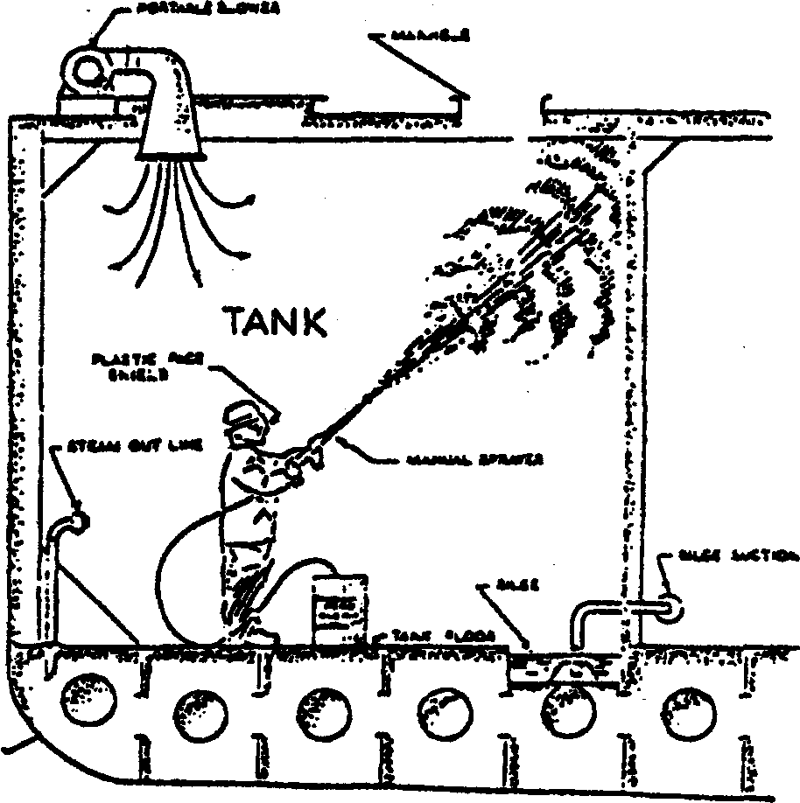
The method is undertaken by spraying a cleaning agent directly onto the surfaces of the tank. After a certain time, during which the cleaning agent works on the residues, the tank is water washed in a normal pattern. This method is very efficient and the consumption of cleaning agent is reasonably low, but it should be borne in mind that it is very important to protect the crew involved in the operation as many cleaning agents are rather dangerous to personnel. Also, this method should never be used with a flammable cleaning agent due to the risk of an electrostatic ignintion.
©Maistal Navigationsskole February 02

5i
Atomisation method: The principle is the same as mentioned for the hand spray method, but instead of sending men into the tanks to apply the cleaning agent, a lance-like apparatus with fine nozzles is introduced into the tank. The cleaning agent is pumped through the nozzles and after some time the tanks are water washed.
As this method almost invariably will generate large electrostatic potentials, it should only be used in incited tanks or in gas-free tanks with a non-flammable cleaning agent.

Special
considerations for Stainless Steel
Tanks made of stainless steel cannot always be cleaned in the same way as coated tanks. The primary resistance of stainless steel is a thin layer of chromic oxide which is created on the surface of the steel. This layer is resistant to most chemicals, but rather sensitive to substances containing chloride such as sea water.
Stainless tanks should thus preferably be washed with fresh water only, but if it for some reason is necessary to use sea water, the tanks should be flushed with fresh water without delay.

Fresh Water Flushing For all kinds of tanks it may be necessary to undertake a final rinsing with fresh or even destilled water to remove any chlorine residues or residues from cleaning agents, which may react with the next cargo.

Any tank cleaning operation is concluded by ventilating and drying the tanks with air.
Ventilation and Drying
Drying of tanks
The drying of the tanks is in fact done in the way that the air blown into the tank picks up the humidity of the tank atmosphere, and thereby removing the water from the tank when the air again leaves the tank. However it is important to remember a few fundamental principles of how air can accumulate/contain humidity. The relation between the temperature of the air and the water content in g/m³ is so, that the air is able to contain a higher amount of humidity at a higher temperature as it is seen from the curves:
©Marstal Navigalionsskoie February 02

52
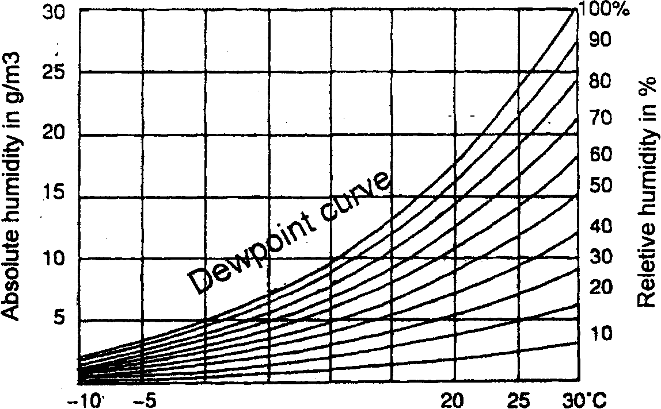
0 5 10 15
Temperature of air
On the diagram is given the absolute humidity in g/m³ on the left axis, and the relative humidity in % on the right axis as a function of the temperature. When the air reaches a relative humidity of 100% the air is saturated and then no longer capable to take up more humidity.
An example will show that only about 1,5 grams of water vapour can be removed per m³ of supplied air if the air blown in has a temperature of 20°C and a relative humidity of 90%, which is not unusual when at sea. One also has to be aware that there is no reason in trying to dry tanks if the empty tanks are surrounded by cold ballast tanks where the steel temperature is below the dew point of the air blown in. From the curves can be read as an example that a 20°C warm air with a relative humidity of 90% will start to condense if the temperature of the air falls to below about 18°C. So therefore it can be recommended that the dew point of the air is determined and compared with the steel temperature of the tank if in doubt whether it is worth while to start drying tanks now or wait until the relative humidity is lower.
In some ships it is possible to dry the air before it is blown into the tanks. This can be done by means of for example a "Munters Dryer" or by blowing the air through receptacles (cylinders) filled with a moisture absorbing substance, which later can be regenerated. Using those methods the dew point of the air can be significantly lowered, and the air will therefore be able to remove considerably larger quantities of water per m³ air and furthermore it will be possible to dry even very cold steel bulkheads.
If the tanks are equipped with heating coils or if the ship is equipped with an air heater then it will be possible to heat up the tanks during the drying, and it will be seen from the curve above that a raise in temperature from for instance
©Marstal Navigationsskole February 02
53
Inspection:
Tests:
20° to 25° will make it possible to remove about 8 grams of water per m³ in stead of only 1,5 grams per m³. The heating will of cause also result in a higher steel-temperature, so condensation will be less probable; but in practice it is often seen that it is difficult to "catch" the under side of the deck, which results in condensation under the deck and "rain" in the tanks.
Chemical cargoes will mostly demand very clean tanks. Normally the shipper will appoint a surveyor to inspect the ship's tanks and a number of independent survey companies undertakes such commissions. The vessel should al-
«
ways ensure proof of any inspection carried out.
When the surveyor inspects the tanks, he often carries out different tests to ensure the cleanliness of the tank walls. Such a test- could be a hydrocarbon test or a chloride test. Most of these tests can easily be made by the crew itself, and if sufficient time is at hand, tests should be made before arrival to ensure that any residues are traced and removed, thus avoiding the rejection of the tanks.
©Marslal Navigationsskole February 02
55
Pollution regulations
Introduction
The international community has become seriously concerned about ship-generated marine pollution in recent years. More than 80 international conventions and related instruments address the problem. Among these MARPOL is considered as the most important.
MARPOL, which deals with all forms of marine pollution except the disposal of land-generated waste into the sea by dumping, was born as a result of an international Conference. In 1969, the IMO Assembly - inspired partly by the Torrey Canyon disaster of two years before - decided to convene an international conference to adopt a completely new convention. The conference met in London in 1973 and IMO adopted the International Convention for the Prevention of Pollution from Ships, 1973. This was modified by a protocol in 1978 and is now usually known as MARPOL 73/78. The convention finally entered into force in October 1983 - ten years after the first conference was held.

Marpol 73/78 has three Protocols dealing respectively with Reports on Incidents involving Harmful Substances, on Arbitration and The Protocol of 1997 (Annex VI) and six Annexes which contain regulations for the prevention of the various forms of pollution:
Marpol 73/78
Annex I Pollution by Oil
Annex n Pollution by Noxious Liquid Substances carried in bulk
Annex ffl Pollution by Harmful Substances Carried By Sea In Packaged Form
Annex IV Pollution by Sewage from Ships Annex V Pollution by Garbage from Ships Annex VI Air Pollution from Ships
Annexes IV and VI have not yet entered into force, as the text in Article 15 of the MARPOL convention stipulates that optional Annexes "...shall enter into force 12 months after the date on which not less than 15 States, the combined merchant fleets of which constitute not less than 50 per cent of the gross tonnage of the world's merchant shipping have become parties to it...." The present status (October 1998) is: 71 countries with 42.50 percent of world tonnage have accepted Annex IV and only two countries have accepted Annex VI'.

' Focus on IMO October 1998 "MARPOL - 25 years"
©Marstal Navigationsskole February 02

56
The relevant Annexes As chemical tankers transport both oil products and noxious liquid substances it is relevant in this chapter to deal with both Annex I and Annex II. In the Definitions section in MARPOL it is worth noting that "harmful substance" includes any substance discharged into the sea which is liable to:
create hazards to human health, harm living resources and marine life,
damage amenities or interfere with other legitimate uses of the sea.

in/relation to harmful substances or effluents containing such substances, means any release howsoever caused from a ship and includes any escape, disposal, spilling, leaking, pumping, emitting or emptying. "Discharge" does not include: dumping within the meaning of the London Convention, or release of harmful substances directly arising from offshore exploration, exploitation and associated processing of sea-bed mineral resources; or release of harmful substances for purposes of legitimate scientific research into pollution abatement or control. "Ship" means a vessel of any type whatsoever operating in the marine environment and includes hydrofoil boats, air-cushion vehicles, submersibles, floating craft and fixed or floating platforms.
"Discharge",

MARPOL Annex I, Regulations for the Prevention of Pollution by Oil
In MARPOL oil is defined as being any kind of mineral oil and mixtures thereof, including crude oil, natural gas condensate, oil sludge and oily residues, fuel oils and all other refined oil products except petrochemicals which are classified according to the regulations concerning noxious liquid substances in bulk. A "List of oils" is found in Appendix I to Annex I:

©Marstal Navigationsskole February 02

57

Appendix I List of oils *
Asphalt solutions
Blending stocks Roofers flux Straight run residue
Oils
Clarified
Crude oil
Mixtures containing crude oil
Diesel oil
Fuel oil no. 4
Fuel oil no. 5
Fuel oil no. 6
Residual fuel oil
Road oil
Transformer oil
Aromatic oil (excluding vegetable oil)
Lubricating oils and blending stocks
Mineral oil
Motor oil
Penetrating oil
Spindle oil
Turbine oil
Distillates
Straight run Flashed feed stocks
Gas oil
Cracked
Gasoline blending stocks Alkylates-fuel Reformates Polymer-fuel
Gasolines
Casinghead (natural)
Automotive
Aviation
Straight run
Fuel oil no. 1 (kerosene)
Fuel oil no. 1-D
Fuel oil no. 2
Fuel oil no. 2-D
Jet fuels
JP-1 (kerosene)
JP-3
JP-4
JP-5 (kerosene, heavy)
Turbo fuel
Kerosene
Mineral spirit
Naphtha
Solvent Petroleum Heartcut distillate oil

* This list of oils shall not necessarily be considered as comprehensive.

©Marstal Navigationsskole February 02

58

The rules for discharge of oily water from tankers are briefly:
Annex I applies to all ships to which MAR.POL 73/78 applies which means virtually all ships except warships or similar ships owned or operated by a State. The discharge of oil or oily water into the sea is prohibited in some areas and severely restricted in others. Ships are required to meet certain equipment and constructional standards and to maintain an Oil Record Book. With the exception of small ships, a survey is required and, for ships trading internationally, certification in a prescribed form is necessary. Ports are required to provide adequate reception facilities for oily mixtures and residues to meet the needs of ships using the ports.
The requirements for the control of operational discharges of oil are given in regulations 9, 10 and 11 of Annex I.
Within 50 nautical miles from nearest land and in "Special Areas" (which are Mediterranean Sea area, the Baltic Sea area, the Black Sea area, the Red Sea area, the "Gulfs area", the Gulf of Aden area, the Northwest European area and the Antarctic area) discharge of oily water is prohibited.
Discharge outside these areas is allowed provided that
a) the tanker is proceeding en route,
b) the instantaneous rate of discharge of oil content does not exceed 30 litres per nautical mile,
c) the total quantity of oil discharged into the sea does not exceed 1/30.000 of the total quantity of the particular cargo of which the residue formed a part (for ships built according to old rules 1/15.000),
d) the tanker has in operation an oil discharge monitoring and control system and an approved slop tank arrangement.
The provision of above shall not apply to the discharge of clean or segregated ballast.

Marstal Navigationsskole February 02

59
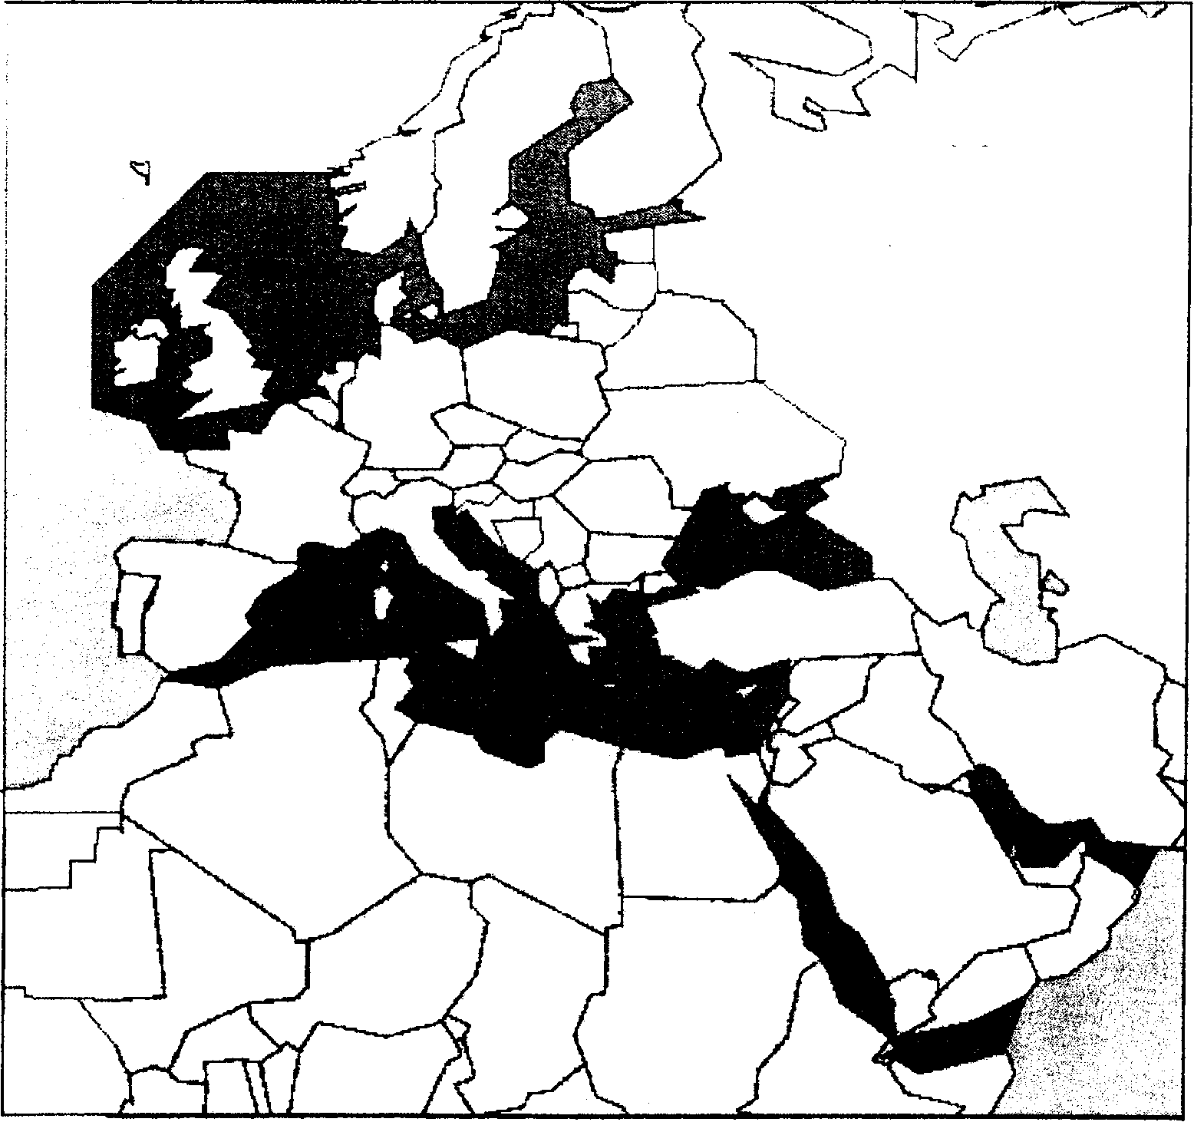

• Special Areas Marpol Annex 1 Also Waters South of 60° S
Rules for discharge of oily water from machinery spaces are also given in regulations 9 and 10 of Annex I. They apply to tankers as well as other ships over 400 GT.
Discharge of oil or oily water is prohibited unless/allowing rules are observed:
Tankers Other ships
rA
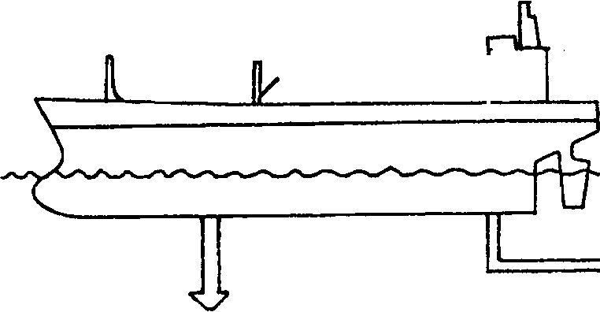
From machinery spaces

1. Ship proceeding en route
/. Tanker proceeding en route
2. Max. 30 litres of oil per mile
3. Max. 1/30.000 of last cargo
2. Oil content below 15 ppm
3. Oil filtering equipment with automatic 15 ppm stopping device and alarm

4. Approved slop tank system and oil content mopnifor
5. Ship must be outside Special Area and more than 50 nautical miles from nearest land.
© Marstal Navigationsskole February 02

60
MARPOL Annex II, Regulations for the Control of Pollution by Noxious Liquid Substances in Bulk
Liquid substances are defined as being substances with a vapour pressure not above 2.8 kp/cm² at 37.8°C (100°F), i.e. substances, which may be transported in a liquid state at ambient temperature and pressure. Liquid substances, which are transported in bulk, must be classified according to the criterias laid out in MARPOL's Annex n, and substances, which are judged as harmful may only be discharged according to particular criterias.
The regulations controlling the discharge of harmful liquid substances are explained on the following pages. Substances, which have not been categorized, have to be provisionally assessed by the authorities before transportation.

Annex n consists of 16 regulations giving detailed requirements for discharge criteria and measures for the control of pollution by Noxious Liquid Substances carried in Bulk (NLS). The principles on which the operational aspects of MARPOL 73/78 are based are:
The structure of Annex II
The regulations
- the maximum quantity of substances per tank which may be discharged into the sea;
- the speed of the ship during the discharge;
- the minimum distance from the nearest land during discharge;
- the minimum depth of water at sea during discharge;
- the maximum concentration of substances in the ship's wake or the dilution of substances prior to discharge;
and
- the need to effect the discharge below the waterline.
Furthermore Annex n has five appendixes giving guidelines for the categorization of noxious liquid substances, a recommended layout for the Cargo Record Book and the form of the so-called NLS Certificate. Annex n also contains a section called "Standards for procedures and arrangements for the discharge of noxious liquid substances" and it has the purpose to provide a uniform international basis for approving procedures and arrangements by which ships carrying noxious liquid substances in bulk can satisfy the discharge provisions of Annex n.
Basically Annex n applies to all ships carrying noxious liquid substances in bulk where a noxious liquid substance is defined as any substance falling into pollution category A, B, C, or D. The pollution categories are explained as:
© Marstal Navigationsskole February 02

Category A:
Category B:
Category C:
Category D:
List of noxious liquid substances carried in bulk
List of other liquid substances
61
Noxious liquid substances which if discharged into the sea from tank cleaning or deballasting operations would present a major hazard to either marine resources or human health or cause serious harm to amenities or other legitimate uses of the sea and therefore justify the application of stringent anti-pollution measures.
Noxious liquid substances which if discharged into the sea from tank cleaning or deballasting operations would present a hazard to either marine resources or human health or cause harm to amenities or other legitimate uses of the sea and therefore justify the application of special anti-pollution measures.
Noxious liquid substances which if discharged into the sea from tank cleaning or deballasting operations would present a minor hazard to either marine resources or human health or cause minor harm to amenities or other legitimate uses of the sea and therefore require special operational conditions.
Noxious liquid substances which if discharged into the sea from tank cleaning or deballasting operations would present a recognizable hazard to either marine resources or human health or cause minimal harm to amenities or other legitimate uses of the sea and therefore require some attention in operational conditions.
Noxious liquid substances carried in bulk and which are presently categorized as Category A, B, C or D and subject to the provisions of this Annex, are so indicated in the pollution category column of chapters 17 or 18 of the International Bulk Chemical Code. (See chapter 2)
Liquid substances carried in bulk which are identified as falling outside the Categories A, B, C or D and not subject to the provisions of Annex n are indicated as "in" in the pollution category column of chapters 17 or 18 of the International Bulk Chemical Code (IBC code).
It is in this connection worth noting that the discharge of bilge or ballast water or other residues or mixtures containing only substances indicated as "ffl" in Annex n shall not be subject to any requirement of this Annex. The discharge into the sea of clean ballast or segregated ballast as well shall not be subject to any requirement of this Annex.

© Marslal Navigationsskole February 02

62

The discharge of tank washing containing Category A.B.CorD:
Category A:
Category B:
Category C:
Category D:
Discharge of Noxious liquid substances inside Special Areas
For all 4 categories discharge into the sea i« prohibited unless the following two conditions are observed:
_ _ if
• The ship is proceeding en route" at a speed pf at least 7 knots in the case of self-propelled ships or at least 4 knots in the case of ships which are not self-propelled;
• the discharge is made at a distance of nouess than 12 nautical miles from the nearest land
Additionally all discharge of residues from categories A, B and C must be made below the waterline, taking into account the location of the seawater intakes; and in a depth of water of not less than 25 metres.
The maximum concentration and quantities which may be discharged of each category is as follows:
All residues must be pumped ashore. If any washing is necessary residues from the cleaning (prewash) must be pumped ashore until the concentration of the substance in the effluent is below a certain value (for most category A substances this value is 0.1 % by weight) and until the tank is empty. Any water subsequently added to the tank may be discharged into the sea under the above mentioned conditions.
The concentration of residue in the ship's wake must not exceed 1 ppm (part per million), and the maximum quantity of discharged residues must not exceed the greater of 1m³ per tank (including piping) or 1/3000 of the tank capacity.
The concentration in the ship's wake must not exceed 10 ppm and the maximum quantity per tank must not exceed the greater of 3 m³ or 1/1000 of the tank capacity.
The quantity of residue in the effluent must not exceed 1 part of the substance in ten parts of water. (For category D the discharge may be made above or below the waterline and in a depth of water of less than 25 metres if desired).
Inside special areas, which are the Baltic Sea area and the Black Sea area the regulations are even more stringent.

² The term en route is taken to mean that the ship is under way at sea on a course, or courses, which so far as practicable for navigational purposes will cause any discharge to be spread over as great an area of the sea as is reasonably practicable.
© Maistal Navigationsskole February 02

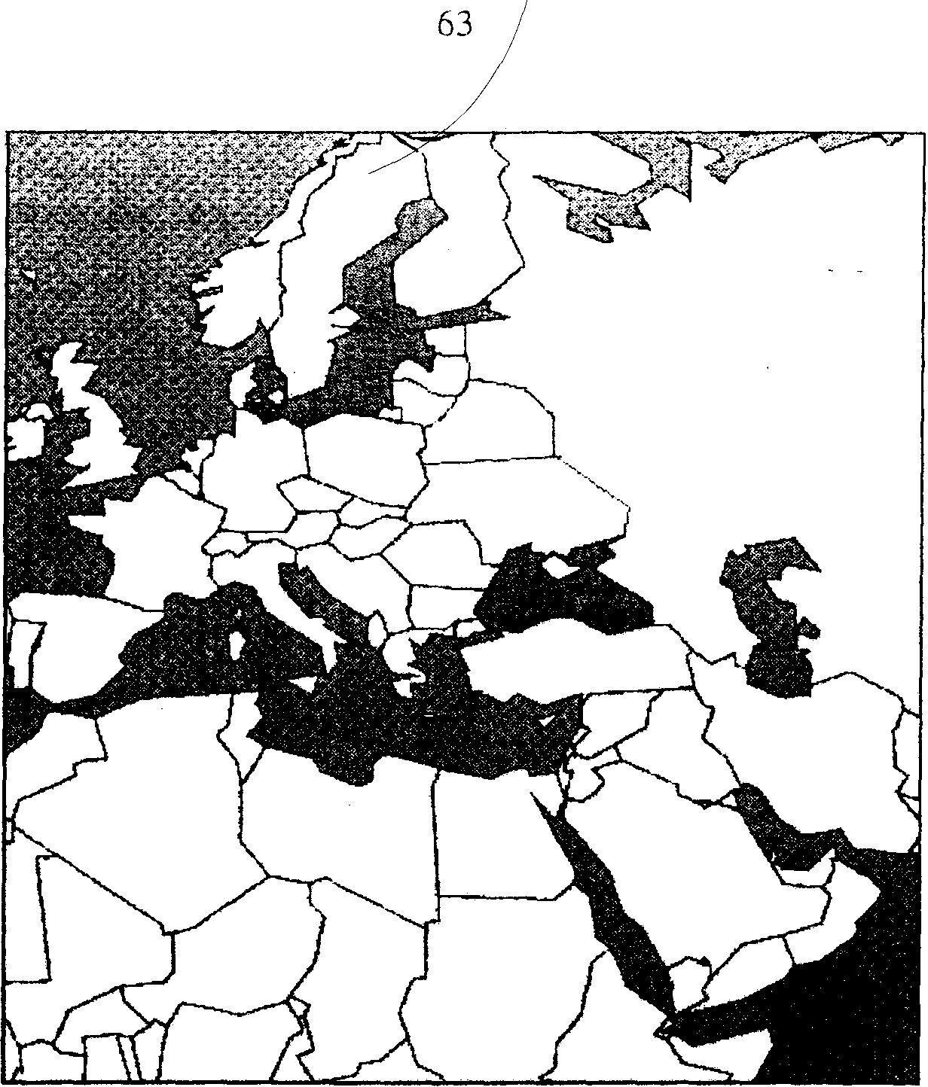

Special Areas Marpol Annex 2. Also waters south of 60° S
Category A:
Category B:
Category C:
As for discharge outside special area but the residues from the cleaning (prewash) must be pumped ashore until the concentration of the substance in the effluent is below 0.05 %.
As for discharge outside special area but the tank shall be prewashed ³
As for discharge outside special area but the concentration in the ship's wake must not exceed 1 ppm and the maximum quantity per tank must not exceed the greater of 1 m³ or 1/3000 of the tank capacity.
As for discharge outside special area.
Approved ventilation procedures may be used to remove cargo residues from the tanks both outside and inside special area. The following is an extract from Appendix C in "Standards for procedures and arrangements" from Annex n giving the procedures to be followed in case of ventilation of cargo residues:
Category D:
Ventilation of cargo residues

³ If the residues are retained on board and discharged into the sea outside Special Area the prewash can be omitted.
© Marstal Navigationsskole February 02

Ventilation procedures
64
7. Cargo residues of substances with a vapour pressure greater than 5000 Pa (50 millibar) at 20°C may be removed from a cargo tank by ventilation.
2. Before residues of noxious liquid substances are ventilated from a tank the safety hazards relating to cargo flammability and toxicity should be considered. With regard to safety aspects, the operational requirements for openings in cargo tanks in the International Bulk Chemical Code, the Bulk Chemical Code, and the ventilation procedures in the ICS Tanker Safety Guide (Chemicals) should be consulted.
3. Port authorities may also have regulations on cargo tank ventilation.
4. The procedures for ventilation of cargo residues from a tank are as follows:
. 1 the pipelines should be drained and further cleared of liquid by means of ventilation equipment;
.2 the list and trim should be adjusted to the minimum levels possible so that evaporation of residues in the tank is enhanced;
.3 ventilation equipment producing an airjet which can reach the tank bottom shall be used;
.4 ventilation equipment should be placed in the tank opening closest to the tank sump or suction point;
.5 ventilation equipment should, when practicable, be positioned so that the airjet is directed at the tank sump or suction point and impingement of the airjet on tank structural members is to be avoided as much as possible; and
.6 ventilation shall continue until no visible remains of liquid can be observed in the tank. This shall be verified by a visual examination or an equivalent method.
Any water subsequently introduced into the tank shall be regarded as clean and shall not be subject to any of the discharge regulations given in MARPOL Annex n.

Efficient stripping
Contrary to the discharge of water containing oil residues from oil cargoes, where the oil content can be detected by an oil content monitor, it is not possible to construct a detector which can detect all residues from chemicals. Therefore in order to ensure that the allowed amount of residues discharged into the sea is not exceeded, MAROL

€> Marstal Navigationsskole February 02

65
Annex II requires that the ship must be constructed with so-called efficient stripping.
To be able to conform to the above mentioned rules it has been necessary to introduce rules for the construction and the equipment of the vessels. The construction requirements differ for vessels constructed before and after 1 July 1986 so that vessels constructed after this date (hereafter referred to as new ships) must comply to one set of rules whereas existing ships should conform to another set of rules.
The most important requirements for new ships are: Every ship shall be provided with pumping and piping arrangements to ensure, through testing under favourable pumping conditions, that each tank designated for the carriage of a Category B substance does not retain a quantity of residue in excess of 0.1 cubic metres in the tank's associated piping and in the immediate vicinity of that tank's suction point. For category C the corresponding maximum is 0,3 m³.
For existing ships the following applies; Every ship constructed before 1 July 1986 shall be provided with pumping and piping arrangements to ensure, through testing under favourable pumping conditions, that each tank designated for the carriage of a Category B substance does not retain a quantity of residue in excess of 0.3 cubic metres in the tank's associated piping and in the immediate vicinity of that tank's suction point. The corresponding requirement for Category C is 0,9 m .
Reception facilities Ports must have adequate reception facilities for any tank washings or residues that must be discharged in compliance with Annex n and terminals must have suitable arrangements to facilitate the stripping of ship's cargo tanks.
It is important to note that cargo hoses and piping systems of the terminal, containing noxious liquid substances received from ships unloading these substances at the terminal, shall not be drained back to the ship.
© Marstal Navigadonsskole February 02
66

Measures of control
Prewash and endorsement in Cargo Record Book by MARPOL Annex II surveyor
Special cases where prewash is required
Regulation 8 states that the government of each Party to the convention shall appoint or authorize surveyors who shall execute control of for instance-the unloading and prewash in accordance with control procedures developed by IMO and adopted by Resolution A.787(19). The surveyors shall as minimum endorse in the Cargo Record Book entries of prewash operations after category A products. If the ship has been given any exemptions from mandatory prewash, such exemptions shall also be endorsed by the surveyor.
At the request of the ship's master, the Government of the receiving party may exempt the ship from the requirements of prewash where it is satisfied that:
(i) the tank unloaded is to be reloaded with the same substance or another substance compatible with the previous one and that the tank will not be washed nor ballasted prior to loading; or
(ii) the tank unloaded is neither washed nor ballasted at sea and the tank is prewashed and resulting tank washings are discharged to a reception facility at another port, provided that it has been confirmed in writing that a reception facility at that port is available and adequate forSuch a purpose; or
(iii) the cargo residues will be removed by ventilation.
If the unloading of category B or C substances is not carried out in accordance with the approved pumping conditions which is the case if the efficient stripping system has not been in use, or if the substance unloaded has been identified as a solidifying or high viscosity substance then the tanks shall be prewashed before the ship leaves the port of unloading. It is possible to obtain an exemption from the prewash in accordance with the conditions given above.
In the "Standards" solidifying substance and high-viscosity substance is defined.
A noxious liquid substance shall be regarded as a Solidifying substance:
1. if the melting point is lower than 15 °C and the cargo temperature at the time of unloading is less than 5°C above its melting point; or
2. if the melting point is equal to or greater than 15 °C and the cargo temperature at the time of unloading is less than 10°C above its melting point.

© Marstal Navigationsskole February 02

67
Benzene can be used as an example to illustrate the problem. Benzene has a melting point of 6 °C and therefore the temperature at the time of unloading must be at least 11 °C if benzene shall not be considered as solidifying and for that reason require a prewash.
A noxious liquid substance shall be regarded as a High-viscosity substance:
1. in the case of category A and B and in the case of category C within special areas if the viscosity at the unloading temperature is equal to or greater than 25 mPa • s.
2. in the case of category C outside special areas if the viscosity at the unloading temperature is equal to or greater than 60 mPa • s.
It is a requirement of chapter 16 in the IBC-code that the viscosity at 20°C and the melting point should be stated on the shipping documents if it is relevant. If the viscosity at 20" exceeds the above mentioned limits it should be stated at which temperature the viscosity will be down to 25 mPa • s or 60 mPa • s.
Every ship to which Annex n applies shall be provided with a Cargo Record Book, whether as part of the ship's official log-book or otherwise, in the form specified in appendix IV to Annex n.
The Cargo Record Book shall be completed, on a tank-to-tank basis, and shall cover operations such as loading, unloading and internal transfer of cargo; ballasting, discharge of ballast and cleaning of cargo tanks; disposal of residues to reception facilities, discharge into the sea or removal by ventilation of residues.
Each operation shall be fully recorded without delay in the Cargo Record Book so that all the entries in the book appropriate to that operation are completed. Each entry shall be signed by the officer or officers in charge of the operation concerned and each page shall be signed by the master of the ship. The entries in the Cargo Record Book shall be in an official language of the State whose flag the ship is entitled to fly, and in English or French.
The Cargo Record Book shall be kept in such a place as to be readily available for inspection and it shall be retained for a period of three years after the last entry has been made.
Cargo Record Book

Survey and certification Surveys are required for all ships to cover Annex n requirements; the condition of the ship and its equipment is
© Marstal Navigationsskole February 02

Carriage and discharge of oil-like substances
68
to be maintained and may not be changed without prior sanction of the marine administration. An "International Pollution Prevention Certificate for the Carriage of Noxious Liquid Substances" (NLS Certificate) is required for ships in international trade.
Chemical tankers which have been surveyed and certified by the marine administration in accordance with the IBC Code or the BCH Code should be accepted as complying with the requirements and do not require a NLS Certificate or an additional survey. Such a ship must have a Certificate of Fitness (see chapter 2).
Regulation 14 of Annex n opens up for the possibility that product tankers may carry certain noxious liquid substances that normally requires to be carried in chemical tankers. The oil like substances are identified in the IBC code chapter 17 by the foot-note "(bb)". MEPC.2/Circ., which is updated every year in December, contains a list of oil like substances. Category C substances which are identified by the Organization as oil-like substances under the criteria developed by the Organization, may be carried on an oil tanker as defined in Annex I and discharged in accordance with the provisions of Annex I, provided that all of the following conditions are complied with:
(a) the ship complies with the provisions of Annex I of the present Convention as applicable to product carriers as defined in that Annex;
(b) the ship carries an International Oil Pollution Prevention Certificate (IOPP Certificate) and its Supplement B and the certificate is endorsed to indicate that the ship may carry oil-like substances in conformity with this regulation and the endorsement includes a list of oil-like substances the ship is allowed to carry;
(c) in the case of Category C substances the ship complies with the ship type 3 damage stability requirements;
(d) the oil content meter in the oil discharge monitoring and control system of the ship is approved by the Administration for use in monitoring the oil-like substances to be carried.

© Marstal Navigationsskole February 02

69
List of oil-like substances
Substance | Pollution Category |  | Substance | Pollution Category
Aviation Alkylates (C8 paraffines and iso-paraffins BPT95-120°C) | (C) |  | Melhylcyclohexane | (C)
Cycloheplane | (C) |  | Nonane (all isomers) | (C)
Cyclohexane | C |  | Octane (all isomers) | (C)
Cyclopentane | (C) |  | Olefin mixtures (C5-C7) | C
p-Cymene | C |  | Pentane (all isomers) | (C)
Ethylcyclohexane | (C) |  | Pentene (all isomers) | C
Heptane (at) isomers) | (C) |  | 1-Phenyl-l-xylyl ethane | C
Heptene (all isomers) | C |  | Propylene dimer | (C)
Hexane (all isomers) | (C) |  | Tetrahydronaphthalene | C
Hexene (all isomers) | . (C) |  | Toluene | C
Isopropylcyclohexane | (C) |  | Xylenes | C

For each of the above substances, compliance with the oil-like substance criterion has to be demonstrated for the particular oil content meter installed.
NB! If a chemical tanker carries an oil-like substance, the substance should be treated as any other noxious liquid substance of category C.

Port State control on
operational
requirements
A ship when in a port of another Party to MARPOL is subject to inspection by officers duly authorized by such Party concerning operational requirements under Annex n, where there are clear grounds for believing that the master or crew are not familiar with essential shipboard procedures relating to the prevention of pollution by noxious liquid substances.
Resolution A.787(19) "Procedures for Port State Control" says that if the deficiencies found in a ship are serious the Port State Control Officer shall take such steps as will ensure that the ship shall not sail until the situation has been brought to order in accordance with the requirements of Annex n. The Guidelines to the resolution has a list of deficiencies which are considered to be of such a serious nature that they may warrant the detention of the ship involved. This list is not considered exhaustive but is intended to give examples of relevant items. The following is an extract of the list:
Areas under the MARPOL Convention, Annex n
1) Absence of P&A Manual.
2) Cargo is not categorized.
3) No Cargo Record Book available.
4) Transport of oil-like substances without satisfying the requirements.
5) Unauthorized discharge bypass fitted.

© Marstal Navigationsskole February 02

70

Any ship, which is certified to transport harmful substances from Annex II must be equipped with a P&A-manual.
Procedures and Arrangement Manual (P&A-manual)
The manual must carefully describe all -procedures to be followed in connection with cargo-handling, tank cleaning, discharge into the sea and ventilation. Obviously these procedures must be in full accordance with the provisions of Annex n.
Furthermore the P&A-manual must contain a detailed description of the cargo handling equipment such as description of cargo pumping and piping arrangements and stripping system; description of underwater discharge outlet for effluents containing noxious liquid substances; type of tank washing machines with capacities and pressure rating etc. etc. The P&A Manual will also contain flow diagrams which in an easy way list the relevant procedures to be used when discharging a noxious liquid substance into the sea. The P&A-manual must be approved by the authorities.
The manual is prepared in accordance with a layout given in "Standards" and will as minimum contain:
1. Main features ofMARPOL 73/78, Annex u
2. Description of the ship's equipment and arrangements
3. Cargo unloading procedures and tank stripping
4. Procedures relating to the cleaning of cargo tanks, the discharge of residues, ballasting and deballasting
Table 1-List of noxious liquid substances allowed to
be carried
Table 2-Cargo tank information
Addendum A: Flow diagrams
Prewash procedures Ventilation procedures
Determination of permitted residue discharge rates for Category B substances (if necessary)
Addendum B:
Addendum C:
Addendum D:
Additional information and operational instructions required or accepted by the Administration (if necessary).
© Marstal Navigationsskole Februaiy 02

71
Here follows as an example an extract of: Table 1-List of noxious licjuid substances allowed to be carried:
 | Page: 1
Table 1. List of noxious liquid substances allowed to be carried

SUBSTANCE | CATS-GORY | TANK GROUPS fTtfOS. CARRIAGE (See Notes) | MELTING POINT •C | VISCOSITY AT20"C mPaJ |  |  | SUITABLE FOR VENTILATION | MISOBLE IN WATER
 |  |  |  | <2S | 2540 | >-60 | SUITABLE FOR VENTILATION | MISOBLE IN WATER
ACETONITRILE | III | 1 | -48.0 | <2S |  |  |  | YES
ACRYLAMIDE SOLUTION (80% or leu) | D | 1 | 10.0 | 3 |  |  |  | YES
ACRYLONITBILE | B | 1 | -86.0 | <25 |  |  | YES
ACRYLONITRILE STYBENE COPOLYMEB DISPERSION IN POLYETHER POLYOL | D | 1,2 | -25.0
ADIPONITBILE | 0 | 1,2 | 2.0 | 8
ALCOHOL IC12-C15) POLY (1-flt ETHOXYLATES | A | 1 | -1.0 |  | 25 |  |  | YES
ALCOHOL 4C12-C15) POLY <7-19» ETHOXYLATES | B | 1,2 | 20.0
ALCOHOL (C12-C1B) POLY (20+» ETHOXYLATES | C | 1,2
ALCOHOL IC6-C17) Iwcondary) POLY (3-6) ETHOXYLATES | A | 1 | -1.0 |  | 40 |  |  | YES
ALCOHOL (C8-C17) IsBcondwyl POLY (7-12) ETHOXYLATES | B | 1,2 | 5.0 |  |  | 70 |  | YES
ALCOHOL (C9- C11 KorimTvl ETHOXYLATE | B | 1

© Marstal Navigationsskole February 02
72
Appendix D; Standard format for the P & A Manual
ADDENDUM A
Flow diagrams - Cleaning of cargo tanks and disposal of tank washings/ballast containing residues of Category A, B, C and D substances

COP 1 (a) <x
COP 2
Pumping/stripping reoulrements | Cat. 8. tanks | Cat. Clanks
New ships 1966 Existing ships 1994 Existing ships 1987 | 0.1m'(NO.t) 0.ain'(E0.3) 10m'(El.O) | 0.3in'(N0.3) O.am'IEO.S) 30m'(E3.0)

no

Resuduels 1 Cat. C substance 1

no

Reddueis Ca.Dtubeanca

no

OKtiageImo lhawarnol ngulatedby Annaxll

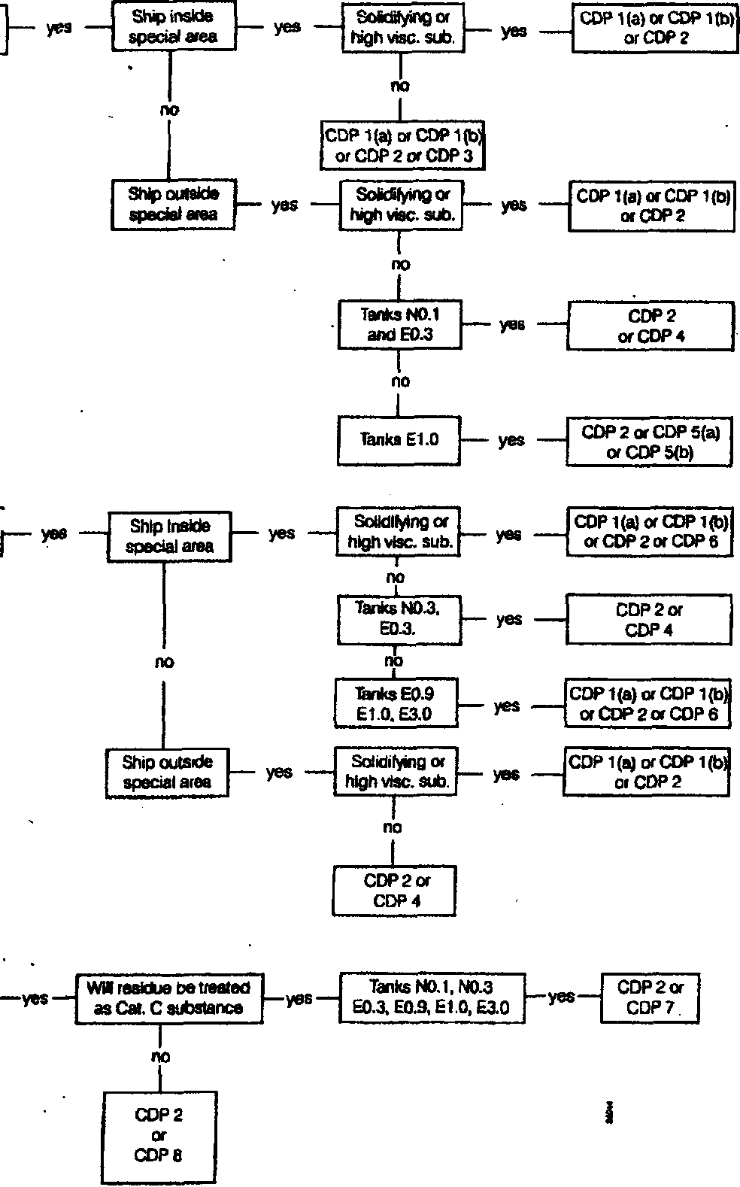

Note: This is a flow diagram giving comprehensive requirements applicable to new and existing ships. The flow diagram for a specific ship should only include parts applicable to that ship.
© Marslal Navigationsskole February 02

73
Standards for procedures and arrangements
Cleaning and disposal procedures (CDP) | Sequence of .procedures
Cleaning and disposal procedures (CDP) | l(a) | l(b) | 2 | 3 | 4 | 5(a) | 5(b) | 6 | 7 | 8
Apply prewash in accordance with appendix B and discharge residue to reception facility | x | x
j Apply prewash in accordance with appendix B and transfer residues to slop tank for discharge to sea in accordance with chapter 10, section 10.5 or 10.6 |  |  |  |  |  | x | x
Apply subsequent wash of minimum one cycle |  | x |  |  |  |  | x
Apply ventilation procedures in accordance with appendix C |  |  | x
Residue may be retained on board and discharged outside special area |  |  |  | x
Residues of substances with viscosities < 60 mPa.s at the unloading temperature may be retained on board and discharged outside special area. Alternatively, tanks may be prewashed and slops discharged asnore |  |  |  |  |  |  |  | x
Dilute residue in cargo tanks with water to obtain residue concentration in mixture of 10% or less |  |  |  |  |  |  |  |  |  | x
Ballast tank or, wash tank to commercial requirements | x |  |  | x | x | x |  | x | x
Conditions for discharge of ballast/ residue/water mixtures other than prewash:  > 12 miles from land >7 knots ship's speed > 25 metres water depth Using underwater discharge | x | x |  | x | x | x | x | x | x | x
 | x | x |  | x | x | x | x | x | x | x
 | x | x |  | x | x | x | x | x
 | x | x |  | x | x | x | x | x | x
Ballast added to tank |  | x |  |  |  |  | x
Condition for discharge of ballasts: > 12 miles from land |  | x |  |  |  |  | x
>25 metres water depth |  | x |  |  |  |  | x
Alternatively, residue/water mixtures may be discharged ashore (N.B. optional not MARPOL requirement) | x | x |  | x | x | x | x | x | x | x
Any water subsequently introduced into the tank may be discharged into | x | x | x | x | x | x | x | x | x | x

Note; Start at the top of the column under the CDP number specified and complete each procedure in sequence where marked x.
© Marstal Navigationsskole February 02
74
The following examples will illustrate the use of the flow diagrams:
Example 1
The ship is outside Special Area and has unloaded a cargo of AcryJonitrile at a temperature of 20°C.
From "Table 1" is found that the pollution category is Cat. B, melting point is - 85 °C and viscosity at 20 °C is <25 mPa.s.
Using the first flow diagram in "Addendum A", -____________________
ADDENDUM A
Flow diagrams - cleaning of cargo tanks and disposal of tank washings/ballast containing residues of Category A, B, C and substances

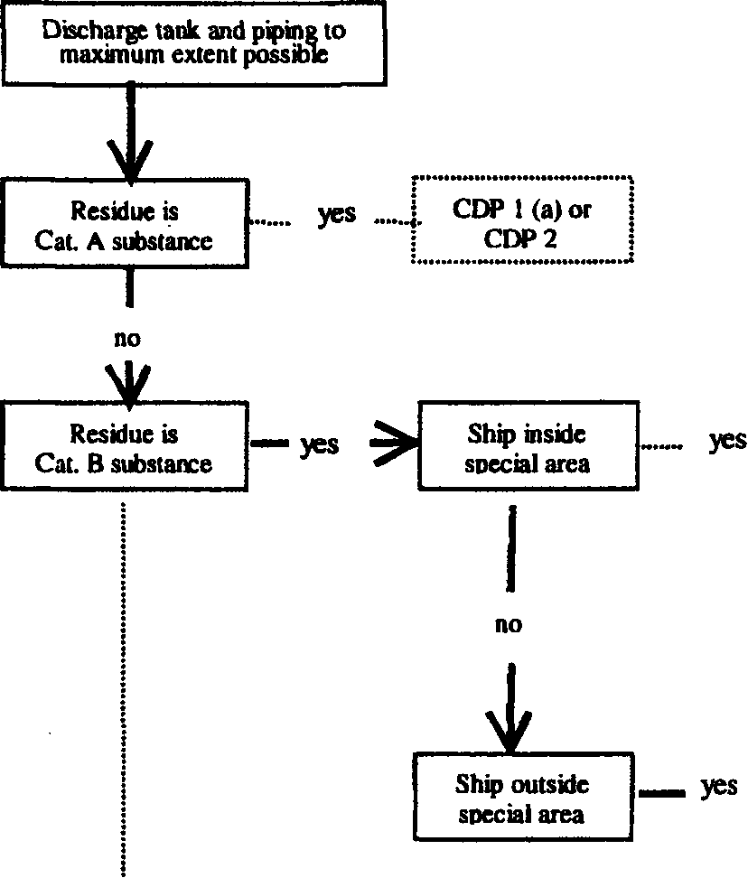
.....I
'' Solidifying or high |... vise. sub. I
-yes

JCDP l(a)orCDPl(b)or| | CDP2orCDP3 |
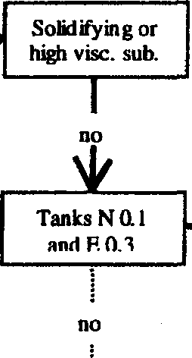
yes
CDP2 or CDP4

we end up in box:
CDP2 or CDP4

The cleaning and disposal procedure could then be:
CDP2:
"Apply ventilation procedures in accordance with appendix C" and from Table 1 acrylonitrile is listed as suitable for ventilation. Or the cleaning and disposal procedure could be:
© Marstal Navigationsskole February 02

75

"-ballast tank, or wash tank to commercial requirements. Then the ballast/residue or water mixture can be discharged >12 miles from land, > 7 knots ship's speed, > 25 metres water depth and using underwater discharge.
CDP4:

Example 2
The conditions are the same as in example 1, but the ship is inside Special Area.
Using again the first flow diagram in "Addendum A''

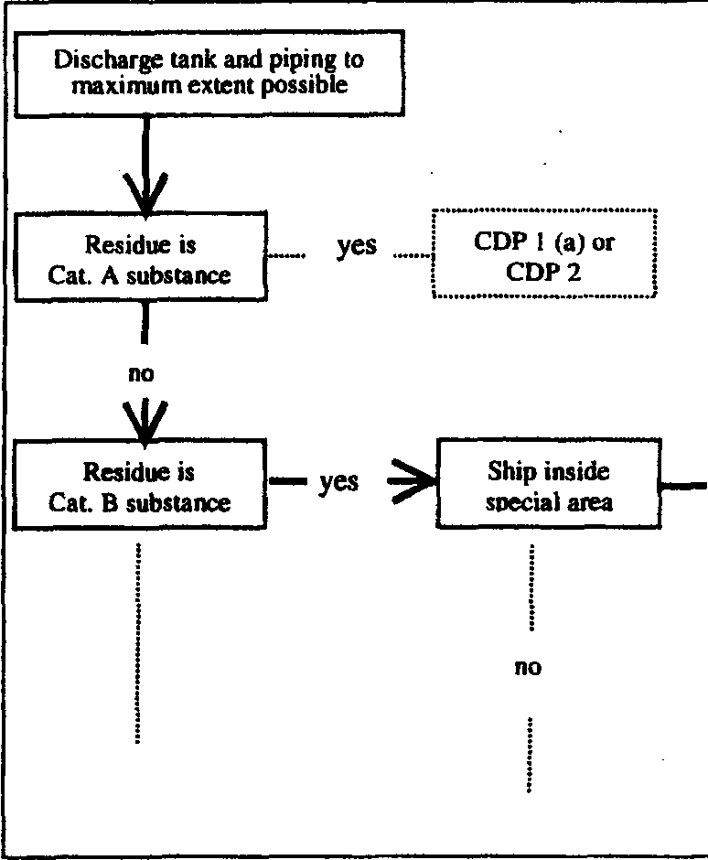
Solidifying or high vise. sub.

.
CDP l(a) or CDP l(b) orCDP2orCDP3

CDP l(a) or CDP l(b) or CDP 2 or CDP 3
we end up in the box:

CDP l(a) and CDP l(b)
CDP2:
CDP 3:
require a prewash and discharge of residue to reception facility before the tank is ballasted or washed to commercial requirements. Then the ballast/residue or water mixture can be discharged >12 miles from land, > 7 knots ship's speed, > 25 metres water depth and using underwater discharge. (CDP l(a) and CDP l(b) is slightly different in how to perform the final wash of the tank, but is in principle the same method).
- as in example 1 above.
Residue may be retained on board and discharged outside Special Area, - that is the tank could be ballasted or, washed to commercial requirements and the ballast/ residue or water mixture can be discharged outside Special Area >12 miles from land, >7 knots ship's speed, >25 metres water depth and using underwater discharge.
As the two examples show it is quite simple to follow the requirements from MARPOL Annex n as far as discharge

© Marstal Navigationsskole February 02

76
of residue/water mixtures is concerned if the instructions in the P & A Manual are watched closely. It should always be taken into account that there may exist some local restrictions that could go beyond the minimum requirements given in MARPOL. So when in doubt - always check with the local agent or local authorities for special conditions for discharge of residue/water mixtures containing noxious liquid substances.
© Marstal Navigationsskole February 02

