ЗАДАЧИ, РЕШАЕМЫЕ НА ГАЗОВОЗАХ И ИХ РЕШЕНИЯ

СОДЕРЖАНИЕ

1. ТЕОРИЯ

2. ПРИМЕРЫ:

№ 1 - Определение, достаточно ли груза на борту для продувки грузовых танков
№ 2 - Определение, какое количество груза требуется для продувки танков
№ 3 - Определение объемной концентрации, если известна весовая концентрация
№ 4 - Определение весовой концентрации, если известна объемная концентрация
№ 5 - Определение максимального количества паров в воздухе
№ 6 - Определение, до какой температуры необходимо охладить воздух, чтобы началась конденсация паров
№ 7 - Определение относительной влажности воздуха
№ 8 - Определение количества свободной воды в танке при охлаждении
№ 9 - Определение количества льда в танке после погрузки
№ 10 - Определение объема кислорода при известной температуре и давлении
№ 11 - Определение количества паров в танке после выгрузки
№ 12 - Определение температуры смеси газов
№ 13 - Определение общего давления насыщенных паров в танке и процентного состава газовой фазы
№ 14 - Определение количества теплоты, проникающей через изоляцию грузового танка
№ 15 - Диаграмма Молье: нахождение энтальпии
№ 16 - Диаграмма Молье: определение, какая часть груза находится в жидкой фазе, а какая в газообразной
№ 17 - Диаграмма Молье: определение плотности перегретого пара и удельной энтальпии
№ 18 - Диаграмма Молье: определение давления газа при данной температуре
№ 19 - Диаграмма Молье: расчет времени работы УПСГ для понижения температуры груза до заданной
№ 20 - Диаграмма Молье: расчет работы одноступенчатой УПСГ с регенеративным теплообменником
№ 21 - Диаграмма Молье: анализ барометрических границ различных режимов работы одноступенчатой УПСГ
№ 22 - Диаграмма Молье: упрощенный вариант расчета времени параллельной работы 3-х двухступенчатых установок
УПСГ при погрузке
№ 23 - Диаграмма Молье: расчет времени захолаживания груза при отсутствии в УПСГ промежуточного охладителя
№ 24 - Диаграмма Молье: анализ барометрических границ различных режимов работы одноступенчатой УПСГ
№ 25 - Диаграмма Молье: построение цикла каскадной УПСГ
№ 26 - Диаграмма Молье: расчет количества теплоты, суммарной хладопроизводительности УПСГ; времени,
необходимого на погрузку
№ 27 - Диаграмма Молье: расчет времени на погрузку
№ 28 - Диаграмма Молье: расчет времени на захолаживания груза
№ 29 - Определение величины подачи и напора насоса при подключении в параллель другого насоса
№ 30 - Определение изменения давления в грузовом трубопроводе при последовательном подключении насосов
№ 31 - Расчет безопасного времени закрытия клапана
№ 32 - Определение давления нагнетания насоса при нормальной работе
№ 33 - Определение потери производительности УПСГ в плотности паров
№ 34 - Определение гидравлических потерь УПСГ
№ 35 - Определение количества обменов при продувке
№ 36 - Охлаждение груза в процессе погрузки
№ 37 - Проникновение тепла во время перехода
№ 38 - Охлаждение груза на переходе
№ 39 - Расчет предела заполнения танка (full-press)
№ 40 - Расчет предела заполнения танка (semi-press)
№ 41 - Расчет предела заполнения танка (full-ref)
№ 42 - Предварительный расчет количества груза
№ 43 - Определение количества груза, необходимого для продувки танка
№ 44 - Определение истинной плотности, зная относительную
№ 45 - Определение весового соотношения газов в смеси
№ 46 - Расчет жидкостной фазы груза
№ 47 - Расчет плотности груза на заданную температуру
№ 48 - Расчет массы одного грамм – моля
№ 49 - Расчет количества жидкости, получаемой сжижением определенного количества газа
№ 50 - Расчет процентного состава паров в равновесии
№ 51 - Расчет веса заданного объёма груза
№ 52 - Расчет максимального объёма груза низкой температуры для безопасной погрузки на pressurized vessel
№ 53 - Расчет максимально допустимой скорости погрузки
№ 54 - Определение количества вакуумных циклов
№ 55 - Инертизация танка
№ 56 - Захолаживание танка жидким этиленом
№ 57 - Проверка совместимости грузов

THEORY

При одинаковых условиях 1 моль любого газа занимает одинаковый объём.
При нормальных условиях 1 моль любого газа занимает объём, равный 22,4 литра. Этот объём называется молярным объёмом газа (размерность л/моль или м³/моль).
Точное значение молярного объёма газа при нормальных условиях (давление 1013 миллибар и температура 0°С) составляет 22,4135 ± 0,0006 л/моль. При стандартных условиях (t=+15°С давление = 1013 мбар) 1 моль газа занимает объём 23,6451 литра, а при t=+20 °С и давлении 1013 мбар 1 моль занимает объём около 24,2 литра.
В численном выражении молярная масса совпадает с массами атомов и молекул (в а.е.м.) и с относительными атомными и молекулярными массами.
Следовательно, 1 моль любого вещества имеет такую массу в граммах,которая численно равна молекулярной массе данного вещества, выраженной в атомных единицах массы.
Например, М(О₂) = 16 а.е.м. • 2 = 32 а.е.м., таким образом, 1 моль кислорода соответствует 32 граммам.

PHYSICAL PROPERTIES OF GAS MIXTURES
If the components of a gas mixture are known, it is possible to perform a variety of calculations using the following relationships.
Molecular mass
Molecular mass of gas mixture = MiVi /100 where Mi = component molecular mass
Vi = percentage component volume
Percentage mass
Percentage mass of component = ViMi/M_{mix} where M_{mix} = molecular mass of gas mixture
Relative vapour density
Relative vapour density of gas mixture (at 0⁰C and 1 bar) = M_{mix}/M_{a} where Ma = molecular mass of air = 29
For example, given the percentage by volume of the components in a gas mixture, Table 2. 7 shows how the molecular mass of the mixture can be determined. The example taken considers the composition of a typical natural gas.

Table 2. 7 Calculation for molecular mass of a gas mixture

Gas Component | Percentage by Volume  (Vi) | Component Molecular Mass (Μi ) | MiVi/  100 | Percentage by Mass
Methane | 83. 2 | 16. 04 | 13. 35 | 67. 6
Ethane | 8. 5 | 30. 07 | 2. 56 | 13. 0
Propane | 4. 4 | 44. 09 | 1. 94 | 9. 8
Butane | 2. 7 | 58. 12 | 1. 57 | 7. 9
Nitrogen | 1. 2 | 28. 02 | 0. 34 | 1. 7
 | 100. 00 |  | 19. 76 | 100. 00
 |  | M_{mix} = 19. 76
Relative density of mixture = 19.76/29 = 0.681

Vapour pressure of liquid mixtures
Dalton's Law of Partial Pressure states that when several gases occupy a common space, each behaves as though its quantity of gas occupies the space alone. The pressure which each gas exerts is called its partial pressure and the total pressure exerted within the enclosing space is the sum of the partial pressures of the components.
Using Dalton's Law it is possible to calculate the saturated vapour pressure of a mixture of liquids at a given temperature. The partial pressure exerted by the vapour of a liquid component is equal to the product of the saturated vapour pressure of that component if it existed alone at that temperature multiplied by the mole fraction of the component in the liquid mixture. The total saturated vapour pressure of the mixture will be the sum of the partial pressures of each component.
Thus, P_{mt} = Σ (P_{nt} x F_{n}) where P_{mt} is saturated vapour pressure of liquid mixture (m) of temperature (t), P_{nt} is saturated vapour pressure of component (n) at temperature (t), F_{n} is mole fraction of component (n) in liquid mixture.
This is the mass of that component divided by the mass of the whole mixture. For example, in Table 2. 7 the mole fraction of the gas mixture is given by: —
MiVi/Mmix x 100
For example, for an LPG of the following composition at -40⁰C: -
Component (n) | Mole Fraction in mixture (F_{n}) | SVP of component at -40⁰C  (Pnt )  (bar) | Partial Pressure of component at -4O⁰C (Pnt x F_{n})  (bar) | Composition of vapour (Partial Pressure/SVP of mixture χ 100)  (% by volume)
Ethane  Propane n-Butane  i-Butane | 0. 002  0. 956 0. 030  0. 012  1. 000 | 7. 748  1. 13 0. 17  0. 284 | 0. 0155  1. 0803 0. 0051  0. 0034  1. 1043 | 1. 4  97. 8 0. 5  0. 3  100. 0
Saturated Vapour Pressure of mixture = 1. 1043 bar.

It is clear from the above example how the presence of a small amount of a very volatile component in the liquid mixture can add significantly to the vapour pressure. Because the components of the liquid mixture are in solution with each other, a low boiling component, such as the ethane in the above example, can remain in the liquid phase at temperatures well above the boiling point of the pure substance. However, the vapour phase will contain a higher proportion of such low boiling point material than does the liquid mixture.

Enthalpy
The enthalpy of a mass of a substance is a measure of its thermodynamic heat (or energy) content, whether the substance is liquid or vapour or a combination of the two. Within the Sl system it is measured in kiloJoules per kilogram. Enthalpy (H) is defined as: —
H = U +PV/M where H = enthalpy (kJ/kg)
U = internal energy (kJ/kg)
P = absolute pressure (kN/m²)
V = total volume of the system — liquid plus vapour (m³) and M = mass in the system (kg) [Note: Newtons = kg m/sec²; Joules = kg m²/sec²]
The total internal energy of a fluid is the thermodynamic energy attributable to its physical state. It includes sensible heat, latent heat, kinetic energy and potential energy. The PV term in the foregoing formula represents the energy available within a fluid due to pressure and volume.
Absolute values of enthalpy are not normally of practical interest —it is the changes of enthalpy which are important in the thermodynamic analysis of a process. Accordingly, the enthalpy of a system is usually expressed from an arbitrarily chosen zero. Since a change in enthalpy expresses the total energy change in a fluid as it passes through any thermodynamic process, it is a useful unit for the analysis of energy changes. This is particularly so in cyclic processes involving compression, expansion, evaporation or condensation such as are encountered in the reliquefaction of boil-off vapours. In such processes, changes in kinetic energy and potential energy are negligible and thus enthalpy changes are calculable from well-established thermodynamic data. Tabular presentation of enthalpy changes for some liquefied gases are available but for many applications the most widely used presentation is that found in Mollier diagrams. On one comprehensive chart the Mollier diagram plots many different factors against absolute pressure (log scale) and enthalpy (linear scale). Mollier diagrams are available for a wide range of fluids, including all the liquefied gases, and should be available on board every LPG ship for the cargoes transported.

The flow-head curve (Curve A)
Curve A shows the pump capacity, given in terms of flow rate (normally m³/hr), as a function of the head developed by the pump, given in terms of metres liquid column (mlc). This curve is called the pump characteristic. By adopting metres liquid column and flow as the main criteria, the pump characteristic is the same, irrespective of the fluid being pumped. Taking curve A, shown in Figure 4. 3, the pump will deliver 100 m³/hr against a head difference of 115 mlc between ship and shore tanks. To convert this head into pressure the specific gravity of the cargo being pumped must be known.
For example, at a head of 105 mlc the increase in pressure across the pump when pumping ammonia at -33⁰C with a specific gravity of 0. 68 would be:
105 x 0. 68 = 71. 4 mlc (water) = 71. 4/10. 2 = 7 barg.
(Note: — the factor 10. 2 in the foregoing equation denotes the height, in metres, of a water column maintained solely by atmospheric pressure)

The net positive suction head curve (Curve B)
Curve B shows the Net Positive Suction Head (NPSH) requirement for the pump as a function of flow-rate. The NPSH requirement at any flow rate is the positive head of fluid required at the pump suction over and above the cargo's vapour pressure to prevent cavitation at the impeller. For example, at a capacity of 100 m³/hr the NPSH requirement for the pump is 0. 5 mlc. This means that with a flow rate of 100 m³/hr a minimum head of cargo equivalent to 0. 5 metres is required at the pump suction to prevent cavitation. An over-pressure of 0. 03 bar in the cargo tank is equivalent to 0. 5 metres head when pumping ammonia at -33⁰C.
NPSH considerations are particularly significant when pumping liquefied gases because the fluid being pumped is always at its boiling point. It must be remembered that if cavitation is allowed to occur within a pump, not only will damage occur to the impeller but the shaft bearings themselves will be starved of cargo. This will restrict cooling and lubrication at the bearing and damage will quickly result.
The power consumption curve (Curve C)
Curve C shows the power absorbed as a function of pump capacity. This curve is normally given for a specific liquid density and can be converted for any liquid by multiplying by the ratio of specific gravities. In this respect, of the cargoes normally transported in gas carriers, vinyl chloride has the highest specific gravity. This is about 0. 97 at its atmospheric boiling point. (Table 2. 5 gives details for other liquefied gases). In cases where cargo pump motors have been sized on the basis of LPG and ammonia cargoes, it will therefore be necessary to reduce discharge rates when pumping vinyl chloride in order to avoid overloading the motor.

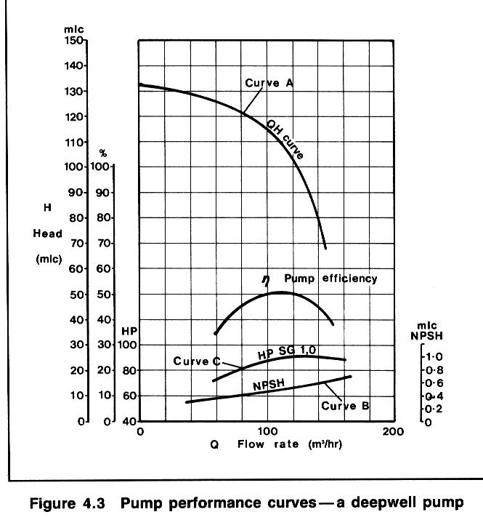

LIQUEFIED GAS HANDLING (EXTRACT)
7.5.5 Cargo tank loading limits
Chapter 15 of the IGC Code recognizes the large thermal coefficient of expansion of liquefied gas and gives requirements for maximum allowable loading limits for cargo tanks. This is to avoid tanks becoming liquid-full under conditions of surrounding fire.
The maximum volume to which any tank may be filled is governed by the following formula:
LL = FL x (pR/pL), where:
LL = loading limit expressed in per cent which means the maximum liquid volume relative to the tank volume to which the tank may be loaded.
FL = filling limit = 98 per cent unless certain exceptions apply.
pR = relative density of cargo at the reference temperature.
pL = relative density of the cargo at the loading temperature and pressure.
The reference temperature (in the expression pR above) is defined as the temperature corresponding to the vapor pressure of the cargo at the set pressure of the relief valves. Some pressurized ships with Type 'C' tanks have a pressure capability of up to about 18 bars with relief valves being designed for this pressure. These loading limits impose a substantial cargo shut-out for fully pressurized ships loading cargo when operating in ambient conditions, well below 45°C which is the maximum operating temperature for which the pressure capabilities of such tanks are designed.
In the case of cargo tanks on fully refrigerated ships, the Gas Codes envisage relief valves set to open only marginally above the vapor pressure of the cargo at the maximum temperature it will reach over the whole cycle of loading, transportation and discharge. Even so, the loading limit must be such that, if a surrounding fire occurs, the tank will not become liquid-full before the relief valve opens. Thus, the amount of cargo shut-out required, over and above the normal operational considerations of cargo expansion, depends upon the margin between the relief valve setting and maximum envisaged vapor pressure on the voyage.
There are good safety reasons for minimizing cargo shut-out. The concept is very simple. The fuller the tank, the longer the tank structure will be able to withstand fire conditions. The tank contents, when exposed to a fire will boil at a constant temperature until the bulk of the liquid has been vented through the relief valve system. After this the upper regions of the tank become exceedingly hot and eventually fail. However, the greater the mass of liquid inside the tank, the longer the tank can withstand unacceptable external temperatures.
Cargo quantities can be maximized by adjustable settings on relief valves. This brings its own problems — particularly for Type 'C' pressurized ships —where the pressure differential between saturation temperature at the maximum allowable pressure is considerable. Relief valves designed for, say, 18 barg do not perform well at the reduced pressures required to minimize shut-out. When operated at such settings, gases are ejected at velocities well below those associated with design pressures, and as a consequence, the effluent is not propelled clear of hazardous areas.
The Gas Codes permit a further alternative solution which obviates any cargo shut-out on loading beyond that of normal operational considerations of cargo temperature change. This solution requires the provision of an additional pressure relieving system with relief valves set to open at the maximum operational vapor pressure of the cargo. The system is brought into operation by the melting of fusible elements suitably located to detect surrounding fire conditions. It is not a popular or very practical solution.

New developments
In recent years IMO recognized that the problem of cargo shut-out on ships with pressurized tanks (Type 'C' tanks) had not been properly solved under the original Gas Code formulae. Either the fire protection afforded by full tanks or the ability of relief valves to project vented gases away from decks and structure is sacrificed.
Amendments to the Gas Codes in 1995 produced a solution which allows additional cargo to be loaded in Type 'C' tank ships. This concession can be granted to all Type 'C' carriers, except those designated by Chapter 19 of the IGC Codes as being 1G ships. These are specialized carriers transporting chlorine, ethylene oxide, methyl bromide and sulphur dioxide —see Appendix 2.
When the Gas Codes were first produced, it was recognized that tank relief valves were sized using empirical formulae based on experimental data from valve manufacturers. This data was based exclusively upon vapor flow. Although manufacturers had made allowances for liquid pick-up in vented gases, IMO decided tank relief inlets should never be exposed to liquid and to this end they required that tanks should never be more that 98 per cent full. This decision leads to the cargo shut-out illustrated by the worked examples.
Since the Gas Codes were first introduced, much work has been done on relief valve operation. It became apparent that with a tank at 98 per cent full, relief valve operation would inevitably involve both liquid and vapor in the vented stream. Such two-phase flow occurs even when tank levels are as low as 80 per cent. This implied that existing relief valves sized using valve manufacturers' methods can cope with all conditions of two-phase flow and still provide protection against over-pressure.
A further concern was dispelled when it was demonstrated that even with a tank 100 per cent full, when relief valves open, no jetting of liquid will occur at the vent riser. Much of this work was based on theoretical analysis made possible by an increased knowledge of the physics of two-phase flow. Theoretical work was backed by practical tests.
With this knowledge IMO decided to amend the Gas Codes as they relate to Type 'C' tanks. In Chapter 15 they added a change in the definition of the relative cargo density for this particular category of tank.
pR = relative density of cargo at the highest temperature which the cargo may reach upon termination of loading, during transport or at unloading, under the ambient design temperature conditions.
In the above definition the expression Ambient design temperature conditions is linked to the performance specification for temperature control of cargoes which states that the upper ambient design temperatures should be a sea temperature of 32°C and an air temperature of 45°C.
The Gas Codes further state that for service in especially hot or cold zones these design temperatures should be increased or reduced, as appropriate, by the national administration.
This allows the shipowner to demonstrate to the relevant national administration the rationale for the selection of the highest temperature.
In these new developments, IMO has retained the requirement for 2 per cent of tank volume to be a vapor space. The tank volume filling limit thus remains at 98 per cent.
Although accepting that pressure relief valves can cope with all aspects of two-phase flow, IMO recognizes that relief valve performance can be affected by the piping system within which it is installed. To this end, administrations will now require shipowners to demonstrate that ships taking advantage of increased loading have tank venting systems which are adequate to deal with all aspects of two-phase flow.
Guidelines which provide a method whereby the adequacy of the vent system can be assessed are now available as an IMO publication. New ships should use the Guidelines as design criteria and, for existing ships, they will demonstrate if modification to the vent system is required.
The advantages of these concessions are easily demonstrated. Considering Case 1 of the worked examples, should the ship concerned be on a long voyage and likely to encounter seas at 32°C and air temperatures of 45°C for prolonged periods the prediction of the highest cargo temperature then becomes, say, 38°C. Under these circumstances the Loading Limit becomes 92 per cent of tank volume. If however, it can be shown that the ship will operate in temperate waters and that the highest cargo temperature is 25°C, then the Loading Limit becomes 96 per cent. If in Case 1, the highest cargo temperature anticipated is 20°C, then the density ratio is unity and the Loading Limit 98 per cent. Furthermore, for cases 2 and 3 of the worked examples the Loading Limit normally becomes 98 per cent.
For shipowners to take proper advantage of these rules they should have performance details such that national administrations can understand how quickly a fully pressurized ship's cargo may warm up during the voyage. Additionally, a clear indication of the route which the ship will take and the ambient conditions existing along that route, will further justify the selected highest temperature.
This selection process deserves a more detailed appraisal than is possible in this book. Accordingly, IACS and SIGTTO have produced a joint publication entitled: Application of the Gas Carrier Code Amendments to Type 'C' Cargo Tank Loading Limits.

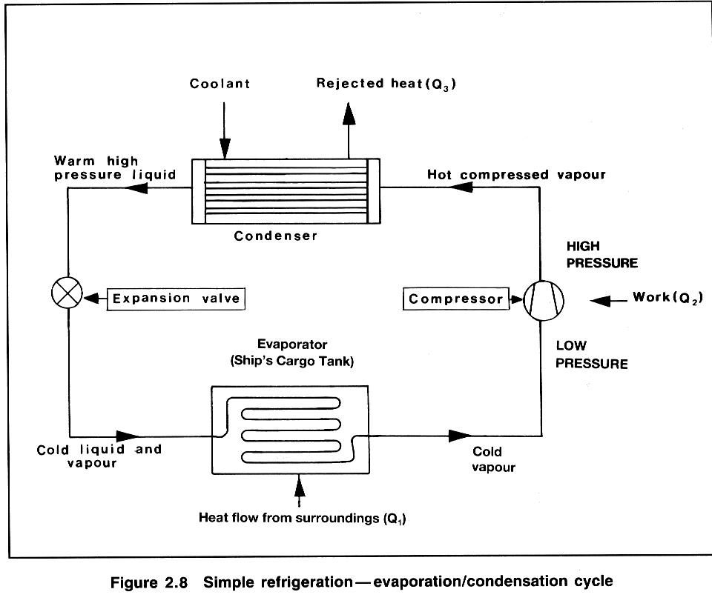
SIMPLE REFRIGERATION / EVAPORATION /
CONDENSATION CYCLE
In considering Figure 2. 8, if:
Q₁ is the heat flow rate from the surroundings into the evaporator
Q₂ is the heat-rate equivalent of work done on the vapour
by the compressor,
and Q₃ is the heat-rate rejected by the condenser
then, if the system were 100 per cent efficient: Q₁+Q₂=Q₃.

Плотность груза.
Основными единицами для подсчета количества груза на борту судна являются его плотность и объём. Используются следующие термины и понятия при определении плотности:
Истинная плотность, или же просто плотность вещества (Density), отображает массу единицы объёма данного вещества в ВАКУУМЕ. Стандартная размерность: кг/л, кг/м³, т /м³.
Реальная плотность (Apparent Density) отображает массу единицы объёма вещества в ВОЗДУХЕ. Стандартная размерность: кг/л, кг/м³, т/м³.
Относительная плотность (Relative Density) выражает отношение массы единицы объёма вещества в вакууме при определенной температуре к массе единицы объёма пресной воды в вакууме, также при определенной температуре. Величина БЕЗРАЗМЕРНАЯ.
Относительная плотность всегда дается с указанием температур, например R.D. 15/15, R.D. 20/4, R.D. 15/20, R.D. 60/60 F и т.д.Ниже приведена таблица истиной и реальной плотности воды при различных стандартных температурах:

Таблица 6. Истинная и реальная плотность воды.
Температура (°С) | Истинная плотность (кг/л) | Реальная плотность (кг/л)
4 | 1,00000 | 0,99888
15 | 0,99913 | 0,99805
15,56(60F) | 0,99904 | 0,99796
20 | 0,99823 | 0,99717
25 | 0,99707 | 0,99604
50 | 0,98807 | 0,98702

Для пересчета относительной плотности в истинную плотность при определенной температуре необходимо значение относительной плотности умножить на значение плотности воды при указанной температуре.

Расчет газовой фазы груза.
Масса паров в грузовом танке определяется также как и масса жидкой фазы груза - произведением плотности на объём. Самое важное, что необходимо запомнить раз и навсегда, и плотность и объём должны быть определены для одного и того же значения температуры. Для подсчета плотности паров используется основное уравнение газов:

pV = nRT или

m
pV = ⎯⎯⎯ ⋅ R ⋅ T
Mr
где р – давление абсолютное (Па);
V - объём (л);
Р_{м}_ давление манометрическое
n - число молей;
m - масса (кг);
Mr - молярная масса (кг/моль) ;
R - универсальная газовая постоянная (8,314 Дж/К);
Т - температура в градусах Кельвина.
Многие сюрвейерские организации для подсчета газовой фазы используют расчетное значение плотности газа:

288,15 1,01325 +p_{M}(bar) Mr
ρ = ⎯⎯⎯⎯⎯⎯ × ⎯⎯⎯⎯⎯⎯⎯ × ⎯⎯⎯⎯⎯
273,15 +t° C 1,01325 23,6451

эта формула верна для идеальных газов.
Для реальных же газов, формула примет иной вид:

288,15 1,01325 +p_{M}(bar) Mr 1
ρ = ⎯⎯⎯⎯⎯⎯ × ⎯⎯⎯⎯⎯⎯⎯ × ⎯⎯⎯⎯⎯ × ⎯⎯
273,15 +t° C 1,01325 23,6451 Z

где Z - фактор сжатия, который при нормальных условиях хранение и перевозки газов очень близок к 1.
Фактор сжатия является функцией от Рr и Тr, где:

Абсолютное давление паров
Рr=
Абсолютное критическое давление

Абсолютная температура паров
Tr = ⎯⎯⎯⎯⎯⎯⎯⎯⎯⎯⎯⎯⎯⎯⎯⎯⎯
Абсолютная критическая температура

В различных справочных пособиях значения фактора сжатия приводятся в графической форме в зависимости от температуры и давления.

Таблица 12. Таблица переводных коэффициентов.
 | Колонка 1 | Колонка 2 | Колонка 3
Название компонента | Молекулярный  вес | Объём жидкости в  ml при t 15,6°C  (60 F) и 760 mm Hg | Относительная плотность при  60/60 F
Methane | 16,04 | 0,00226 | 0,30
Ethane | 30,07 | 0,003566 | 0,3562
Ethylene | 28,05 | 0,0032 | 0,37
Propane | 44,10 | 0,003675 | 0,5070
Propylene | 42,08 | 0,003413 | 0,5210
Propadiene | 40,06 | 0,00282 | 0,600
Methylacetylene | 40,06 | 0,00273 | 0,621
n-Butane | 58,12 | 0,004205 | 0,5840
i-Butane | 58,12 | 0,004362 | 0,5629
1-Butene | 56,11 | 0,003944 | 0,6011
trans-2-Butene | 56,11 | 0,003887 | 0,6100
cis-2-Butene | 56,11 | 0,003780 | 0,6272
1,2-Butadiene | 54,09 | 0,00347 | 0,658
1,3-Butadiene | 54,09 | 0,003643 | 0,6272
Ethylacetylene | 54,09 | 0,00328 | 0,696
n-Pentane | 72,15 | 0,004830 | 0,6311
i-Pentane | 72,15 | 0,004879 | 0,6247
neo-Pentane | 72,15 | 0,005108 | 0,5967
1-Pentene | 70,13 | 0,004589 | 0,457
trans-2-Pentene | 70,13 | 0,004537 | 0,6530
cis-2-Pentene | 70,13 | 0,004482 | 0,6611
2-methyl-l-Butene | 70,13 | 0,004519 | 0,6557
3-methyl-l-Butene | 70,13 | 0,004684 | 0,6325
2-methyl-2-Butene | 70,13 | 0,00447 | 0,663
Cyclopentane | 70,13 | 0,003948 | 0,7505
Isoprene | 68,12 | 0,004195 | 0,6861
Подсчет линейной скорости потока жидкости.
Для предотвращения образования заряда статического электричества из-за свободного падения жидкости в танк и её разбрызгивания в начальный момент погрузки, необходимо обеспечить поступление груза с линейной скоростью потока не более чем 1 м/с. К сожалению, терминалы не оборудуются датчиками, фиксирующими линейную скорость потока. Все существующие динамические счетчики груза (Flowmeter) определяют лишь объёмные характеристики потока груза или же весовые. Поэтому определение объёмной или весовой интенсивности налива для грузов, аккумулирующих статическое электричество, лежит на грузовом помощнике. По международным требованиям, максимальная интенсивность налива, для такого рода грузов, также ограничена линейной скоростью потока в 7 м/с.
Расчеты объёмной скорости потока в трубопроводе по известной линейной его скорости весьма просты:
Объём 1 погонного метра трубопровода • скорость потока • 3600 = м^{э}/час.
И, наоборот, зная интенсивность налива в объёмных единицах, можно легко определить линейную скорость потока:
м^{э}/час : 3600 : объём погонного метра трубопровода - скорость, м/с
Существуют специальные таблицы для облегчения таких расчетов. Ниже приведена таблица объёмов одного погонного метра трубопровода в зависимости от диаметра.

Таблица 13. Объём погонного метра трубопровода в зависимости от его диаметра.
Номинальный диаметр Дюймы | Внутренний диаметр, дюймы | И мп. Галл он на фут | Амер. Галлон на Фут | Литр на метр | Баррель на милю
2 | 2,067 | 0,1451 | 0,1743 | 2,165 | 22
2,5 | 2,469 | 0,2071 | 0,2487 | 3,089 | 31
3 | 3,068 | 0,3198 | 0,3540 | 4,769 | 48
4 | 4,026 | 0,5507 | 0,6613 | 8,213 | 83
6 | 6,065 | 1,250 | 1,501 | 18,64 | 189
8 | 8,071 | 2,213 | 2,658 | 33,01 | 334
10 | 10,192 | 3,529 | 4,238 | 52,63 | 533
12 | 12,090 | 4,966 | 5,964 | 74,06 | 749
14 | 13,250 | 5,964 | 7,163 | 88,96 | 900
16 | 15,250 | 7,901 | 9,489 | 117,84 | 1.192
18 | 17,250 | 10,109 | 12,140 | 150,77 | 1.525
20 | 19,250 | 12,589 | 15,119 | 187,76 | 1.900
24 | 23,250 | 18,370 | 22,062 | 273,99 | 2.772
* Объём рассчитан по внутреннему диаметру трубопровода

Перевозка совместимого груза. (COMPATIBLE TRADE)
Так называемые подобные грузы, совместимы с предыдущим грузом и не теряют своего качества при смешивании с парами и/или жидкими остатками предыдущего груза. Примером таких грузов могут служить Пропан, Бутан, Этан и их смеси, используемые для бытовых нужд. Так, смена груза с Бутана на Пропан, не требует выполнения каких либо сложных операций по подготовке грузовых танков и систем. В большинстве случаев погрузка следующего груза может осуществляться «под пары» предыдущего груза. Однако, даже при перевозке таких совместимых грузов, существует потенциальный риск порчи груза из-за того, что остатки предыдущего груза
превышают некоторые допустимые пределы и снижают качество перевозимого груза. Так, даже простейшая подготовка танков под перевозку совместимых грузов, может превратиться в ночной кошмар при выгрузке.

TASKS

Пример 1:
В дек-танке находится 22 тонн сжиженного этилена (С₂H₄). Необходимо определить, достаточно ли на борту груза для того, чтобы продуть три грузовых танка объёмом 5000 м³ каждый, если после продувки температура танков будет составлять 0°С, а давление 1013 миллибар.
Решение:
1. Определяем молекулярную массу этилена
М = 2 • 12,011 + 4 • 1,0079 = 28,054 г/моль;
2. Рассчитываем плотность паров этилена при нормальных условиях:
р = М/V_{m} = 28,054 : 22,4 = 1,252 г/л;
3. Находим объём паров груза при нормальных условиях:
22 x 10⁶: 1,252 = 27544м³
Обший объём грузовых танков составляет 15000 м³. Следовательно, на борту достаточно груза, для того чтобы продуть все грузовые танки парами этилена.

Пример 2:
Необходимо определить, какое количество пропана (С₃Н₈) потребуется для продувки грузовых танков обшей вместимостью 8000 м³, если температура танков составляет +15° С, а давление паров пропана в танке после окончания продувки не будет превышать 1013 миллибар.
Pешение:
1. Определим молярную массу пропана С₃Н₈:
М = 3 х 12,011т + 8 - 1,0079 = 44,1 г/моль.
2. Определим плотность паров пропана после продувки танков:
р = М : v = 44,1 : 23,641 = 1,865 кг/м³.
3. Зная плотность паров и объём, определяем общее количество пропана, необходимое для продувки танка:
m = р • v = 1,865 8000 = 14920 кг = 15 т.

Пример 3:
Определим объёмную концентрацию бутана в воздухе, если известно, что его весовая концентрация составляет 876 мг/м³.
Решение: С(ррм) = (24,1 : 58,1) - 876 = 363 ррм (или мл/м³)

Пример 4:
Решим обратную задачу. По известной объёмной концентрации 364 ррм токсина (Бутана) в воздухе, определим его весовое соотношение в атмосфере.
Решение: С(мг/м³) = (58,1 : 24,1)- 363 = 876 мг/м³

Пример 5:
Воздух имеет температуру +20°С, какое максимальное количество паров воды он может содержать?
Решение: Из таблицы 2 выбираем значение максимального содержания паров воды в воздухе при данной температуре = 17,7 г/м³.

Пример 6:
Воздух при температуре +30°С содержит 13 г/м³ паров воды. До какой температуры необходимо охладить воздух, чтобы началась конденсация паров и сколько свободной воды образуется при охлаждении воздуха до -10°С.
Решение:
Из таблицы 2 выбираем значение температуры, соответствующее данному содержанию насыщенных паров в воздухе =15°С. Далее находим максимальное содержание паров воды при температуре -10°С (из таблицы) = 2,15 г/м³.
Для определения количества воды, которое может образоваться при охлаждении воздуха с заданной влажностью, определяем разницу между значением влажности воздуха при заданной температуре и содержанием паров при температуре охлаждения:
13 г/м³ - 2,15 г/м³ = 10,85 г/м³ т.е. из каждого кубометра воздуха образуется 10,85 грамм воды.

Пример 7:
Масса воздуха при +10°С содержит 5 г/м³ паров воды. Определить относительную влажность воздуха.
Решение:
Из таблицы 2 находим, что при температуре +10°С максимальное содержание паров воды в воздухе равно 9,3 г/м³. Значит относительная влажность составит (5 г/м³ • 100%) : 9,3 г/м³ = 53,8%.
Пример 8:
Атмосфера танка объёмом в 1.000 м³ при +25°С имеет относительную влажность 75%. Какое количество свободной воды образуется в танке при его охлаждении до -40°С.
Решение:
При +25°С максимальное содержание паров в воздухе, выбранное из таблицы 2 составит 23,5 г/м³, следовательно при относительной влажности 75% содержание паров воды будет: (23,5 г/м³ х 75%) : 100% = 17,625 г/м
далее из таблицы находим максимальное количество паров воды при температуре -40°С = 0,120 г/м³. Определяем содержание свободной воды при температуре —40°С: 17,625 г/м³ - 0,120 г/м³ = 17,505 г/м³
всего же в атмосфере танка образуется свободной воды: 17,505 г/м³ х 1.000 м³ = 17.505 г = 17,5 кг

Пример 9:
Температура точки росы в танке объёмом 5.000 м³ определена как -20°С. В танк должен быть погружен пропан при температуре —41°С. Сколько льда образуется в танке после погрузки?
Решение:
Содержание паров воды при -20°С = 0,92 г/м³
Содержание паров воды при -41 °С = 0,11 г/м³
Свободной воды/льда в танке = 0,81 г/м³
Всего образуется льда 0,81 г/м³ х 5.000 м³ = 4.050 г = 4,0 кг.

Таблица. 2. Таблица зависимости плотности насыщенного водяного пара от температуры.
t,°C | ρ | t,°C | ρ | t,°C | ρ
-50 | 0,038 | --19 | 1,01 | +12 | 10,60
-49 | 0,43 | -18 | 1,10 | +13 | 11,34
-48 | 0,048 | -17 | 1,20 | +14 | 12,14
-47 | 0,055 | -16 | 1,30 | +15 | 13,00
-46 | 0,061 | -15 | 1,40 | +16 | 13,88
-45 | 0,068 | -14 | 1,52 | +17 | 14,79
-44 | 0,075 | -13 | 1,66 | +18 | 15,73
-43 | 0,084 | -12 | 1,81 | +19 | 16,70
-42 | 0,094 | -11 | 1,97 | +20 | 17,70
-41 | 0,106 | -10 | 2,15 | +21 | 18,80
-40 | 0,119 | -9 | 2,34 | +22 | 19,90
-39 | 0,132 | -8 | 2,54 | +23 | 21,00
-38 | 0,145 | -7 | 2,75 | +24 | 22,20
-37 | 0,162 | -6 | 2,97 | +25 | 23,50
-36 | 0,180 | -5 | 3,20 | +26 | 24,80
-35 | 0,200 | -4 | 3,46 | +27 | 26,30
-34 | 0,220 | -3 | 3,74 | +28 | 27,80
-33 | 0,245 | -2 | 4,04 | +29 | 29,30
-32 | 0,275 | -1 | 4,38 | +30 | 31,00
-31 | 0,305 | 0 | 4,70 | +31 | 32,80
-30 | 0,340 | +1 | 5,07 | +32 | 34,80
-29 | 0,380 | +2 | 5,46 | +33 | 36,90
-28 | 0,420 | +3 | 5,87 | +34 | 39,10
-27 | 0,460 | +4 | 6,30 | +35 | 41,50
-26 | 0,510 | +5 | 6,75 | +36 | 43,70
-25 | 0,560 | +6 | 7,22 | +37 | 45,90
-24 | 0,610 | +7 | 7,71 | +38 | 48,10
-23 | 0,670 | +8 | 8,22 | +39 | 50,30
-22 | 0,750 | +9 | 8,75 | +40 | 52,50
-21 | 0,830 | +10 | 9,30 | +45 | 67,00
-20 | 0,920 | +11 | 9,92 | +50 | 83,00

Пример 10:
Какой объём займут 96 г кислорода при 3-х (300.000 Па) барах давления и температуре +77°С.
Решение:
1. Прежде всего, определим, сколько молей составляют 96 г кислорода.
В периодической таблице элементов мы видим, что атомная масса кислорода составляет 15,9994. Это значит, что один моль кислорода (6,02 • 10²³ атомов) будет иметь массу ~16 г. Соответственно молекула кислорода, состоящая из 2-х атомов, будет иметь массу 32 г/моль.
2.. Далее нам надо определить, сколько молей кислорода составляет 96 г.
$\text{pV}=\frac{m}{M}⋅R⋅T$$V=\frac{m⋅R⋅T}{P}$96 г : 32 г/моль = 3 моль,
3. Теперь, используя Уравнение Менделеева-Клайперона, мы можем определить объём:
заметим, что Дж = H • м, а Па = Н/м²

Пример 11:
Определим, какое количество паров (масса) содержится в танке объёмом 5.000 м³ после выгрузки бутана (С4Ню), если манометрическое давление в танке составляет 0,1 бара, а температура +5°С?
$\text{pV}=\frac{m}{M}⋅R⋅T$Решение:
Из уравнения состояния идеального газа
$m=\frac{p⋅V⋅\text{Mr}}{R⋅T}$
Определим искомую величину (1)

Для нашего примера давление р будет равно сумме манометрического и атмосферного давлений р = 1013 мбар +100 мбар = 1,11 бар или же 1,11•10⁵ Па, а температура Т = 273 + 5° С.
Подставляя известные величины в выражение (1) получим массу паров бутана, оставшихся в грузовом танке после выгрузки сжиженного газа.
m = 1,11 •10⁵ • 5 • 10³ • 58,1 = 0.0138 • 10 ⁸ кг = 13,8 тонн.
8,31434 • 278

Пример 12:
Смешиваются 5 кг пропана при температуре t_{p} = - 40°C и 8 кг бутана при температуре t_{b} = +2°С. Удельная теплоёмкость пропана с_{р} = 2476 Дж/кг•К, а для бутана с_{b} = 2366 Дж/кг•К. Определим температуру смеси газов (Т_{m})
Решение:
Ясно, что Т_{b} > Т_{m} > Т_{p} и можно записать ΔT_{p} = (Т_{m}-Т_{р}), а для бутана ΔT_{b} = (Т_{b}-Т_{m})
для нашего случая ΔT_{p} = (Т_{m}-233) ΔT_{b} = (275 – Т_{m})
рассчитаем температуру смеси по формуле (1):
m_{р} • c _{p} • ΔT_{p} = m_{b} • с_{b} • ΔT_{b}
5 • 2476 • (Т_{m} -233) = 8 • 2366 • (275 - Т_{m})
12380-T_{m}-2884540 = 5205200 -18928 • Т_{m}
31308 • Т_{m} = 8089740
Т_{m} = 8089740
31308
Т_{m} = 258,39
Т_{m} = 258,4- 273 = -14,6°С
В общем случае расчет температуры смеси можно выразить формулой:
Т_{m} = m₁ c₁ T₁ + m₂ c₂ T₂
m₁ c₁ + m₂ c₂

Пример 13:
Судно должно погрузить смесь 100 тонн пропана и 400 тонн бутана, температура смеси составляет - 8°С (смотри расчет температуры смеси газов). Давление насыщенных паров для пропана при этой температуре, определенное по графику или взятое из таблицы, составляет 3,69 бара. А давление насыщенных паров бутана, составит при этой температуре 0,78 бара. Необходимо определить давление насыщенных паров смеси (то есть общее давление в танке) и процентный состав газовой фазы над поверхностью жидкости.
Решение:
Рассчитаем молярное соотношение пропана и бутана в составе смеси. Для этого определим молярную массу пропана (С₃Н₈) и бутана (С₄H₁₀) . С помощью периодической таблицы элементов находим, что один атом углерода имеет массу 12,01115 г/моль, а атом водорода- 1,00797 г/моль.
Молярная масса пропана: 12,01115 г/моль • 3 + 1,00797 г/моль • 8 = 44,09721 г/моль ≈ 44,1 г/моль,
молярная масса бутана: 12,01115 г/моль • 4 + 1,00797 г/моль • 10 = 58,1243 г/моль ≈ 58,1 г/моль
Теперь определим количество молей каждого вещества в смеси. Соотношение масс пропана и бутана 100 тонн : 400 тонн, но если использовать не тонны, а граммы, то соотношение останется тем же самым 100г : 400г. Расчет количества вещества (молей) будем производить по соотношению:
п = т/Мr, где n- число молей, Mr - молярная масса, m - масса вещества.
число молей пропана: 100 г : 44,1 г/моль = 2,27 моль
число молей бутана: 400 г : 58,1 г/моль= 6,88 моль
общее число молей смеси 9,15 моль
Рассчитаем парциальное давление пропана и бутана, используя закон Рауля:
молярный состав пропана в жидкой фазе: $\frac{2,\text{27}}{9,\text{15}}=0,\text{248}$ → 24,8%
молярный состав бутана в жидкой фазе: $\frac{6,\text{88}}{9,\text{15}}=0,\text{752}$→ 75,2 %
парциальное давление пропана составит: 0,248 • 3,69 бар = 0,915 бар
парциальное давление бутана составит: 0,752 • 0,78 бар = 0,587 бар
давление насыщенных паров смеси 1,502 бар
давление в танке (манометрическое) ≈ 0,5 бар
Состав смеси в газовой фазе (над поверхностью жидкости) можно рассчитать следующим образом:
Содержание пропана в газовой фазе: 0,915 бар : 1,502 бар = 0,609 → 60,9 %
Содержание бутана в газовой фазе: 0,587 бар : 1,502 бар = 0,391 → 39,1 %
Как можно видеть, газ, всасываемый компрессором в систему повторного сжижения, состоит на 60,9% из паров пропана и на 39,1% из паров бутана, несмотря на то, что в жидкой фазе пропана содержится всего 24,8%.

Пример 14:
Определить количество теплоты, которое проникает через изоляцию одного грузового танка судна вместимостью 75000 м³. Танк изолирован полиуретановой пеной, наполненной фреоном, толщиной 100 мм, тепловоспринимающая поверхность танка 690 м². Температура окружающей среды составляет +30°С, а температура груза -40°С.
Решение:
Из таблицы 3 выбираем значение удельной теплопроводности полиуретановой пены, — 0,023 Вт/м •К.
Подставим известные нам значения в формулу: Q= (0,023 690 • 70) : 0,1 = 11109 Вт = 11,11 кВт
Если произойдет отделение изоляции танка от его переборок (например, при образовании льда между переборкой танка и изоляцией), то приток тепла будет значительно больше, поскольку в том месте, где отстала изоляция сталь будет единственным изоляционным материалом между грузом и окружающей средой. Как можно найти из таблицы, удельная теплопроводность стали составляет 50,2 Вт/м-К. При толщине стали 20 мм, приток тепла в танк составит:
Q = (50,2- 690 • 70) : 0,02 = 121233000 Вт = 121233 кВт.
Как видим, приток тепла через переборку танка будет на несколько порядков выше, чем приток тепла через 10 см слой изоляции. Правда этот расчет не является реалистичным, поскольку на практике мы не сталкиваемся с тем, чтобы вся изоляция танка отвалилась. Даже в таком, гипотетическом случае, на внешней поверхности танка будет образовываться слой льда, который будет выполнять роль своего рода изолирующего материала. В этом случае приток тепла в танк будет значительно ниже.

Таблица 3. Теплофизические характеристики некоторых материалов.
Тип изоляции | Теплопроводность, Вт/м•К | Плотность, Кг/м³ | Теплоёмкость, кДж/кг•К
Неподвижный воздух | 0,024 | 1,29 | 1,0
Полистирол (пена) | 0,038 | 25 | 1,34
Эбонит (разрыхленный) | 0,029 | 65 | 1,38
Полиуретан (пена) | 0,023 | 40 | 1,26
PVC (пена) | 0,033 | 40 | 1,34
Бакелит | 0,041 | 32 | 1,34
Стекловата (в mатах) | 0,035 | 20 | 0,84
Стекловата насыпью | 0,041 | 60 | 0,84
Минеральная вата в матах | 0,035 | 45 | 0,84
Минеральная вата насыпью | 0,041 | 100 | 0,84
Перлит | 0,035 | 50 | 0,84
Сталь | 50,2 | 7800 | 0,46

Пример 15:
Проведите линию, соответствующую давлению в 2 бара (0,2 Мра) через участок диаграммы, отражающий смену фаз (рис. 13). Найдем энтальпию для 1 кг кипящего пропана при абсолютном давлении 2 бара.
Решение:

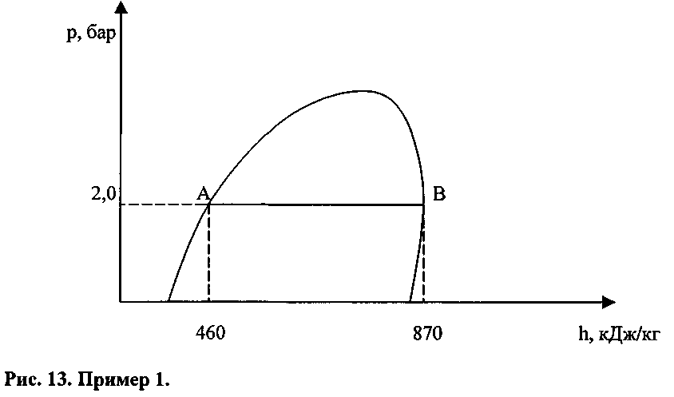

Кипящий жидкий пропан характеризуется левой кривой диаграммы. В нашем случае это будет точка «А». Проведя из точки А вертикальную линию к шкале h, мы определим значение энтальпии, которое составит 460 кДж/кг. Это означает, что каждый килограмм пропана в данном состоянии (в точке кипения при давлении 2 бара) обладает энергией в 460 кДж. Следовательно, 10 кг пропана обладают энтальпией 4.600 кДж. Далее определим величину энтальпии для сухого насыщенного пара пропана при том же давлении в 2 бара. Для этого проведем вертикальную линию из точки «В» до пересечения со шкалой энтальпии. В результате найдем, что максимальное значение энтальпии для 1 кг пропана в фазе насыщенных паров составит 870 кДж. Внутри диаграммы линии, направленные из точки критического состояния газа вниз, отображают количество частей газа и жидкости в фазе перехода. То есть 0,1 означает, что смесь содержит 1 часть паров газа и 9 частей жидкости. В точке пересечения давления насыщенных паров и этих кривых мы определим состав смеси.(её сухость или влажность) Температура перехода постоянна в течение всего процесса конденсации или парообразования. Если пропан находится в замкнутой системе (в грузовом танке), в ней присутствуют и жидкая и газообразная фазы груза. Можно определить температуру жидкости, зная давление паров, давление паров по температуре жидкости. Давление и температура связаны между собой, если жидкость и пар находятся в равновесном состоянии в замкнутой системе. Заметим, что кривые температуры, расположенные в левой части диаграммы, следуют почти вертикально вниз, пересекают фазу парообразования в горизонтальном направлении, и в правой части диаграммы опять опускаются вниз почти вертикально.

Пример 16:
Предположим, что мы имеем 1 кг пропана в стадии смены фаз (часть пропана жидкость, а часть - пар). Давление насыщенных паров составляет 7,5 бар, а энтальпия смеси (пар-жидкость) равна 635 кДж/кг. Необходимо определить, какая часть пропана находится в жидкой фазе, а какая в газообразной?
Решение:
Отложим на диаграмме, прежде всего известные величины, давление паров 7,5 бар и энтальпию 635 кДж/кг. Далее мы можем определить, что точка пересечения давления и энтальпии лежит на кривой, которая обозначена 0,2. А это, в свою очередь означает, что мы имеем пропан в стадии кипения и 2 (20%) части пропана находятся в газообразном состоянии, а 8 частей (80%) находятся в жидком состоянии.

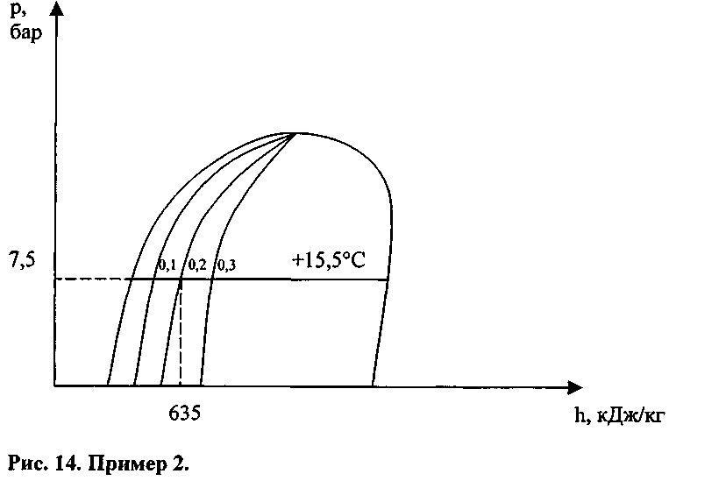
Также можно определить температуру жидкости, которая составляет 60°F или же +15,5°С (для перевода температуры мы будем использовать таблицу термодинамических характеристик пропана).
Чтобы найти давление в танке (манометрическое давление) необходимо помнить, что оно меньше давления насыщенных паров (абсолютного давления) на величину атмосферного давления, равного 1.013 мбар. В дальнейшем для упрощения расчетов мы будем использовать значение атмосферного давления равное 1 бару. То есть в нашем случае давление насыщенных паров или абсолютное давление равно 7,5 бар, то манометрическое давление в танке составит 6,5 бар.
Ранее уже упоминалось, что жидкость и пары в равновесном состоянии находятся в замкнутой системе при одной и той же температуре. Это верно, однако на практике можно заметить, что пары, находящиеся в верхней части танка (в куполе) имеют температуру значительно выше, чем температура жидкости. Это обусловлено нагревом танка. Однако, такой нагрев не влияет на давление в танке, которое соответствует температуре жидкости (точнее сказать температуре на поверхности жидкости). Пары непосредственно над поверхностью жидкости имеют ту же самую температуру, что и поверхность жидкости, и, как раз на поверхности жидкости, и происходит смена фаз вещества.
Как видно (рис. 11-14), на диаграмме Молье кривые плотности направлены из левого нижнего угла диаграммы «сачка» в правый верхний угол. Значение плотности в диаграмме может быть дано в lb/ft³. Для пересчета в СИ используется переводной коэффициент 16,02 (1,0 lb/ft³ = 16,02 кг/м³).

Пример 17:
В этом примере будем использовать кривые плотности. Требуется определить плотность перегретого пара пропана при абсолютном давлении 0,95 бара и температуре +49°С (120°F). Также определим удельную энтальпию этих паров.
Решение:

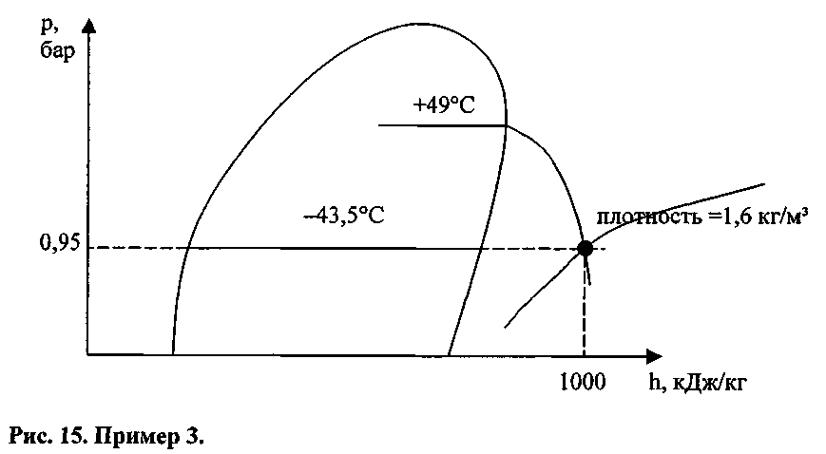

Процесс определения искомых параметров виден из рис 15. В наших примерах используются термодинамические характеристики для одного газа - пропана. В подобных расчетах для любого газа меняться будут только абсолютные величины термодинамических параметров, принцип же остается тот же самый для всех газов.
В дальнейшем для упрощения, большей точности расчетов и сокращения времени будем использовать таблицы термодинамических свойств газов. Практически вся информация, заложенная в диаграмму Молье, приведена в табличной форме.
С помощью таблиц можно определить численное значение параметров груза, но трудно представить себе как идет процесс охлаждения, если не использовать хотя бы схематичное отображение диаграммы. «р - h» .

Пример 18:
В грузовом танке при температуре -20°С находится пропан. Необходимо определить как можно точнее давление газа в танке при данной температуре. Далее необходимо определить плотность и энтальпию паров и жидкости, а также определить разность энтальпии между жидкостью и парами. Пары над поверхностью жидкости находятся в состоянии насыщения при той же температуре, что и сама жидкость. Атмосферное давление в нашем случае составляет 980 миллибар. Необходимо нарисовать упрощенную диаграмму Молье и отобразить все параметры на ней.
Решение:
Используя таблицу, определяем давление насыщенных паров пропана. Абсолютное давление паров пропана при температуре -20°С - 2,44526 бар. Давление в танке будет равно:

Абс. давление (2,44526 бар) - атм. давление (0,980 бар) = Давлению в танке (избыт. или маном. давл.) (1,46526 бар)

В колонке, соответствующей плотности жидкости находим, что плотность жидкого пропана при -20°С составит 554,48 кг/м³. Далее находим в соответствующей колонке плотность насыщенных паров, которая равна 5,60 кг/м³. Энтальпия же для жидкости составит 476,2 кДж/кг, а для паров 876,8 кДж/кг. Соответственно разность энтальпии составит (876,8 - 476,2) = 400,6 кДж/кг.
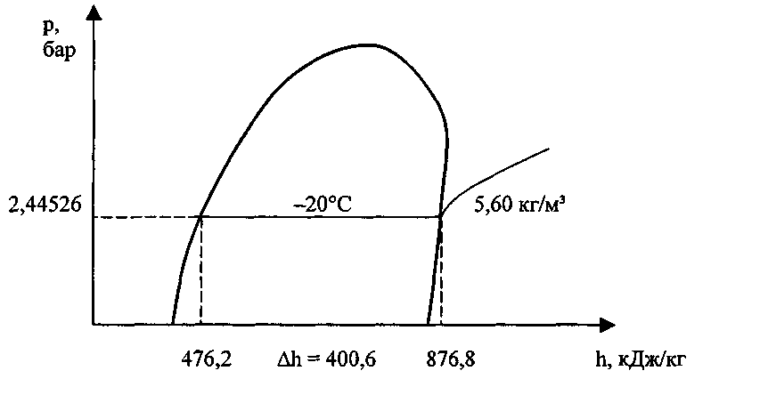

Пример 19.
Расчет времени работы УПСГ для понижения температуры груза до заданной величины.
Груз: пропан, 1.000 тонн Температура груза в танке: -5°С Температура всасывания компрессора: +6°С Давление нагнетания компрессора: 6,95 бара Температура нагнетания компрессора: t_{H}= +55°С Подача компрессора (производительность): 350 м³/час Заданная температура груза: -10°С Атмосферное давление: 1 бар.
Решение:
Для упрощения решения задачи, разделим расчет времени работы УПСГ на 2 этапа:
А - построение цикла установки по исходным данным. Б - расчет времени работы установки.

А - Построение цикла (рис. 5).
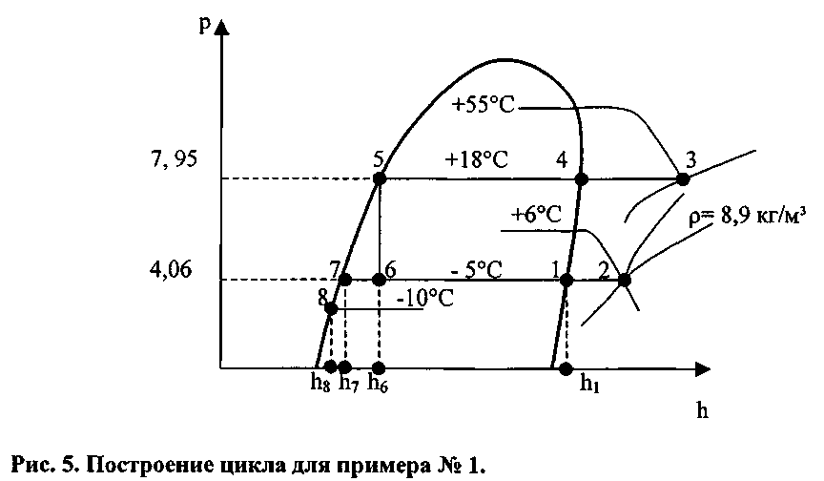

По температуре груза в танке - 5 ° С определяем абсолютное давление всасывания р₀ = 4,06 бар (абс) и наносим на диаграмму Молье нижнюю барометрическую границу цикла.
По давлению нагнетания компрессора р_{н} = 6,95 бара (манометрическое)
наносим верхнюю барометрическую границу цикла р_{к} = 7,95 бара (абс)
На пересечении изобары р₀ = 4,06 бара и изотермы t_{BC} = +6°C определяем точку 2, характеризующую состояние паров на всасывании компрессора. Поскольку использование диаграммы Молье, имеющейся в судовой документации, представляет некоторые трудности из-за мелкого масштаба, то для решения задач проще использовать таблицы или графики термодинамических характеристик грузов. В нашем случае плотность перегретых паров определяется по соответствующему графику, вход в который производится по нижней шкале (температура паров). На левой шкале (плотность пара) выбирается значение в кг/м³, соответствующее точке пересечения значения температуры и кривой абсолютного давления паров.
Пересечение изобары р_{к} = 7,95 бара и изотермы нагнетания t_{H} = +55°C, дает точку 3, оценивающую состояние паров груза после их сжатия в компрессоре.
Точки 4 и 5 лежат на пересечении верхней барометрической границы цикла с правой и левой пограничными кривыми, соответственно.
Наконец, точка 6, характеризующая состояние парожидкостной смеси, сбрасываемой в грузовой танк, лежит на пересечении перпендикуляра, опущенного из точки 5 на нижнюю барометрическую границу цикла. Через эту точку проходит линия постоянного паросодержания X = 0,18, по которой можно оценить эффективность работы рассматриваемой УПСГ. Даже при весьма благоприятных внешних температурных факторах t_{K} = +18°С (определяется по давлению конденсации) и to = -5°C, всего лишь 82% от общего количества всасываемого пара, возвращается в танк в виде жидкости, остальная же часть - в виде пара. Состояние жидкости в грузовом танке оценивается точкой 7, лежащей на пересечении to= -5°C с левой пограничной кривой.

Б - Расчет времени.
Время Т, необходимое для понижения температуры груза до заданной, определяется как частное от деления общего количества теплоты, которую необходимо отвести из груза Q_{OTB} на холодопроизводительность УПСГ Q₀ (в терминологии холодильной техники)
τ = Q_{овт} / Q₀
Удельная энтальпия жидкого пропана при температуре t₀ = -5°C h₇ = 511,6 кДж/кг (из таблиц), а удельная энтальпия жидкого пропана при t_{зад} = -10°С h₈ = 499,5 кДж/кг. Точка 8 находится на пересечении изотермы t_{зад} = -10°С с левой пограничной кривой. Количество теплоты, которое необходимо отвести из груза, чтобы понизить его температуру до заданной величины, составит:
Q_{овт} = (h₇ - h₈) • m_{г} = (511,6 - 499,5) • 1000-10³кг = 12.100-10³кДж
Количество же теплоты, необходимое для преобразования 1 кг парожидкостной смеси в точке 6 в насыщенный пар в точке 1, определяется как разность энтальпий (h₁- h₆). Поэтому холодопроизводительность установки будет равна:
Q₀ = (h₁- h₆) • V_{s} • p_{s},
где V_{s} - подача компрессора,
p_{s}- плотность пара на всасывании компрессора (точка 2).
Плотность пара можно определить или по диаграмме Молье, что достаточно неточно, используя уравнение состояния идеального газа, или же из таблиц и графиков (приложение 1).
Q₀ = (893,2 - 570,2) • 350 • 8,3 = 938.315кДж/час
Итак, время, необходимое для понижения температуры пропана от -5°С до -10°С составит:
τ = Q_{овт} / Q₀= (12.100-10³):938.315 = 12,9 ч ~ 13 часов.

Пример 20.
Расчет работы одноступенчатой УПСГ с регенеративным теплообменником (РТО) для понижения температуры груза до заданных параметров (рис. 6).

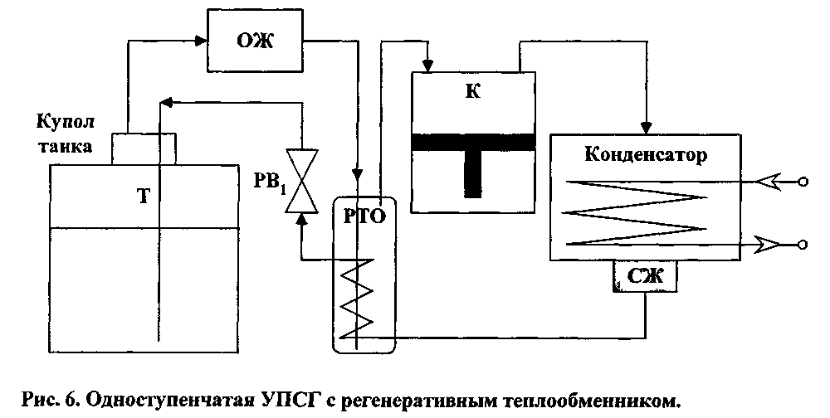

В расчетах будем использовать данные предыдущего примера.
Как уже упоминалось, эффективность работы любой УПСГ определяется тем, какая часть всасываемого пара возвращается в танк в виде жидкого груза. Для увеличения возврата массовой доли сжиженного газа в грузовой танк используется переохлаждение конденсата, когда фактическое давление в конденсаторе превышает давление насыщенного пара для данной температуры перед его дросселированием в регулирующем клапане.
Наиболее простое конструктивное решение идея переохлаждения конденсата нашла в установке в систему сжижения регенеративного теплообменника (РТО). Конденсат направляется из ресивера в РТО по змеевику, который охлаждается холодными парами груза (с температурой, соответствующей температуре груза в танке). Пусть переохлаждение конденсата в РТО достигает 10°С. Тогда для наших значений температура жидкого пропана на выходе из РТО составит +8°С и, соответственно энтальпия h₉ = h_{6’} = 544,2 кДж/кг (рис. 7).
Изменение цикла работы одноступенчатой УПСГ показано на диаграмме Молье линией (5-5') - переохлаждение конденсата в РТО, (5'-6') - дросселирование в РВ, (2-2') - дополнительный перегрев пропана в РТО, (2'-3') - сжатие в компрессоре.
Как видно из рисунка 7 переохлаждение конденсата смещает точку (6), характеризующую состояние возвращаемой в танк парожидкостной смеси, влево, увеличивая тем самым в ней относительную массу возвращаемой жидкости до 90 %.
Изменение цикла УПСГ вызывает рост её холодопроизводительности, что сокращает время, необходимое для понижения температуры груза до заданных параметров.
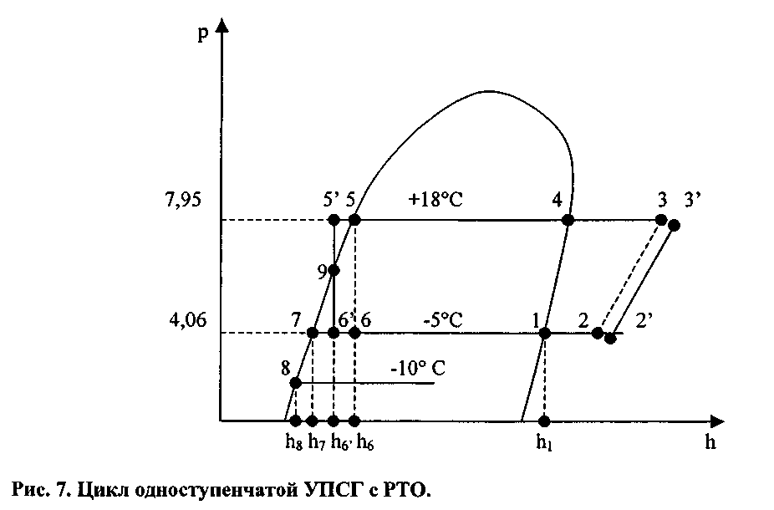
Подставив новые численные значения энтальпии h₆' в формулу для определения холодопроизводительности установки, мы получим:
Q₀ = (h₁-h₆.) • Vs • _{Ps} = (893,2-544,2) • 350 • 8,3 = = 1.013.845кДж/час
время, необходимое для понижения температуры груза с -5°С до -10°С составит:
τ = Q_{овт} / Q₀= (12.100 • 10³) : 1.013.845 = 11,9 часа.

То есть, 1 час мы сэкономили на понижение температуры в танке при использовании РТО.
Согласно правилам технической эксплуатации судовых УПСГ, при нормальной работе грузового конденсатора температура конденсации груза t_{K}

t _{к} = t_{з.в.ср.} + ( 6 – 7)° C.

а температура забортной воды t_{з.в.ср} t_{вх} - t_{вых}
t_{з.в.ср = ⎯⎯⎯⎯⎯}
2

Пример 21.
Анализ барометрических границ различных режимов работы одноступенчатой УПСГ.
1) Температура перевозки пропана to= -5°C, а температура забортной воды в конденсаторе t₃ _{B} ⁼ +8°С, для такой температуры воды температура конденсации пропана составит t_{K} = t_{3.B}. + 10°С = 17°С.
Из таблиц термодинамических характеристик пропана, находим:
t_{K} = +18°C => p_{К} = 7,95 бар
t₀ = - 5°C => p₀ = 4,06 бар
Отсюда Δр = p_{К} - po = 3,89 бар < Δp_{доп}. = 6,5 бар.
Как видно из примера, работа одноступенчатой УПСГ на пропане протекает для установленного температурного режима в нормальном режиме.
2) Температура перевозки пропана to = -40°C, а температура забортной воды
составляет t₃._{B}.= +27°C, для которой температура конденсации пропана в
грузовом конденсаторе составит t_{K} = t,._{B} + 10°С = 27°С + 10°С = +37°С.
По аналогии с предыдущим примером, определяем давление всасывания и давление нагнетания:
t_{K} = +37°С => р_{к} = 12,8 бар
t₀ = -40°C => р₀ = 1,11 бар
Δр = p_{К} - po = 11,69 бар > Δр _{Доп}= 6,5 бар.
Как видно из примера, перевозка пропана для рассматриваемого температурного режима, при использовании одноступенчатой УПСГ, намного превышает допустимые пределы завода-изготовителя.

3) Для приведенной выше температур забортной воды t₃._{B}.= +27°C и
конденсации t_{K} = +37°С, определим нижнюю барометрическую границу, при которой допускается транспортировка пропана:
Итак, для
t_{K} = +37°C => р_{к} = 12,8 бар
р₀ = р_{к} - Δр _{Доп} = 12,8 - 6,5 = 6,3 бара,

Для пропана абсолютное давление 6,3 бара соответствует температуре груза +11°С, что вызывает не выполнение условий транспортировки груза (—40°С). Рассмотренные примеры, дают представление об одной из основных причин, которая послужила толчком к конструированию более сложных УПСГ.

Пример 22.
Упрощённый вариант расчета времени параллельной работы 3-х двухступенчатых установок при погрузке (рис.10).
Груз- пропан при температуре: -30°С на манифолде
Температура транспортировки: -40°С
Температура всасывания 1-й ступени: to = -25°C
Давление нагнетания 1-й ступени: р_{н1}= 4,5 бара.
Температура нагнетания 1-й ступени: t_{н1} = +50°С
Давление нагнетания 2-й ступени: р_{н2} = 10,9 бара
Температура нагнетания 2-й ступени: _{tн2} ⁼ +78°С
Температура конденсата на выходе ПО: +11°С
Решение:

А — Построение цикла работы установки.
1) По заданным температурам груза на манифолде t₀, давлению нагнетания 1-й ступени р_{п}, наносим барометрические границы каждой ступени цикла:
р₀= 1,68 бар (t=-30°C),
р_{п} = 5,5бар (t = +4°C),
р_{к} = 11,9 бар (t_{к} = +34°С).
2) Пересечение изобары р₀=1,68 бар и изотермы t_{BC} = -25°C характеризует состояние пара на всасывании 1-й ступени компрессора (точка 2). Плотность паров определяем из диаграммы «Плотность перегретых паров пропана».

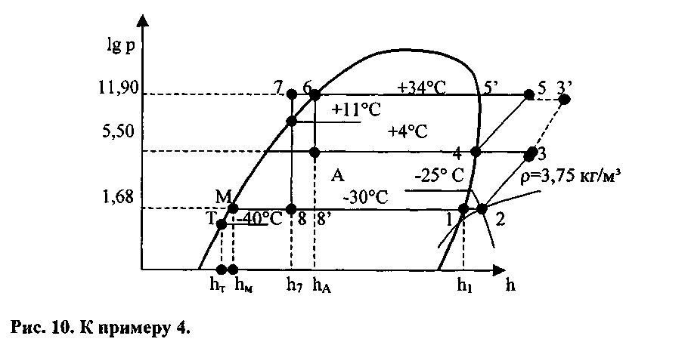

3) Точка 3 и точка 5 характеризующие состояние пара на выходе из первой и второй ступеней компрессора, соответственно, лежат на пересечении изобар р_{п}= 5,5 бара и р_{к}= 11,9 бара с соответствующими изотермами t_{H1} = +50°C н₂ = +78°С.
4) Точка 4, оценивающая состояние пара на выходе из ПО, лежит на пересечении изобары промежуточного давления с правой пограничной кривой, а точки 5' и 6 на пересечении изобары конденсации с левой и правой пограничными кривыми.
5) Эффективность работы УПСГ во многом определяется положением точки 7, характеризующей степень переохлаждения конденсата в ПО. Она находится на пересечении изотермы, соответствующей температуре конденсата на выходе из змеевика ПО t_{пп} = +11°С и изобары конденсации.
6) И, наконец, точка 8, иллюстрирующая состояние возвращаемой в грузовой танк жидкости, определяется точкой пересечения перпендикуляра, опущенного из точки 7 на изобару ро = 1,68 бар (дросселирование).

Б - Упрощенный расчет времени работы установки.
Допустим, что установка оборудована 3-мя двухступенчатыми компрессорами с подачей каждого 500 м³/час. Требуется определить время, необходимое для погрузки 1000 тонн пропана, имеющего температуру в береговой емкости -30°С, если температура груза в танке должна быть -40°С в течение всего времени погрузки.
Нанесем на диаграмму точку (М), соответствующую состоянию груза на манифолде (для определения значений всех параметров используем термодинамические таблицы), и точку Т, которая будет соответствовать состоянию груза в танке во время погрузки. Воспользуемся методикой расчета, использованной в примере №1.
T = Q_{OTB}/Qo,
q_{ОТВ} - количество теплоты, которое необходимо отвести от поступающего в танк груза;
Qo - суммарная холодопроизводительность 3-х компрессорных установок подачей 500 м³/час каждая.
q_{ОТВ} = (h_{м} - h_{т}) • m_{г} = (453,1 - 430,1) • 10⁶ = 23 • 10⁶кДж
Qo = 3 • V_{s} • p_{s} • (h₁ - h₈) = 3 • 500 • (864,1 - 551,8) • 3,75 = 1,76-10⁶ кДж/час
T= 13,06 часов

Пример 23.
По данным предыдущего примера произведем расчет времени захолаживания груза при отсутствии в УПСГ промежуточного охладителя.

1) Теплота, которую нам необходимо отвести из груза, останется той же самой: Q_{OTB} = 23 • 10 ⁶ кДж

2) При отсутствии ПО цикл будет состоять из процессов (1-2-3-3'-6-8'), поэтому Qo будет равно:
Q₀ = 3 • V_{s} • p_{s} • (h₁- h_{A}) = 3 • 500 • 3,75 • (864,1 - 614,4) = 1,40 • 10⁶кДж/час
Соответственно: Т = 16,4 часа.
Сравнение полученных результатов наглядно демонстрирует роль промежуточного охладителя в повышении эффективности работы УПСГ.

Пример 24.
Анализ барометрических границ различных режимов работы двухступенчатой УПСГ.

1) Проведем анализ работы УПСГ на базе данных примера 3, а именно, груз- пропан, температура перевозки t₀= -40°C, температура конденсации t_{K} = +37°С, температура конденсата на выходе из ПО t_{n} = +11°С. Тогда:
t_{K} = +37°С р_{к} = 12,8 бар
t₀ = -40⁰C р₀ = 1,11 бар
t_{n} - +11°С р„ = 6,65 бар
Δр₁ = p_{к} – p _{п} = 6,24 бар < Δ р_{доп} = 6,5 бар
Δр₂ = р_{п} – р₀ = 5,45 бар < Δр_{доп} = 6,5 бар
Как видно из приведенного примера, перевозка пропана обеспечивается работой двухступенчатой УПСГ при любых температурных режимах.

2) Рассмотрим барометрические границы для этилена в тех же температурных режимах:
температура транспортировки to= -40°C,
температура конденсации t_{K} = +7°С,
температура конденсата на выходе из ПО t_{n} = -12°С. Tогда:
t_{K}= +7°C р_{к} = 47,9 бар
t₀ = -40°C р₀ = 14,5 бар
t_{n} = -12°С р_{п} = 30,8 бар
Δр₁ = p_{к} – p _{п} = 17,1 бар > Δ р_{доп} = 6,5 бар
Δр₂ = р_{п} – р₀ = 16,3 бар > Δр_{доп} = 6,5 бар
Как можно видеть из этого примера, перевозка этилена, даже при весьма благоприятных температурных условиях, не может быть обеспечена использованием двухступенчатой УПСГ с промежуточным охладителем.
Пример 25.
По данным, приведенным в предыдущем разделе, построить цикл каскадной УПСГ.
Решение:
На диаграмме Молье для этилена (рис.12) нанесем барометрические границы для нижней ветви каскада (ветвь этилена):

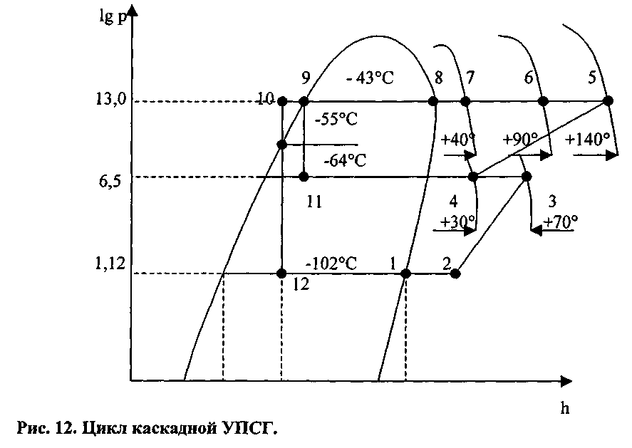

р₀= 1,12 бар => to = -102°C
р_{к} = 13,0 бар => t_{K} = -50°С
р_{п} = 6,50 бар => t_{п} = -64°С

(Данные из таблиц термодинамических таблиц для этилена) точка 2, характеризующая состояние паров на всасывании 1-й ступени компрессора, находится на пересечении изобары ро и изотермы, соответствующей температуре всасывания t_{BC1}= -50°C. Точки 3 и 4 пересечение промежуточного давления р„ = 6,5 бар и изотерм t_{H1} = +70°С - нагнетания 1-й ступени компрессора и t_{BC2} = +30°C температуры всасывания 2-й ступени компрессора. Пересечение изобары конденсации р_{к} = 13 бар с изотермой t_{H2} = +140°C (температура нагнетания 2-й ступени) дает точку 5 состояния паров на выходе из второй ступени компрессора. Точка 6 характеризует состояние паров на выходе из газового теплообменника ГТО (пересечение р_{к} = 13 бар и t_{ГТО} = +90°С). Точка 7 характеризует состояние паров после прохождения водяного теплообменника ВТО (пересечение р_{к}=13 бар и t_{BTO} = +40°C. И, наконец, точка 10 характеризует состояние паров этилена на выходе из промежуточного охладителя (при давлении р_{к} = 13 бар и температуре t_{ПО} = 55°С.
Вертикаль (9-11) отображает процесс дросселирования на регулировочном вентиле РВ_{Ь} а вертикаль (10-12) - дросселирование конденсата в РВ₂ перед сбросом в танк, когда температура парожидкостной смеси достигает температуры -102°С. Точно также на диаграмме Молье строится цикл для верхней ветви установки (R22). Температурный напор в 6°С, создаваемый в И-КД, позволяет передавать теплоту от этиленовой ветви установки к хладоновой ветви. Перепады давления на всех ступенях компрессоров находятся в пределах допустимой нормы. Таким образом, рассмотренная нами каскадная УПСГ может обеспечить транспортировку этилена при любых температурных режимах.

Пример 26.
Атмосфера в танке перед началом погрузки состоит на 100% из паров пропана Груз — пропан. Береговой газоотвод отсутствует
Объем грузовых танков (6 танков) 5200 m³
Количество груза к погрузке 2707 Мт
Температура забортной воды 11 С
Давление в танке перед погрузкой 0,1 бара
Температура танков перед погрузкой 18° С
Температура груза на манифолде 10° С
Температура танка во время погрузки -4 С
Вес материала грузовых танков 740 Мт
Удельная теплоемкость стали 0,419 кДж/кгК
Суммарный вес изоляции танков 14,4 Мт
Удельная теплоемкость изоляции 0,84 кДж/кгК
Компрессорная установка 3 одинаковых одноступенчатых компрессора
Давление всасывания на компрессорах 3,15 бара
Давление нагнетания компрессоров 7,6 бара
Температура всасывания 2 С
Температура нагнетания 58 С
Скорость всасывания каждого компрессора 410 м³/ч
Атмосферное давление 1000 млбар
Рассчитать количество теплоты, которое необходимо удалить из материала танка
Рассчитать количество теплоты, которое необходимо удалить из изоляции танков
Рассчитать количество теплоты, которое необходимо удалить из атмосферы танка
Найти с помощью кривых «Приложения 1» количество теплоты, поступающее в танк из внешней среды
Рассчитать суммарную холодопроизводительность компрессорной установки
Рассчитать полное время, необходимое на погрузку, если во время погрузки используются все три компрессора
Решение:
Q_{T} = m_{T} c_{T} ( t₁ – t₂ ) = 740 10³ 0,419 (291-269) = 6,82 10⁶ кДж
Q_{i} = m_{i} c_{i} ( t₁ – t₂ ) = 14,4 10³ 0,840 (291-269) 0,5 = 0,13 10⁶ кДж
Q_{L} = m Δh = 2,707 10⁶ (549,3 – 514,0) = 95,56 10 ⁶ кДж
Q_{A} = V_{T} ρ_{A} Δh_{A} = 5,200 1,95 (945 – 514) = 4,37 10⁶ кДж
Q’_{TR} = 19 kW * 0,5 = 9,5 => 9,5 * 3600 = 0,034 10⁶кДж/ч
Q’_{net}= V_{S} • ρ_{S} • Δh=410 * 8,8 * (894,2 – 578,3) = 1,14 10⁶кДж/ч

Общее время, необходимое на погрузку

Q_{T} + Q_{i} + Q _{L}+ Q_{A} (6,82+0,13+95,56+4,37) • 10⁶ кДж
τ = ⎯⎯⎯⎯⎯⎯⎯⎯ = ⎯⎯⎯⎯⎯⎯⎯⎯⎯⎯⎯⎯⎯ = 31,6 ч.
Q_{net} – Q_{TR} (3 • 1,14 - 0,034) • 10⁶ кДж

Пример 27.
How long time will it take to load 10500 ton of Propane, when the cargo has to be cooled from + 20° С to -5°C during loading Seawater temperature is 32°C
Решение:
1. The surface area of the tanks is 6980 m² and the K-value is 0.223 W/m² °C.
Heat ingress pr hour will be: 6980 • 0,223 • 3600/4,187 • 37 = 4,95 • 10⁴ kcal/hr
2. The enthalpy to be removed is found in the Mollier diagram.
Enthalpy of saturated liquid propane at +20°C =112 kcal/kg
Enthalpy of saturated liquid propane at -5°С = 97 kcal/kg
Enthalpy to be removed is thus = 15 kcal/kg.
3. The capacity of the compressor in 2-stage operation is max. 860 • 10³ kcal/hr.
Maximum loading capacity is then: = 54033 kg/hr
With 3 compressors running our maximum loading capacity will be about 162 t/hr.
The required loading time is then: 10500/162 = 2 days 17 hours

Пример 28.
How long time (compressor - hours) will it take to cool a cargo of 10500 t propane from -5°C to -35°C.
Решение:
The compressor's capacity (2 - stage cooling) is taken from the compressor curve above at a mean temperature of -25°C. corresponding to a pressure of app. 2 Bar abs. (-25°C is chosen because the cooling process is getting slower as the temperature drops):
Capacity = 400 • 10³ kcal/hr
The enthalpy to be removed is found in the Mollier diagram as 16 kcal/kg.
The heat ingress is calculated at a mean temperature difference of 55°C to be approx. 7,4 • 10⁴ kcal/hr.
The necessary cooling time is thus: = 515 hours.

Пример 29.
Определить, как изменится величины подачи и напора насоса при выгрузке пропана с температурой -40° С, при подключении в параллель второго грузового насоса (рис.25)
Решение:
Построим результативную характеристику работы двух одинаковых насосов в параллель по имеющемся характеристикам одного грузового насоса и берегового трубопровода. Подача при автономном действии одиночного насоса составит 530 м³/час (точка пересечения характеристики насоса и берегового трубопровода). Точка же пересечения суммарной характеристики параллельного включения насосов и характеристики берегового трубопровода, позволит нам определить величину подачи 2-х насосов при параллельном включении, которая составит 745 м³/час. Напор при автономном включении одного насоса составляет 137,5 м, а при использовании 2-х насосов при параллельном включении, напор составит 210 метров.
Для того, чтобы определить насколько изменится давление в трубопроводе, будем использовать уже известную нам формулу:
Н = Рн / р g, откуда Рн =p g H
Из термодинамических характеристик для пропана определяем плотность пропана при температуре -40° С, которая составит 578 кг/м³. Подставив численные значения плотности р, напора Н и ускорения свободного падения g, получим: При автономном действии насоса:
Рн= 578 • 9,81 • 137,5 = 779649 Па = 779649 • 10 ⁻⁵ = 7,8 бар
При параллельном включении насосов:
Рн= 578 • 9,81 • 210 = 1190742 Па = 1190742•10 ⁻⁵ = 11,9 бар.

Пример 30.
Определить, как изменится величина давления в грузовом трубопроводе при выгрузке пропана с температурой —40° С при последовательном подключении в трубопровод бустерного насоса. (характеристики бустерного насоса точно такие же, что и грузового насоса.
Решение:
Используя напорные характеристики грузового (1) и бустерного (2) насосов, строим результирующую напорную характеристику насосов, включенных последовательно (1+2).
При данной величине подачи грузового насоса (530 м³/час) определяем величину напора. Для автономно действующего насоса она составит 130 метров, а для последовательного включения грузового и бустерных насосов, величина напора составит 220 метров. Для определения величины давления в трубопроводе, будем использовать туже формулу, что и в первой задаче.
Для автономно действующего насоса получим:
Рн= 578 x 9,81 • 130 = 676130 Па = 676130 • 10⁻⁵ = 6,8 бара
А для последовательно включенных насосов:
Рн= 578 • 9,81 • 220 = 1247440 Па = 1247440 • 10⁻⁵ = 12,5 бара

Пример 31.
Рассчитать безопасное время закрытия клапана грузового трубопровода при погрузке пропана. Температура пропана -20 ° С, давление в грузовом трубопроводе - 7,0 бар, длина грузового трубопровода -1200 метров, скорость звука в пропане составляет 1060м/с.
Решение:
Определяем фазу гидравлического удара по формуле:
Т= 2L / а ( с).
Т= 2 x 1200 / 1060 = 2,26 с
Далее, рассчитываем время безопасного закрытия клапана при отношении tз/ Т > 5
t3 = T•5 = 2,26 • 5 = ll,3c.

Пример 32.
For the pump min. allowed pump head has been determined.
H min = 106 mLC
E.g., ammonia of -30°C is discharged at a tank pressure of 0,2 kp/cm² gauge
Medium Ammonia
Temperature t = -30°C
Tank pressure pS = 0,2 kp/cm²
Specific weight of ammonia at -30°C γ = 0,678 kp/dm³ (see p. 21 of "LGA properties")
Manometric head
H * γ 106 - 0,678
dP_{man} = ---------- = ---------- = 7,2 kp/cm²
10 10
Reading at pressure gauge: pDmin = Δ p man + pS = 7,2 + 0,2 = 7,4 kp/cm²

The pump is working within the allowed range when the pressure gauge shows 7,4 kp/cm² and more.

Пример 33:
Аммиак находится в танке при давлении 3,98 бара, при этом температура его груза в куполе танка составляет -2°С. На всасывании компрессора пары аммиака поступают с температурой +20 ° С. Определить потери производительности установки повторного сжижения в плотности паров.
Решение:
Плотность перегретых паров аммиака температуре -2° С и давлении 3,98 бара составляет 3,17 кг/м³
Плотность перегретых паров аммиака температуре +20° С и давлении 3,98 бара составляет 2,90 кг/м³ (данные выбираем из таблиц термодинамических характеристик аммиака)
Таким образом, потеря в плотности паров составит:
3,17 кг/м³ - 2,90 кг/м³ = 0,27 кг/м³ или же в процентном выражении: 0,27 / 3.17 x 100% = 8.5%
Определив, потери возникающие в данном случае на каждый градус превышения температуры на всасывании, получим следующее: превышение температуры паров во всасывающем трубопроводе составит: 20°С - (-2°С) = 22°С
потери массовой производительности на каждый градус превышения температуры: 8.5% / 22 x 100% = 0.4%
Такие же расчеты произведенные для любых других газов, показали, что процентное значение потерь массы паров во всасывающем трубопроводе для всех типов грузов, перевозимых на судах, примерно одинаково и составляет 0,4% на каждый градус превышения температуры паров на всасывании компрессора по сравнению с её значением на выходе из танка.

Пример 34:
Аммиак находится в танке под давлением р_{т} = 4 бара, давление на всасывании компрессора (р_{B}) составляет 3,6 бара. Определить гидравлические потери производительности компрессорной установки.
Решение:
Шероховатости внутренней поверхности трубопроводов, их изгибы, фланцевые соединения, клапаны - все это также снижает весовое соотношение перерабатываемого компрессором газа на каждый м³ за счет падения давления на всасывании компрессора.
Величина падения давления (Δ р) (превышение давления в танке над давлением всасывания компрессора) составляет 0,4 бара. Следовательно, величину потерь в массовом соотношении всасываемых паров на каждый м³, можно выразить следующим образом:
ρ_{T} - ρ_{B} 0,4
Δρ = ⎯⎯⎯⎯ Или же Δρ = ⎯⎯ x 100% ≈ 10%
ρ_{T} 4,0
Таким образом, общая величина потерь, для рассмотренного случая, составит: 0,4% x (22° C) + 10% = 18,8%

Как видно, примерно 1/5 часть времени работы установки реконденсации уйдет на компенсацию потерь во всасывающем трубопроводе.

Пример 35:
The number of purges needed to obtain a certain requirement is given by the following equation:

logC – logC₀
Number of purges, n = ⎯⎯⎯⎯⎯⎯⎯⎯⎯
logP_{a} - logP

n = number of purges
С = final content of the gas/oxygen to be removed
Co = initial content of the gas/oxygen to be removed
P = pressuration pressure (bar)
Pa = absolute pressure after exhaust (bar)

Пример 36:
Cooling during loading.
We are going to load 7500 t of Commercial Propane. Temperature of cargo is 20 C and the pressure is 9.5 bar a, which has to be reduced to 4.8 bar a at the manifold. Sea-water temperature is 32° С and all 3 compressors are used to cool the cargo down to -5°C.
Решение:
From sheet A & B: Capacity = 3• 80 m³/h = 3 • 40 t/h = 120 t/H
Time = 7500 / 120 = 62.5 h = 2^{d}15^{h}
From sheet C: Use of power: 340 kW pr. unit

SHEET A:
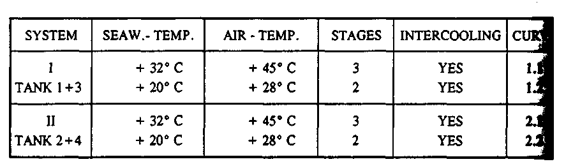

SHEET B:
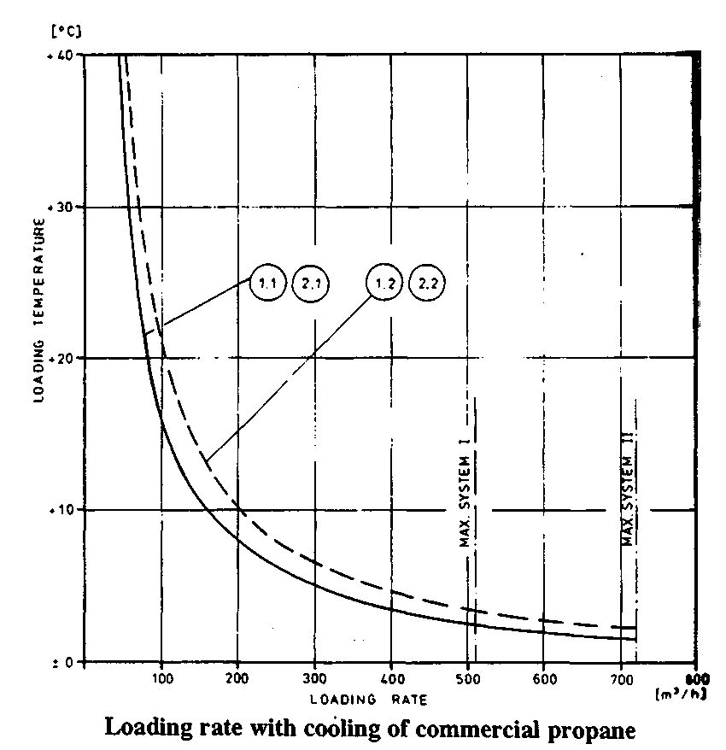

SHEET C:

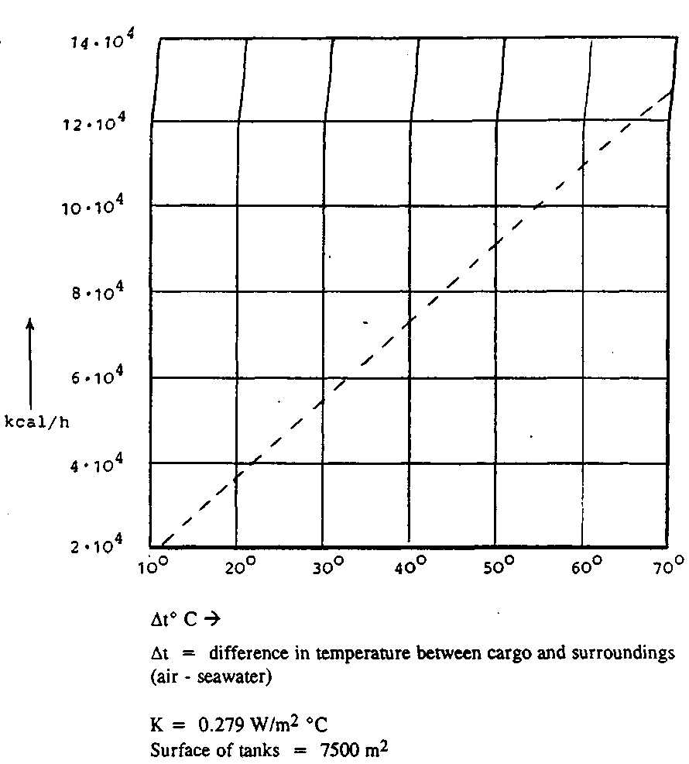

If you wish the cost price you might reckon the fuel consumption to abt. 200g/HP • h 270g/kW • h
and at a power consumption of 340 kW pr. compressor. You will get: 270 • 3 • 340 • 62.5 • 10-⁶ = 17.21
Cost price about 5.000 $

Пример 37:
Heat penetration during voyage.
We expect a sea-water temperature of 32°С which gives At = 37°C.
Решение:
From sheet C: Heat penetration = 6.8 • 10⁴ kcal/h
1 compressor's work = 625 • 10³ kcal/h
1 compressor has to work : (24 • 6,8) : 62.5 = 2.6 hours/day

Пример 38:
Cooling down at sea.
The temperature of cargo has to be lowered to -45 °C in 4 steps of 10 centigrades. 1 compressor is run on each system, sea-water still 32°C. For system II you get:
From sheet D: From -5° to -15° : 35 hours
From -15° to -25° : 65 hours
From -25° to -35° : 100 hours
From -35° to -45° : 200 hours
From -5° to -45° : 400 hours = 16.7 days

SHEET D:

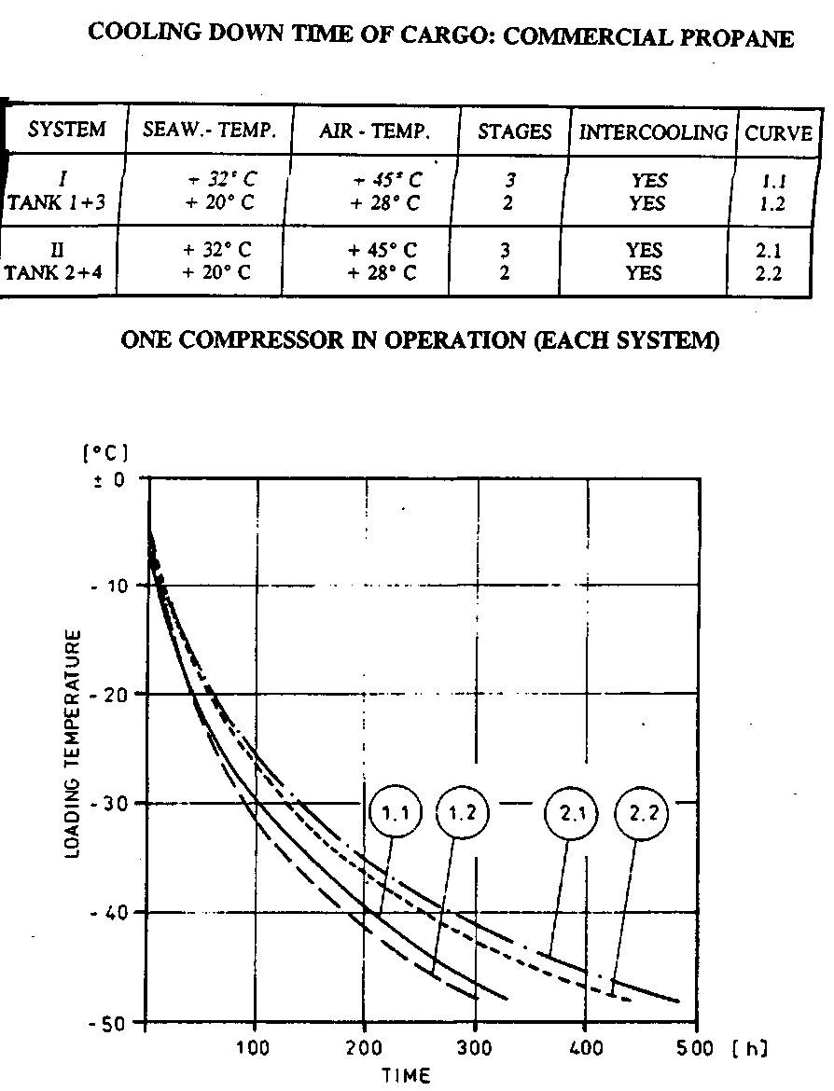

If all 3 compressors are running the cooling down time might come down to about 250 hours. From sheet С you will see that consumption of power is going down as temperature is lowered.
Пример 39:
A fully pressurized ship loading propane at 20°C with relief valves set at 16 barg.

LL = FL x (pR / pL)

Reference temperature +49°C (corresponding to SVP of 16 + 1 =17 bar for propane)
Density of liquid propane at 49°C = 452 kg/m³
Loading temperature +20°C
Density of liquid propane at 20°C = 502 kg/m³

LL = 98 x (452 / 502) = 88.2

Therefore, the tank can be filled to 88.2 per cent of tank volume.

Пример 40:
A semi-pressurized ship loading propane at -42°C with relief valves set at 5 barg and having no additional pressure relieving facility fitted.
Here, since no additional pressure relief is fitted in accordance with the Gas Codes, the reference temperature must be taken as the temperature corresponding to vapor pressure at set pressure of relief valves, i.e. a temperature corresponding to an SVP of 5 + 1 =6 bar.
Reference temperature = + 8°C
Density of liquid propane at 8°C =519 kg/m³
Loading temperature = - 42°C
Thus, the tank can be filled to 87.4 per cent of tank volume.
Density of liquid propane at -42°C = 582 kg/m³

LL = 98 x (519 / 582) = 87.4

Пример 41:
A fully refrigerated ship loading propane at -42°C with relief valves set at 0.25 barg.
Reference temperature -37.5°C
Density of liquid propane at -37.5°C = 577 kg/m³
Loading temperature -42°C
Density of liquid propane at -42°C = 582 kg/m³

LL = 98 x (577 / 582) = 97.1

Thus, the tank can be filled to 97.1 per cent of tank volume.

(NOTE: see "Liquefied gas handling" para. 7.5.5 for detailed explanation)

Пример 42:
Произвести предварительные расчеты количества пропана, который необходимо погрузить при температуре -20°С, обеспечивая полную грузовместимость судна и определить объём груза и взливы в каждом танке.
Расчетный дифферент судна на отход - 1 метр на корму. Установочные давления для предохранительных клапанов - 0,3 бар и 4,0 бар.
Решение:
Для расчетов будем использовать мерительные таблицы.
Используя таблицы термодинамических характеристик пропана, определим давление насыщенных паров пропана при заданной температуре (при -20°С, давление насыщенных паров составит 2,4452 бара) Это давление соответствует манометрическому давлению газа в танке, в 1,44 бара. Следовательно, MAVRS должно быть выставлено на 4,0 бара перед началом погрузки.
По соотношению
d_{M}
FL = ⎯⎯⎯ ⋅ 98 %
d_{C}
определяем предел заполнения танка. Для этого из термодинамических таблиц находим плотность пропана при давлении, соответствующем установочному давлению предохранительного клапана 4,0 бара (манометрическое) и плотность пропана при температуре груза - 20°С:
Установочное давление 4,0 бар
Атмосферное давление 1,013 бар
Давление насыщения 5,013 бар
Плотность пропана при 5,013 бара составляет 526,21 кг/м³
Плотность пропана при температуре -20°С составит 5 54,48 кг/м³ Подставляя эти значения получим:
dr ⋅ 98% 526,21 кг/м³
Fl = ⎯⎯⎯⎯ = ⎯⎯⎯⎯⎯ = 93%
dl 554,48 кг/м³
Зная процентное значения предела заполнения танка, рассчитываем объём жидкой фазы груза в каждом из 4-х танков.

Номер танка | Объём танка (100 %} | Объём заполнения  (93%)
Танк№1 | 828,340 м³ х 0,93 | 770,356 м³
Танк №2 | 987,180м³хО,93 | 918,077м³
Танк №3 | 1060,220 м³ х 0,93 | 986,005 м³
Танк №4 | 1 060,220 м³х 0,93 | 986,005 м³

Из мерительных таблиц выбираем значение взливов груза в танках (с учетом поправки за поплавок и дифферент в 1 метр на корму)

Номер танка | Объём заполнения | Исправленный  взлив
Танк№1 | 770,356 м³ | 8,395 м
Танк №2 | 918,077м³ | 8,123м
Танк №3 | 986,005 м³ | 8,109м
Танк №4 | 986,005 м³ | 8,131м
Если предварительный расчет груза был произведен с достаточной точностью, действительные взливы в танках на момент окончания погрузки (показания мерительных устройств) можно рассчитать, используя необходимые поправки за сжатие ленты и вертикальное сжатие танка, с учетом фактической температуры груза и паров.

Пример 43:
Перед погрузкой необходимо продуть атмосферу танка парами пропана. Температура атмосферы грузового танка перед продувкой составляет +15°С. Определить количество сжиженного пропана (в м³), необходимое для продувки танка объёмом 3.000м³, если терминал может поставить сжиженный пропан при температуре -41 ° С.
Решение:
Определим массу паров пропана, для замены атмосферы танка. Для вычислений будем использовать таблицы термодинамических параметров перегретых паров пропана. По графику находим плотность (р) перегретых паров пропана при температуре +15°С и давлении 1,75 кг/м³. Зная объём танка и плотность паров, определяем их массу:
m = ρ x V = 1,75 ⋅ 3000 = 5250 кг
Для того, чтобы определить, сколько сжиженного пропана потребуется для замены атмосферы танка, из таблицы термодинамических характеристик пропана (Приложение) по температуре -41° С выбираем значение плотности сжиженного пропана (р_{ж}), равное 579,66 кг/м³:
V = m : ρ _{ж} = 9057 м³

Пример 44:
Определить истинную плотность пропана, если его относительная плотность в вакууме RD15/15= 0,5013.
Решение:
Из таблицы 6 выбираем истинную плотность воды при температуре 15° С. d_{B} = 0,99913 кг/л
Умножим относительную плотность пропана на истинную плотность воды, в результате чего получим истинную плотность пропана при +15° С.
0,5013 х 0,99913 = 0,50086 кг/л.
Таким же образом осуществляется пересчет реальной относительной плотности в реальную истинную плотность. Только заданное значение реальной относительной плотности необходимо умножать на значение реальной плотности воды при соответствующей температуре.
Пример 45:
Грузоотправитель предоставил процентное молярное соотношение газовой смеси, состоящей из метана, пропана и этана. Необходимо определить весовое соотношение (%) газов в смеси.
Решение:

Компонент | %-ный состав (в молях) | Вид операции | Колонка 1 | Молярный состав
Метан | 33,3 | умножить | 16,04 | 534,1
Этан | 33,3 | умножить | 30,07 | 1.001,3
Пропан | 33,4 | умножить | 44,09 | 1.472,6
Всего: | 100,0 | Всего: |  | 3.008,0

Kоэффициент пересчета можно определить соотношением:
100,00
Коэффициент = ⎯⎯⎯⎯⎯⎯ = 0,03324
3008,00
Умножив коэффициент пересчета на молярный состав каждого компонента, получаем весовое соотношение каждого компонента в смеси:

Компонент | Молярный состав |  | Коэффициент |  | Весовое соотношение (%)
Метан | 534,1 | X | 0,03324 | = | 17,8
Этан | 1.001,3 | X | 0,03324 | = | 33,3
Пропан | 1.472,6 | X | 0,03324 | = | 48,9
Всего: |  |  |  |  | 100,0

Пример 46:

Расчет ЖИДКОСТНОЙ фазы груза.
(Propane)
Calculate the volume at 15°C when:
Density 15 °C = 510kg/m³
Volume sounded at-25 °C = 1000m³
Решение:

The table 54 gives: Volume reduction factor = 1.103. Thus
Volume at l5°C = 1000-1.103 = 1103m³
To get the mass the volume at 15 °C must be multiplied with the density at 15 °C.
Mass (Weight in vacuo) = 1103-510 = 562530 kg
If weight in air is wanted the density should be corrected first
Air corrected density_{15 C} = Density_{15 C} - 1.1 (kg/m³)
Thus: Weight in air = 1103-508.9 = 561317kg
For products other than pure saturated hydrocarbons two different methods of calculating the liquid mass are commonly used.
Density is specified at the temperature which the product has in the tank and the mass is deducted from:
Mass = Volume _{t} • Density _{t}
Density at 15 °C along with a Density сcorrection factor is given
Density at tank temperature can now be found from:
Density _{t} = Density _{15 C} - β ⋅ Δ t where:
β is density correction factor
Δt is the temperature difference between tank temperature and 15 °C.
Please notice that the density becomes smaller when the temperature rises. Finally the mass is again found from:
Mass = Volume _{t} • Density _{t}

Пример 47:

DENSITY AT TEMPERATURE
(Propylene Oxide)
Density _{15 C} = 835.4 kg / m³
β = 1.25/°C
Volume at 22°C = 3485 m³
Решение:
Density _{22 C} = 835.4 - 7 • 1.25 = 826.65 kg/m³
Mass = 3485 • 826.65 = 2880875 kg
If Relative Density and not density is specified the R.D has to be changed to density before being of any use. This is done be multiplying R.D. a°/b° with the density of fresh water at b°.
Density at a° = (R.D. a°/b°) • (Fw density at b°)

Densities of fresh water: kg/m3) at different temperatures.
0°C | = 999.8
4°C | = 1000.0
15 °C | = 999.1 | 60°F = 999.0
20°C | = 998.2
25 °C | = 997.0

Пример 48:
Calculate the mass of one gram-mole of Propane.
Решение:
The chemical formula for Propane is C₃H₈
From the Physical Tables
Atomic mass of one Carbon atom = 12.011
Atomic mass of one Hydrogen atom = 1.008
Therefore :
C₃H₈ = (3 x 12.011) + (8 x 1.008) = 44.097

Пример 49:
Gaseous Propane is to be liquefied for storage. How many grammes of liquid Propane will be formed by the liquefaction of 500 litres of the gas, the volume being measured at standard conditions.
Решение 1:
Molecular Weight of Propane = 44.097
Gram-moles of Propane = 300 / 22.414 (Avagadro's Number) = 22.307
Weight of Propane Liquid = Gram-moles x Molecular Weight = 22.307 x 44.097 = 983.69 grammes

Решение 2:
Weight of Propane Liquid = 1.033 + P x 273 x M.WT. x Volume
1.033 273+t 22.414
As the gas is at STP, the values of P and t are zero
Therefore : Weight of Propane liquid = 44.097 x 500 / 22.414 = 983.69 grams

Пример 50:
Calculate the percentage composition of the vapour in equilibrium with a Liquefied gas at a temperature of 21°C containing:
0.8% Ethane, 32.4% Propane and 66.8% N-Butane
Решение:

 | (a) | (b) | (c) | (d) | (e) | (f) | (g) | (h) | (2)
Liquid Gas Mixture | Vol% | Kg/1  @  21 °C | Kg/1001 | M.Wt. | Kg/ mol | Mole  Fract. | Vap. Press | Partl. Press | Vap.% by Vol Соmр.
Ethane | 0.8 | . 3828 | .30624 | 30.068 | .0053 | .0051 | 40.0 | .204 | 4.34
Propane | 32.4 | .5010 | 16.2324 | 44. 097 | .3681 | .3552 | 8.7 | 3.090 | 65.73
N -Butane | 66.8 | .5768 | 38.5302 | 58.120 | .6629 | .6397 | 2.2 | 1.407 | 29.93
 | 100% |  |  |  | 1.0363  = (X) | 1.0000 |  | 4.701  = (Y) | 100%

Therefore the vapour in equilibrium with this particular mixture of liquefied gas contains :
Ethane 4.34%
Propane 65.73%
Butane 29.93%
Composition of the liquid in volume %.
Kilograms per litre of the individual components at 21 C, taken from the Physical Tables.
(а х b) gives kilograms per 100 litres of the mixture.
Molecular Weight.
(c/d) gives the Kg-mole per 100 litres.
(e/x) gives the mole fraction.
(X) The sum of the components in column (e).
(g) Vapour pressure (saturated), in Ata from the vapour pressure diagram or Physical Tables.
(h) (f x g) gives the partial pressures in the mixture in Ata £ 21°C.
(Y) The sue of the partial pressures, i.e. the total saturated vapour pressure of the mixture corresponding to a temperature of 21°C.
(z) (h/Y) gives the percentage volume composition of the vapour in equilibrium with the liquid.

Пример 51:
Calculate the weight of 1000 M³ of Propane vapour measured at a gauge pressure of 0.3 Kg/cm² and temperature of -3O°C.
Решение:
Wt. of Propane Liquid = 1.033 + P x 273 x M.Wt. x Volume м³ = 2.852 tonnes (2852 Kg)
1.033 273 + t 22414
Пример 52:
Calculate the maximum volume of liquid propane at a temperature of -40°С, which can be safely loaded into an unrefrigerated pressure vessel of 300 M-⁵, for storage at an ambient temperature of 20°C. Disregard any vapour calculations.
Решение:
When the ambient temperature of 20 С has been reached, the pressure vessel should contain 294 M³ (98% level) of Propane liquid at 20°C.
Density of Propane @ 20°C = 0.5020
Density of Propane @ -40°C = 0.5797
Shrinkage factor for -40°C = 0.997952 (Approx)
The weight of Propane @ 20°C = Volume x Density = 294 x 0.5020 = 147.588 tonnes
Therefore the unrefrigerated pressure vessel must not be filled with more than 147.588 tonnes of Propane at -40°С in order to allow for expansion to 98% volume at the expected ambient temperature.
Volume of Propane 9 -40°C = Wt. of Propane / Density @ -40°C x Shrinkage Factor = 147.588 / 0.5797 x 0.997952 = 255 M³

Пример 53:

MAXIMUM LOADING RATE
When loading relatively warm products (e.g. VCM), the loading rate must be compatible with the total reliquefaction capacity available. As there are restrictions imposed by the settings of the cargo tank vapour relief valves, the cargo loaded will have to be cooled (i.e. have heat removed) to acceptable tank pressures DURING loading. The information required in order to be able to calculate the required loading rate can be found from the thermodynamic tables and from the Builder's/Manufacturer's specifications.
Temperature of cargo at manifold = Enthalpy in K.Cal/Tonne
Final temperature required = Enthalpy in K.Cal/Tonne
Heat to be removed during load = Difference (1)
Total reliquefaction capacity = K.Cal/hour
Heat ingress through tank insul. = K.Cal/hour
Net reliquefaction capacity avail. = Difference (2)
MAXIMUM LOADING RATE = (1) divided by (2) tonnes/hour

Пример 54:
Судно вместимостью 8.000 м³ после визуальной инспекции танков имеет в танках воздух с содержанием кислорода (O₂) 21% по объёму. Рабочие компрессора могут создать в танках вакуум 50% (-0,5 бара манометрическое давление или же 0,5 бара абсолютное давление). По окончании продувки танков азотом атмосфера в танках должна содержать кислорода не более 1 % от объёма танка. Определить, какое количество вакуумных циклов вам необходимо произвести и какое количество азота вы при этом используете?
Решение:
ln 1 – ln 21_{H} 0 – 3,04
Nn = ⎯⎯⎯⎯⎯⎯⎯⎯ = ⎯⎯⎯⎯⎯ = 4,41
1,0 0,69
Для того, чтобы достичь 1% содержания кислорода в атмосфере танка, необходимо произвести 4,5 вакуумных цикла.
Поскольку степень вакуумирования составляет 50%, то за каждый вакуумный цикл будет происходить смена 50 % объёма танка (в нашем случае 4000 м³). Соответственно за 4,5 цикла будет израсходовано:
4,5 х 4000= 18000м³ азота
Эту задачу можно решить "шаг за шагом", используя соотношение
p _{H}
C_{K} (%) =⎯⎯⎯ × C_{H} (%)
p _{K}
Где Сн - концентрация газа в начале каждого цикла, а Ск - концентрация газа в конце каждого цикла.
То есть в нашем случае за первый вакуумный цикл концентрацию кислорода можно снизить до: (0,5/1,0) •21% =10,5%,
За второй цикл, соответственно:
(0,5/1.0) • 10,5% = 5,25%.
За третий цикл:
(0,5/1,0) 5,25% = 2,63%
За четвертый:
(0,5/1.0) • 2,63%% - 1,31 %% и т.д.
расход азота за 4 цикла составит:
8.000м³ • 50% = 4.000м³ • 4 - 16000 м³

Пример 55:
Содержание кислорода в танке объёмом 4.000м³ до начала инертизации -21% по объёму. Необходимо продуть танк до содержания кислорода 3% по объёму.
Решение:
Отношение процентного содержания кислорода до и после инертизации будет равно 7. Натуральный логарифм числа 7 составляет 1,95, то есть необходимо произвести 2 полных обмена атмосферы танка, чтобы содержание кислорода в нем понизилось до 3% процентов. Эта формула дает правильный результат в случае однородной смеси газов в танке, однако, если сработает «эффект поршня», то число обменов будет меньше.
Вышеуказанная формула хороша, если для инертизации используется азот. То есть содержание кислорода в продувочном газе принято равным «О». Что же произойдет, если мы будем продувать атмосферу танка с помощью инертного газа, который содержит некоторое количество кислорода. В таком случае вышеуказанная формула примет вид:
C_{H} – O₂^{ИГ}
n = ln ⎯⎯⎯⎯⎯⎯⎯
C_{К} – O₂^{ИГ}
где O₂^{ИГ} - содержание кислорода в инертном газе.
Эта же формула может использоваться для расчета числа обменов объёма при вентиляции танков воздухом.
Ниже приведены значения натуральных логарифмов для некоторых чисел.

Число | Натуральный логарифм | Число | Натуральный логарифм
5 | 1,609 | 15 | 2,708
6 | 1,792 | 16 | 2,773
7 | 1,946 | 17 | 2,833
8 | 2,079 | 18 | 2,890
9 | 2,197 | 19 | 2,944
10 | 2,303 | 20 | 2,996
И | 2,398 | 30 | 3,401
12 | 2,485 | 40 | 3,689
13 | 2,565 | 50 | 3,910
14 | 2,639 | 60 | 4,094

На практике расход азота будет несколько выше, чем рассчитанный вышеописанным методом.
Для практического применения этой формулы рекомендуется к расчетной величине количества смен объёмов добавлять еще 10% от этого количества.
Для нашего примера величина необходимого количества смен объёмов составляет 1,95, на практике же необходимо увеличить это количество на 10%: 1,95 + 0,20 = 2,15 , то есть расход азота будет выше на 10%.

Для определения количества азота, необходимого для продувки танков можно использовать следующие соотношения:
1. 1 литр жидкого азота (-196°С) = 0,8086 кг = 691 литру газообразного азота при +15°С и атмосферном давлении.
2. 1 кг жидкого азота = 855 литрам газообразного азота при +15°С и атмосферном давлении.

Пример 56:
В этом параграфе мы произведем практические расчеты времени захолаживания танков жидким этиленом и рассчитаем количество этилена, которое нам потребуется для этой операции. Прежде всего сделаем несколько основных предположений:
Приток тепла в систему грузовых танков извне предположим постоянным на период всего захолаживания и равным 50% от расчетного значения при погрузке этилена с температурой -103°С.
Средняя температура воздуха составляет +45°С (наихудшие условия).
Температура забортной воды +32°С (наихудшие условия).
Температура пространства, окружающего танки (Void spaces), в верхней части составляет +41°С, а в нижней +28°С (в танке находится этилен с температурой —104°С).
Суточное колебание температур составляет 15°С (разница между дневной и ночной температурами).
Давление паров в танке в процессе продувки удерживается в пределах 1,25 бар (абсолютное давление) для обеспечения наиболее оптимального режима испарения этилена.
Максимально допустимая скорость захолаживания танка 10°С/час (требование завода-изготовителя).
Учитывая суточное колебание температуры в 15°С, мы можем вычесть половину этого значения от предполагаемой температуры Void Space в верхней его части (температура в нижней части зависит от температуры забортной воды, а её суточные колебания приняты несущественными). То есть температура составит +34°С.

В таком случае средняя температура изоляции определится:

(45°С - 7°С) + 32°С
⎯⎯⎯⎯⎯⎯⎯⎯⎯ = +35° C
2

Первоначальная температура (перед началом захолаживания) составит среднее арифметическое от суммы дневной температуры воздуха за вычетом половины значения суточного колебания температуры и температуры забортной воды:

(34°С + 28 ° С ) 1
⎯⎯⎯⎯⎯⎯⎯⎯ - 104 ° С ⋅ ⎯⎯ = + 37 ° С
2 2
Теперь можно рассчитать минимально возможное время захолаживания. Температура атмосферы танка +35°С, температура груза -104°С, следовательно:

104 + 35
Время захолаживания = -------------- = 14 часов
10

Это минимально возможное время захолаживания, т.е. нижний предел, Следующий этап - определение средней температуры паров этилена в процессе захолаживания. Практика показывает, что, обычно температура паров на выходе из танка примерно на 10°С ниже, чем температура танка. Рассмотрим самый неблагоприятный вариант, и разницу температур примем равной 20°С. В таком случае температура паров в начале процедуры будет равна:

+35°С-20°С = +15°С

на окончание же захолаживания, температура паров этилена составит:

-104°С + 20°С = -84°С

следовательно, средняя температура паров этилена составит:

(15° С + (-84° С)) / 2 =-35°С

удельная теплота парообразования для этилена при давлении 1,25 бара и температуре -102°С составляет 477кДж/кг, а при -35°С
561 кДж/кг. Следовательно, на испарение в танке каждого килограмма жидкого этилена, из общей теплоты материала танка и его изоляции будет затрачено 561 кДж.
Теперь необходимо определить подвод теплоты в танк в единицу времени через его изоляцию. Величину этой теплоты снимаем с графика по температуре груза, температуре воздуха и забортной воды (график составляется заводом-изготовителем для каждого судна).
Пусть в нашем случае для всех танков эта величина составила:
Qbh = 148950 кДж/час
Далее нужно определить, какое количество теплоты необходимо удалить из материала танка (сталь - удельная теплоемкость = 0,47 кДж/(кг К), вес 900 тонн, разность температур: ti = +35°С, t₂ = -104°С, ДТ = 139°С)
Qt = m • с • ΔT = 0,47 • 900000 • 139 = 58797000 кДж
и из изоляции танка (полиуретановая пена с теплоемкость 1,25 кДж/кг, вес изоляции 46068 кг, разница температур для изоляции на момент начала погрузки составит: t₁ = 39°С, t₂ = -37°С, ДТ = 78°С)
Q_{t} = m • с • ΔT = 46068 • 1,25 • 78 = 4491630 кДж.
При условии, что за 14 часов поток тепла извне составит:
Q_{BH} = 148950 • 14 = 2085300 кДж,
то общее количество теплоты, которое необходимо удалить получится равным:
Q = Qt + Qi + qbh = 2085300+ 4491630 + 58797000 = 65373930 кДж
Зная удельную теплоту парообразования этилена, мы можем определить его количество, необходимое для захолаживания (отвода теплоты за счет испарения):
m = Q/r = 65373930 : 561 = 116.531 кг этилена = 116,5 т.
Если полученное количество этилена разделить на время захолаживания, то мы получим общую производительность подачи сжиженного этилена:
116,5 : 14 = 8,323 тонн/час
Исходя из таких расчетов, Определяем интенсивность подачи сжиженного этилена при захолаживании танков.

Пример 57:
После выгрузки пропилена - сырца (Propylene Chemical Grade), судно предъявлено под погрузку того же пропилена, но предназначенного для производства полимеров (Propylene Polymer Grade). Первый вид груза содержит 85% Пропилена и 15% Пропана, во втором же виде груза содержание Пропилена не должно быть менее 99,5 % по весу (см. паспортные характеристики грузов). Перед началом погрузки соотношение пропилена было следующим:

В судовых танках - 85,0 % по весу
В береговом танке - 99,7 % по весу
Количество Пропилена, заявленного к погрузке - 4700 тонн.
Для расчетов будем использовать данные из предыдущего примера: Общее количество остатков груза на борту судна составляет 69,5 тонн. Количество примесей (пропана) в этом случае можно определить как:
69,5 г х 15% = 10,425 т
Количество примесей же в береговом танке будет равно:
4700 т х 0,3% = 14,100 т
Суммируя полученные значения, определим общее количество примесей в грузе Пропилена после его погрузки на борт:
10,425 т + 14,100 т = 24,525 т.
Поскольку количество груза на борту после погрузки будет равно 4770 т (груз + остатки в грузовых танках), то весовое процентное соотношение примесей в грузе в процентном отношении составит:
(24,525 т : 4770 т) х 100 % = 0.51 %.
То есть, вышеприведенные расчеты показывают, что после погрузки под пары Технического Пропилена, груз Полимерного Пропилена не будет соответствовать спецификации (99,5 % содержание Пропилена), иными словами, груз будет испорчен.
Такие расчеты рекомендуется производить при любом сомнении в отношении того, будет ли выполнено требование по сохранности груза при его погрузке под пары или на остатки предыдущего груза.
Приведенный выше пример наглядно иллюстрирует опасность порчи груза из-за большого количества паров предыдущего груза в танках. При определении процедур, необходимых для подготовки грузовых танков, всегда следует уменьшать количество предыдущего груза на борту выпариванием остатков и стравливанием избыточного давления.

